Research and Development forNext-generation Information Technology of

Ministry of Education, Culture, Sports, Science and Technology

"Research and Development of Innovative Simulation Software"

**MIT License Free Software**

FrontISTR

Ver. 3.7

User's Manual

This software is the outcome of "Research and Development of Innovative Simulation Software" project supported by Research and Development forNext-generation Information Technology of Ministry of Education, Culture, Sports, Science and Technology. We assume that you agree with our license agreement of “MIT License” by using this software either for the purpose of profit-making business or for free of charge. This software is protected by the copyright law and the other related laws, regarding unspecified issues in our license agreement and contract, or the condition without either license agreement or contract.

Corresponding Clerks:

FrontISTR forum

5-1-5 Kashiwa-no-ha, Kashiwa, Chiba 277-8563 JAPAN

Tel/Fax : 04-7136-4604

E-mail : fstr_seminar@multi.k.u-tokyo.ac.jp

Contents

1. Introduction 1

1.1 Position of this Manual 1

1.2 Purpose of this Manual 1

1.3 What’s new in Ver.3.6 1

1.4 What’s new in Ver.3.5 2

2. Finite Element Method Analysis Theory 4

2.1 Infinitesimal Deformation Linear Elasticity Static Analysis 4

2.1.1 Basic Equation 4

2.1.2 Principle of Virtual Work 5

2.1.3 Formulation 6

2.2 Nonlinear Static Analysis Method 7

2.2.1 Geometric Nonlinear Analysis Method 8

2.2.1.1 Decomposition of Increments of Virtual Work Equation 8

2.2.1.2 Principle of Virtual Work 8

2.2.1.3 Formulation of Total Lagrange Method 9

2.2.1.4 Formulation of Updated Lagrange Method 11

2.2.2 Material Nonlinear Analysis Method 12

2.2.2.1 Hyperelastic Material 12

2.2.2.2 Elastoplastic Material 13

2.2.2.3 Viscoelastic Material 16

2.2.2.4 Creep Material 16

2.2.3 Contact Analysis Method 18

2.3 Eigenvalue Analysis 19

2.3.1 Generalized Eigenvalue Problem 19

2.3.2 Problem Settings 20

2.3.3 Shifted Inverse Iteration Method 20

2.3.4 Algorithm to Solve Eigenvalues 21

2.3.5 Lanczos Method 21

2.3.6 Geometric Meaning in the Lanczos Method 21

2.3.7 Tridiagonalization 23

2.4 Heat Conduction Analysis 24

2.4.1 Basic Equation 24

2.4.2 Discretization 25

2.5 Dynamic Analysis Method 28

2.5.1 Formulation of Implicit Method 28

(1) Handling of Mass Term 29

(2) Handling of Attenuation Term 29

2.5.2 Formulation of Explicit Method 29

2.6 Frequency Response Analysis 31

2.6.1 Formulation 31

3. Analysis Flow and Input/Output File 34

3.1 Analysis Flow 34

3.2 Overall Control Data 35

3.3 Mesh Data 35

3.4 Analysis Control Data 36

3.5 Output File 37

3.6 Execution Procedure 37

(1) Preparation of FrontISTR 37

(2) Preparation of Input Files 37

(3) Execution of Single Domain Analysis 38

(4) Parallel Execution on Linux 38

(5) Parallel Execution on Windows 38

(6) Excution of Parallel Domain Contact Analysis 38

3.7 Restrictions at Time of Execution 39

4. Element Library and Material Data 41

4.1 Element Library 41

4.2 Material Data 49

4.2.1 Elastic Static Analysis, Linear Dynamic Analysis and Eigenvalue Analysis 49

4.2.2 Heat Conduction Analysis 50

(1) In the case of link, plane surface and solid element 50

(2) In the case of an interface element 51

(3) In the case of a shell element 51

4.2.3 Nonlinear Static Analysis 54

5. Overall Control Data 55

5.1 Outline of Overall Control Data 55

5.2 Input Rules 55

5.3 Header List 56

(1) !CONTROL 57

(2) !MESH 58

(3) !RESTRAT 59

(4) !RESULT 60

(5) !SUBDIR 61

6. Single Domain Mesh Data 62

6.1 Outline of Single Mesh Data 62

6.2 Input Rules 62

6.3 Header List of Single Domain Mesh Data 64

(1) !AMPLITUDE (M1-1) 66

(2) !EGROUP (M1-2） 67

(3) !ELEMENT（M1-3） 69

(4) !EQUATION（1-4） 71

(5) !HEADER（M1-5） 73

(6) !INITIAL CONDITION （M1-6） 74

(7) !MATERIAL (M1-7) 75

(8) !NGROUP (M1-8) 84

(9) !NODE (M1-9) 86

(10) !SECTION (M1-10) 88

(11) !SGROUP (M1-11) 91

(12) !ZERO (M1-12) 93

(13) !CONTACT PAIR　(M1-13) 94

(14) !END （M1-14） 95

7. Analysis Control Data 96

7.1 Outline of Analysis Control Data 96

7.2 Input Rules 98

7.3 Analysis Control Data 100

7.3.1 Header List of Computing Control Data 100

(1) Control data common to all analyses 103

(2) Static analysis control data 104

(3) Eigenvalue analysis control data 106

(4) Heat conduction analysis control data 107

(5) Dynamic analysis control data 110

(6) Dynamic analysis　(Frequency Response Analysis) Control Data 112

7.3.2 Solver Control Data 115

7.3.3 Post Process (Visualization) Control Data 117

7.4 Details of Analysis Control Data Parameters 125

7.4.1 Common Control Data 125

(1) !VERSION (1-1) 125

(2) !SOLUTION (1-2) 125

(3) !WRITE, VISUAL (1-3) 125

(4) !WRITE, RESULT (1-4) 126

(5) !WRITE, LOG (1-5) 126

(6) !OUTPUT_VIS (1-6) 126

(7) !OUTPUT_RES　(1-7) 127

(8) !RESTART　(1-8) 128

(9) !ECHO (1-9) 128

(10) !ORIENTATION (1-10) 128

(11) !SECTION (1-11) 129

(12) !END (1-12) 129

7.4.2 Control Data for Static Analysis 129

(1) !STATIC (2-1) 129

(2) !MATERIAL (2-2) 130

(3) !ELASTIC (2-2-1) 130

(4) !PLASTIC (2-2-2) 131

(5) !HYPERELASTIC (2-2-3) 133

(6) !VISCOELASTIC (2-2-4) 134

(7) !CREEP (2-2-5) 134

(8) !DENSITY (2-2-6) 135

(9) !EXPANSION_COEFF (2-2-7) 135

(10) !USER_MATERIAL (2-2-8) 136

(11) !BOUNDARY (2-3) 136

(12) !SPRING (2-3-1) 136

(13) !CLOAD (2-4) 137

(14) !DLOAD (2-5) 137

(15) !ULOAD (2-6) 139

(16) !CONTACT_ALGO (2-7) 139

(17) !CONTACT (2-8) 139

(18) !TEMPERATURE (2-9) 140

(19) !REFTEMP (2-10) 140

(20) !STEP　(2-11) 141

(21) !TRS (2-12) 142

7.4.3 Control Data for Eigenvalue Analysis 142

(1) !EIGEN (3-1) 142

7.4.4 Control Data for Heat Conduction Analysis 142

(1) !HEAT (4-1) 142

(2) !FIXTEMP (4-2) 143

(3) !CFLUX (4-3) 144

(4) !DFLUX (4-4) 144

(5) !SFLUX (4-5) 145

(6) !FILM (4-6) 146

(7) !SFILM (4-7) 146

(8) !RADIATE (4-8) 147

(9) !SRADIATE (4-9) 148

(10) !WELD_LINE (4-10) 148

7.4.5 Control Data for Dynamic Analysis 149

(1) !DYNAMIC (5-1) 149

(2) !VELOCITY (5-2) 153

(3) !ACCELERATION (5-3) 154

(4) !COUPLE (5-4) 155

(5) !EIGENREAD(5-5) 155

(6) !FLOAD(5-6) 156

7.4.6 Solver Control Data 157

(1) !SOLVER　(6-1) 157

7.4.7 Post Process (Visualization) Control Data 159

(1) !VISUAL (P1-0) 159

(2) !surface_num, !surface, !surface_style (P1-1～3) 159

(3) !display_method (P1-4) 162

(4) !color_comp_name　!color_comp　!color_subcomp (P1-5　P1-7　P1-8) 162

(5) !isoline_number　!isoline_color (P1-9　P2-22) 164

(6) !initial_style　!deform_style (P1-15　P1-16) 164

(7) !deform_scale (P1-14) 164

(8) !output_type (P1-19) 167

(9) !x_resolution　!y_resolution (P2-1　P2-2) 167

(10) !viewpoint　!look_at_point　!up_direction (P2-5　P2-6　P2-7) 168

(11) !ambient_coef　!diffuse_coef　!specular_coef (P2-8　P2-9　P2-10) 169

(12) !color_mapping_bar_on !scale_marking_on !num_of_scales (P2-16 P2-17 P2-18) 170

(13) !font_size !font_color !backgroud_color (P2-19　P2-20　P2-21) 170

(14) !data_comp_name　!data_comp　!data_subcomp (P3-1　P3-3　P3-4) 171

(15) !method (P4-1) 171

8. User Subroutines 172

8.1 Input of User Defined Material 172

8.2 Subroutine regarding Elastoplasticity Deformation (Uyield.F90) 172

8.3 Subroutine regarding Elastic Deformation (Uelastic.F90) 173

8.4 Subroutine regarding User Defined Materials (umat.f) 174

8.5 Process Subroutine of User Defined External Load (uload.f) 175

9. Example Verification 176

9.1 Verification by Simple Geometric Model 176

(1) Elastic static analysis 176

(2) Nonlinear static analysis 182

(3) Eigenvalue analysis 188

(4) Heat conduction analysis 192

(5) Linear dynamic analysis 198

(6) Frequency Response Analysis 203

9.2 Example of Actual Model for Elastic Static Analysis 205

9.2.1 Analysis Model 205

9.2.2 Analysis Results 208

9.2.2.1 Example of Analysis Results 208

9.2.2.2 Verification Results of Analysis Performance by Verification Example EX02 210

9.2.2.3 Comparison of Computing Time by Verification Example EX01A 212

9.3 Example of Actual Model for Eigenvalue Analysis 213

9.3.1 Analysis Model 213

9.3.2 Analysis Results 216

(1) EX06 Turbine blade 216

(2) EX07 Turbine rotor 217

(3) EX08 Spring 218

(4) EX09 Cylindrical shell 219

(5) EX10A Wine glass 220

9.4 Example of Actual Model for Heat Conduction Analysis 221

9.4.1 Analysis Model 221

9.4.2 Analysis Results 224

9.5 Example of Actual Model for Linear Dynamic Analysis 226

9.5.1 Analysis Model 226

9.5.2 Analysis Results 227

# Introduction

## Position of this Manual

This manual describes the data input method regarding the analysis range applicable to FrontISTR, and the execution procedures of FrontISTR.

## Purpose of this Manual

The purpose of this manual is to describe the basic contents of the data structure peculiar to the programs and the analysis functions, in order for the user to execute FrontISTR. Regarding the analysis execution control in FrontISTR, it is necessary to specify the overall control data and computing control data. Moreover, analysis of the mesh data is executed by inputting the distributed mesh file. The details of the relationships between the input methods and input data of these control data are described from the following Chapter.

## What’s new in Ver.3.7

The following functionalities are updated:

* Input/Output
  + Fix in stress computation in 6x6 solver
  + Added output function of principal stress and principal strain
  + Fix in output function of laminated shell elements
  + Added !INCLUDE function in analysis (.cnt) files
  + Added LINK card in !EQUATION (MPC input)
  + Output material ID in UCD output
  + Added STEPLOG function in !SOLVER
  + Added output function of non-zero element of stiffness matrix
  + Added MONITOR output in !SUBDIR
  + Output participate factor and efficient mass (eigenvalue analysis)
  + Fix in some functions to handle for large-scale mesh input
  + Added TYPE=TIMEVALUE option in !AMPLITUDE input
  + Improved input function of Abacus files
  + Fix in name search function of MATERIALs’ group name
  + Fix in logfile output
  + Fix in global summary output
* Refiner
  + Added refine functions for contact problems
  + Fixed in UCD output of Refiner
* Analysis
  + Fix in functions of spring boundary conditions
  + Speed-up of search algorithm for contact pair in contact analysis  
     (Update of Algorithm and OpenMP parallelization)
* Elements
  + Added TLOAD_C3D8IC element (thermal stress analysis)
  + Added in parallel contact analysis function for truss element (301 element) and tetrahedron (341 element)
* Material
  + Fix in computation of elasto-plastic materials when OpenMP is enabled
* Analysis functionality
  + Fix in flush test
* Linear Solver
  + Added ISAINV and IRIF preconditioner
  + Added Intel PARDISO interface
  + Fix in OpenMP atomic pragma
  + Fix in USEJAD card in !SOLVER
  + Added interface for METIS ver. 5.0
  + Fix in hecmw_solver_direct routine
  + Fix in SSOR preconditioner when OpenMP=1
  + Added function for rigid-body mode of mixed DOF element in ML preconditioner
* Examples/Tutorials
  + Added examples of mixed DOF shell element (761 element and 781element)
  + Added examples of spring boundary conditions
  + Confirmed that all tutorial examples are executed successfully
* Partitioner
  + Fix in output of 1 domain distributed mesh in partitioner
* Others
  + Fix in initialization in fstr_setup_util.f90
  + Fix in intent option

## What’s new in Ver.3.6

The following functionalities are updated:

* Input/Output
  + Speed-up in file input
  + Change of output when 761 or 781 shell element is used
  + Removal of debug messages
* Refiner
  + Fix when constant value is specified in !EQUATION
* Analysis
  + Fix in frequency response snslysis
  + Fix in thermal stress analysis when !SOLUTION,TYPE=STATIC is specified
  + Fix in updating normal direction for pressure when !SOLUTION,TYPE=NLSTATIC is specified
  + Fix in subroutine getContactStiffness
* Elements
  + OpenMP parallelization of element loops
  + Fix in B-bar element (solid element)
  + Fix in shell element
  + Fix in truss element
  + Fix of invalid memory access when shell, beam, truss and solid elements exist
* Material
  + Fix in orthotropic elastic material
* Linear solver
  + Fix in matrix dumping
  + Memory reduction in 3x3 ILU preconditioner
  + Added 4x4 CG solver
  + Added 6x6 CG solver
  + Estimating condition number of preconditioned matrix with 3x3 CG / GMRES (experimental)
  + Added divergence check in 3x3 CG solver
  + Recycle of setup information of preconditioners when 3x3 solver is used
  + Interface for external AMG preconditioner (ML) for 3x3 solvers (experimental)
  + Communication hiding in matrix-vector multiplication in 3x3 solvers (experimental)
  + Explicit master-slave elimination for imposing multipoint constraints
  + Iterative linear solver available for contact analysis (experimental)
* Partitioner
  + Speed-up in file input
  + Extended logging
  + OpenMP parallelization of the loop for generating distributed mesh

## What’s new in Ver.3.5

The following functionalities are updated:

* Analysis functionality
  + Analysis of mixed element type models of beam / shell elements and solid elements (see 3.74.16.3(3))
  + Orthotropic material for shell elements (see 4.2.2(3))
  + Multiple layered shell analysis (see 4.2.2(3))
  + Pressure load follows the deformation in finite deformation analysis (see 7.4.2(14))
  + Dynamic analysis with beam elements (see 3.7)
  + Monitoring of multiple nodes in dynamic analysis (see 7.4.5(1))
  + Monitoring of nodal stress and strain in dynamic analysis (see 7.4.5(1))
  + Applying window function on input fluid tranction in coupling analysis (see 7.4.5(4))
* Partitioner
  + Drastic speed-up when partitioning into large number of subdomains
  + Metis Ver.5 series support (see Installation Manual)
* Mesh refinement
  + Refinement of models with multiple element types
  + Interpolation of input nodal temperature based on refinement information
* Linear solver (see 7.4.6(1))
  + Multi-color ordering in SSOR preconditioner and hybrid parallel computation
  + Ordering for vector processors
  + More combination of preconditioner and iterative methods for 3-dof problems
  + Matrix dumping

Also, Ver.3.5 includes the following fixes:

* Fix of drilling DOF in shell elements
* Fix in convergence check in nonlinear analysis
* Fix of time in output files in restarted linear dynamic analysis
* Fix of node IDs in message files in coupling analysis
* Fix of ILU preconditioner
* Avoid erroneous behavior when compiled by some compilers with optimization flags

# Finite Element Method Analysis Theory

Chapter 2 describes the analysis method by the finite element method (FEM) used in this development code. Regarding the stress analysis method of solids, the infinitesimal deformation linear elasticity static analysis method is described first, and the geometric nonlinear analysis method and the elastoplasticity analysis method which are required when handling finite deformation problems are described next. Furthermore, a summarized evaluation method of the fracture mechanics parameters which can be acquired using the results of the stress analysis by FEM is described. Finally, the eigenvalue analysis and heat conduction analysis method is described.

## Infinitesimal Deformation Linear Elasticity Static Analysis

The formulation for the elastic static analysis based on the infinitesimal deformation theory is described in this section. The linear elasticity is assumed as the stress and strain relationship.

### Basic Equation

The equilibrium equation of solid mechanics, dynamic boundary conditions and the geometric boundary conditions (basic boundary conditions) are given by the following equation (Refer to Figure 2.1.1).

|  |  |
| --- | --- |
|  | (2.1.1) |
|  | (2.1.2) |
|  | (2.1.3) |

Herein, is the stress, is the surface force, is the body force, and expresses the dynamic boundary and expresses the geometric boundary.





Figure 2.1.1:　Boundary Value Problem in Solid Mechanics (Infinitesimal Deformation Problem)

The strain and displacement relational expression in the infinitesimal deformation problem is given by the following equation.

|  |  |
| --- | --- |
|  | (2.1.4) |

The stress and strain relational expression (constitutive equation) in the linear elastic body is given by the following equation.

|  |  |
| --- | --- |
|  | (2.1.5) |

Herein, C is the fourth order elastic tensor.



### Principle of Virtual Work

The principle of the virtual work regarding the infinitesimal deformation linear elasticity problem equivalent to the basic equations (2.1), (2.1.2) and (2.1.3), is expressed as in the following equation.

|  |  |
| --- | --- |
|  | (2.1.6) |
|  | (2.1.7) |

Furthermore, in consideration of the constitutive equation (2.1.5), equation (2.1.6) is expressed as in the following equation.

|  |  |
| --- | --- |
|  | (2.1.8) |

In equation (2.1.8), is the strain tensor and C is the forth order elastic tensor. In this case, when stress tensor and strain tensor are expressed by each vector forms and , the constitutive equation (2.1.5) is expressed as in the following equation.



|  |  |
| --- | --- |
|  | (2.1.9) |

Herein, D is the elastic matrix.

In consideration of stress and expressed by the vector forms and equation (2.1.9), equation (2.1.8) is expressed as in the following equation.



|  |  |
| --- | --- |
|  | (2.1.10) |

Equation (2.1.10) and equation (2.1.7) are the principles of the virtual work discretized in this development code.

### Formulation

The principle equation (2.1.10) of the virtual work is discretized for each finite element to acquire the following equation.

|  |  |
| --- | --- |
|  | (2.1.11) |

Using the displacement of the nodes which consist of elements, the displacement field is interpolated for each element as in the following equation.

|  |  |
| --- | --- |
|  | (2.1.12) |

The strain in this case, is given as in the following equation using equation (2.1.4).

|  |  |
| --- | --- |
|  | (2.1.13) |

Equations (2.1.12) and (2.1.13) are substituted with equation (2.1.11) to acquire the following equation.

|  |  |
| --- | --- |
|  | (2.1.14) |

Equation (2.1.14) can be summarized as in the following equation.

|  |  |
| --- | --- |
|  | (2.1.15) |

Where,

|  |  |
| --- | --- |
|  | (2.1.16) |
|  | (2.1.17) |

The components of the matrix and vectors defined by the following equations (2.1.16) and (2.1.17) can be calculated and overlapped for each finite element.

The following equation can be acquired by forming equation (2.1.15) for the arbitrary virtual displacement.



|  |  |
| --- | --- |
|  | (2.1.18) |

On the other hand, the displacement boundary condition equation (2.1.3) is expressed as in the following equation.

|  |  |
| --- | --- |
|  | (2.1.19) |

Node displacement **U** can be determined by solving equation (2.1.18) by the restriction condition equation (2.1.19).

## Nonlinear Static Analysis Method

As mentioned above, in the analysis of the infinitesimal deformation problem, the finite element analysis can be performed by discretizing this equation with the finite element, using the principle of virtual work equivalent to a basic equation, such as the equilibrium equation. Even in the analysis of a finite deformation problem which handles finite deformation of structures, the point of using the principle of virtual work is basically the same. However, in a finite deformation problem, even though linearity of the material is assumed, the principle equation of virtual work will become a nonlinear equation regarding the displacement. In order to solve the nonlinear equation, repeated calculations by an iterative method is generally used. In the iterative calculation, an incremental analysis method is used, where a calculation is sectionally performed for certain small load increments, and repeating this calculation results in a final deformed state. When an infinitesimal deformation problem is assumed, the layout before and after deformation to define the strain and stress has not been distinguished in particular. Thus, when an infinitesimal deformation is assumed, the layout to describe the basic equation has not been a problem, even though it was before or after the deformation. However, when implementing an incremental analysis in a finite deformation problem, whether to refer to the initial status as a reference layout, or refer to the starting point of the increments can be selected. The former is called the total Lagrange method, and the latter is called the updated Lagrange method. For details, refer to the references and etc. at the end of this Chapter.

Both the total Lagrange method and updated Lagrange method have been adopted for this development code.

### Geometric Nonlinear Analysis Method

#### Decomposition of Increments of Virtual Work Equation

The status to time ｔ is already known. The incremental analysis assumed here is where the status of t’ = t + Δｔ is unknown. (Refer to Figure 2.2.1) The equilibrium equation, dynamic boundary conditions and geometric boundary conditions (basic boundary conditions) of the static boundary value problem are as follows.

|  |  |
| --- | --- |
|  | (2.2.1) |
|  | (2.2.2) |
|  | (2.2.3) |

However, are the Cauchy stress (true stress), body force, outward normal vector of the object's surface, fixed surface force and fixed displacement in each time t’. These equations are described for the layout of in time t’.





Time t’

Time 0

Initial Layout

Item t

Current Layout

Figure 2.2.1:　Concept of Incremental Analysis

#### Principle of Virtual Work

The principle of virtual work equivalent to the equilibrium equation of equation (2.2.1) and the dynamic boundary conditions of equation (2.2.2) is given by the following equation.

|  |  |
| --- | --- |
|  | (2.2.4) |

Herein, is the linear portion of the Almansi strain tensor, and is specifically expressed by the following equation.



|  |  |
| --- | --- |
|  | (2.2.5) |

Equation (2.2.4) 2.4) should be solved with the geometric boundary conditions, strain displacement relational expression and the stress strain relational expression; however, equation (2.2.4) 2.4) is described in the layout of time t’, and the layout of time t’ is unknown at the present stage. Therefore, the formulation is performed referring to layout V of time 0, or layout at time t.



#### Formulation of Total Lagrange Method

The formulation based on the total Lagrange method used in the development code is described in this section.

The principle equation of the virtual work at time t’ assuming the initial layout of time 0 is the reference, is given by the following equation.

|  |  |
| --- | --- |
|  | (2.2.6) |
|  | (2.2.7) |

However, respectively express the 2nd Piola-Kirchhoff stress tensor and the Green-Lagrange strain tensor at time t’, assuming the initial layout of time 0 is the reference. Moreover, is the body force converted per unit volume of the nominal surface force vector and the initial layout, and is given by the following equation in connection with equations (2.2.1), (2.2.2) and (2.2.3).



|  |  |
| --- | --- |
|  | (2.2.8) |
|  | (2.2.9) |

The Green-Lagrange strain tensor at time t is defined by the following equation.

|  |  |
| --- | --- |
|  | (2.2.10) |

Thus, the displacement and the 2nd Piola-Kirchhoff stress at time t’ are expressed by the decomposed increments as in the following equation.



|  |  |
| --- | --- |
|  | (2.2.11) |
|  | (2.2.12) |

In this case, in relation to the displacement increment, the increment of the Green-Lagrange strain is defined by the following equation.

|  |  |
| --- | --- |
|  | (2.2.13) |
|  | (2.2.14) |
|  | (2.2.15) |
|  | (2.2.16) |

Equations (2.2.11)(2.2.12)(2.2.13)(2.2.14)(2.2.15) and (2.2.16)を、are substituted with equations (2.2.6) and (2.2.7) to acquire the following equation.

|  |  |
| --- | --- |
|  | (2.2.17) |

Herein, is assumed to be expressed as in the following equation in connection with and the forth order tensor .



|  |  |
| --- | --- |
|  | (2.2.18) |

Equation (2.2.17) is substituted with equation (2.2.18) and having two or more polynomials of Δu are omitted to acquire the following equation.



|  |  |
| --- | --- |
|  | (2.2.19) |

Equation (2.2.19) is discretized by the finite element to acquire the following equation.

|  |  |
| --- | --- |
|  | (2.2.20) |

Herein, are the initial displacement matrix, initial stress matrix, external force vector and internal force vector respectively.



Therefore, the recurrence equation to acquire the time t’ status from the time t status is given by the following equation.

Step1 :



Step2 :



Step3 :



#### Formulation of Updated Lagrange Method

The principle equation of the virtual work at time t’ assuming the current layout of time t is the reference, is given by the following equation.

|  |  |
| --- | --- |
|  | (2.2.21) |
|  | (2.2.22) |

However,

|  |  |
| --- | --- |
|  | (2.2.23) |
|  | (2.2.24) |

although tensor and vector , are using the current layout of time t as the reference, the Green-Lagrange strain does not include the initial displacement (displacement to time t) ;



|  |  |
| --- | --- |
|  | (2.2.25) |

however, the equation becomes as follows.

|  |  |
| --- | --- |
|  | (2.2.26) |
|  | (2.2.27) |

On the other hand,

|  |  |
| --- | --- |
|  | (2.2.28) |

since the equation becomes as above, when this is arranged by substituting with equations (2.2.21) and (2.2.22), and equation (2.2.25), the equation which must be solved is given as follows.

|  |  |
| --- | --- |
|  | (2.2.29) |

In this case, is assumed to be expressed as in the following equation in connection with and the forth order tensor .



|  |  |
| --- | --- |
|  | (2.2.30) |

This is substituted with equation (2.2.29) to acquire the following equation.

|  |  |
| --- | --- |
|  | (2.2.31) |

Equation (2.2.31) is discretized by the finite element to acquire the following equation.

|  |  |
| --- | --- |
|  | (2.2.32) |

Herein, are the initial displacement matrix, initial stress matrix, external force vector and internal force vector respectively.



Therefore, the recurrence equation to acquire the time t’ status from the time t status is given by the following equation.

Step1 :



Step2 :



Step3 :



### Material Nonlinear Analysis Method

In this development code, 2 types of analysis, such as isotropic hyperelasticity and the elastoplasticity can be performed for nonlinear materials. When the material applicable for analysis is an elastoplastic material, the updated Lagrange method is applied, and the total Lagrange method is applied for hyperelastic material. Moreover, the Newton-Raphson method is applied to the repetitive analysis method.

The outline of these constitutive equations of materials is shown in the following.

#### Hyperelastic Material

The elastic potential energy in isotropic hyperelastic material can acquire the isotropic response from the initial state without the activation of stress. Therefore, the function of the main invariable of the right Cauchy-Green deformation tensor C $\left( I_{1},I_{2},I_{3} \right)$, or the main invariable of the deformation tensor excluding the change in volume $\left( {\overline{I}}_{1}, {\overline{I}}_{2}, {\overline{I}}_{3} \right)$, can be expressed as $W=W\left( I_{1}, I_{2}, I_{3}\right)$, or $W=W\left( {\overline{I}}_{1}, {\overline{I}}_{2}, {\overline{I}}_{3}\right)$.

The constitutive equation of hyperelastic material is defined by the relationship between the 2nd Piola-Kirchhoff stress and the Green-Lagrange strain, and the total Lagrange method is applied for the deformation analysis.

The elastic potential energy W of the hyperelasticity model included in this development code is listed in the following. If the elastic potential energy W is known, the 2nd Piola-Kirchhoff stress and the stress-strain relationship can be calculated as follows.

|  |  |
| --- | --- |
| $$S=2\frac{∂W}{∂C}$$ | (2.2.33) |
| $$C=4\frac{∂^{2}W}{∂C∂C}$$ | (2.2.34) |

(1) Neo Hookean Hyperelasticity Model

The Neo-Hookean hyperelasticity model is a material model with an expanded linear rule (Hooke rule) having isotropy so that it can respond to finite deformation problems. The elastic potential is as follows.

|  |  |
| --- | --- |
| $$W=C_{10}\left({\overline{I}}_{1}-3\right)+\frac{1}{D_{1}}{\left(J-1\right)}^{2}$$ | (2.2.35) |

Herein, $C_{10}$ and $D_{1}$ are the material constants.

(2) Mooney Rivlin Hyperelasticity Model

|  |  |
| --- | --- |
| $$W=C_{10}\left({\overline{I}}_{1}-3\right)+C_{01}\left({\overline{I}}_{2}-3\right)+\frac{1}{D_{1}}{\left(J-1\right)}^{2}$$ | (2.2.36) |

Herein, $C_{10,} C_{01}$ and $D_{1}$ are the material constants.

(3) Arruda Boyce Hyperelasticity Model

|  |  |
| --- | --- |
| $$W=μ \left[ \frac{1}{2}\left( {\overline{I}}_{1}-3\right)+\frac{1}{20λ_{m}^{2}} \left( {\overline{I}}_{1}^{2}-9\right)+\frac{11}{1050λ_{m}^{2}}\left( {\overline{I}}_{1}^{3}-27\right)+\frac{19}{7000λ_{m}^{2}}\left( {\overline{I}}_{1}^{4}-81\right)+\frac{519}{673750λ_{m}^{2}}\left( {\overline{I}}_{1}^{5}-243\right) \right]+\frac{1}{D}\left( \frac{J^{2}-1}{2}-\ln{J} \right)$$ | (2.2.37) |
| $$μ=\frac{μ_{0}}{1+\frac{3}{5{λ_{m}}^{2}}+\frac{99}{175{λ_{m}}^{4}}+\frac{513}{875{λ_{m}}^{6}}+\frac{42039}{67375{λ_{m}}^{8}}}$$ | (2.2.38) |

Herein, $μ$, $λ_{m}$ and $D$ are the material constants.

#### Elastoplastic Material

In this development code, the elastoplasticity constitutive equation according to the associated flow rule is applied. Moreover, the constitutive equation expresses the relationship between the Jaumman rate and the deformation rate tensor of the Kirchhoff stress, and the updated Lagrange method is applied in the deformation analysis.

(1) Elastoplastic Constitutive Equation

The yield criteria of an elasto-plastic solid is assumed to be given as follows.

Initial Yield Criteria

|  |  |
| --- | --- |
|  | (2.2.39) |

Consecutive Yield Criteria

|  |  |
| --- | --- |
|  | (2.2.40) |

Where,

*F*:　Yield function

σy0: Initial yield stress,　　　　σy: Consecutive yield stress

**σ**: Stress tensor,　　　 **e**: Infinitesimal strain tensor

$e^{p}$: Plastic strain tensor, ${\overline{e}}^{p}:$ Equivalent plastic strain

The yield stress-equivalent plastic strain relationship is assumed to conform to the stress-plastic strain relationship in a single axis state.

Stress-plastic strain relationship in a single axis state:

|  |  |
| --- | --- |
|  | (2.2.41) |
|  | (2.2.42) |



Equivalent stress-equivalent plastic strain relationship:

|  |  |
| --- | --- |
|  | (2.2.43) |
|  | (2.2.44) |

The consecutive yield function is generally a function of temperature and plastic strain work. However, for simplification, the function is only assumed to be the equivalent plastic strain in this section. Since F=0 continues to be satisfied during the progression of the plastic deformation, the following equation must be established.



|  |  |
| --- | --- |
|  | (2.2.44) |

in equation (2.2.44) expresses the time derivative function of F, and the time derivative function of a certain amount of A is expressed as hereafter.



In this case, assuming the existence of plastic potentialΘ, the plastic strain rate is expressed by the following equation.

|  |  |
| --- | --- |
|  | (2.2.45) |

Herein, is the factor.



Furthermore, assuming that plastic potentialΘis equivalent to yield function F, the associated flow rule is assumed as in the following equation.

|  |  |
| --- | --- |
|  | (2.2.46) |

When this equation is substituted with equation (2.4.44), the following equation can be acquired.

|  |  |
| --- | --- |
|  | (2.2.47) |

Where, **D** is the elastic matrix,

|  |  |
| --- | --- |
|  | (2.2.48) |

the stress-strain relational expression of the elastoplasticity can be written as follows.

|  |  |
| --- | --- |
|  | (2.2.49) |

When the yield function (2.2.49) of an elastoplastic material is known, the constitutive equation can be acquired from this equation.

(1) Yield Function

The elastoplastic yield functions included in this development code are listed in the following.

・Von Mises Yield Function

|  |  |
| --- | --- |
| $$F= \sqrt{3J_{2}}-σ_{y}=0$$ | (2.2.50) |

・Mohr-Coulomb Yield Function

|  |  |
| --- | --- |
| $$F= σ_{1}-σ_{3}+ \left( σ_{1}+σ_{3} \right)\sin{ϕ}-2 c\cos{ϕ}=0$$ | (2.2.51) |

・Drucker-Prager Yield Function

|  |  |
| --- | --- |
| $$F= \sqrt{J_{2}}- α σ :I-σ_{y}=0$$ | (2.2.52) |

In this case, material constant α and σy are calculated as follows from the viscosity and friction angle of the material.

|  |  |
| --- | --- |
| $$α=\frac{2\sin{ϕ}}{3+\sin{ϕ}} , σ_{y}=\frac{6 c\cos{ϕ}}{3+\sin{ϕ}}$$ | (2.2.53) |

#### Viscoelastic Material

A generalized Maxwell model is applied in this development code. As shown in the following, the constitutive equation becomes a function of deviatoric strain **e** and deviatoric viscosity strain **q**.

|  |  |
| --- | --- |
| $σ \left( t \right)= KtrεI+2G\left(μ_{0}e+μq\right)$ | (2.2.54) |

Which becomes,

|  |  |
| --- | --- |
| $μq=\sum_{m=1}^{M}{μ_{m}}q^{(m)}; \sum_{m=0}^{M}{μ_{m}}=1$ | (2.2.55) |

Moreover, q can be calculated from the following equation.

|  |  |
| --- | --- |
| $${\dot{q}}^{(m)}+\frac{1}{λ_{m}}q^{\left(m\right)}=\dot{e}$$ | (2.2.56) |

Herein, $λ_{m}$ is the relaxation. Relaxation factor G is expressed by the following Prony series.

|  |  |
| --- | --- |
| $$G \left( t \right)= G\left[μ_{0}+\sum_{i=1}^{M}{μ_{m}\exp\left({-t}/{λ_{m} }\right)}\right]$$ | (2.2.57) |

#### Creep Material

Time dependent displacement under constant stress conditions is a phenomenon called "creep". The viscoelasticity behavior mentioned above can also be considered as a type of linear creep phenomenon. Several types of nonlinear creeping are described in this section. The method to form the constitutive equation by adding to the strain generated momentarily is generally used for this phenomenon, and the strain while a certain constant load is continued, is assumed to be creep strain $ε^{c}$. The creep strain rate which is defined as a function of the stress and overall creep strain, is generally used in the constitutive equation in consideration of the creep.



|  |  |
| --- | --- |
| $${\dot{ε}}^{c}≡\frac{∂ε^{c}}{∂t}=β \left( σ, ε^{c} \right)$$ | (2.2.58) |

In this case, assuming the strain generated momentarily is the elastic strain $ε^{e}$, the overall strain can be expressed as in the following equation where the creep strain is added.

|  |  |
| --- | --- |
| $$ε=ε^{e}+ ε^{c}$$ | (2.2.59) |

Which becomes,

|  |  |
| --- | --- |
| $$ε^{e}={c^{e}}^{-1} :σ$$ | (2.2.60) |

As mentioned in the above plastic material, the time integration method for the numerical analysis must be indicated for the constitutive equation which indicates the creep. The constitutive equation when creep is taken into consideration is,

|  |  |
| --- | --- |
| $$σ_{n+1}=c : \left( ε_{n+1}-ε_{n+1}^{c} \right)$$ | (2.2.61) |
| $$ε_{n+1}^{c}=ε_{n}^{c}+ Δt β_{n+θ}$$ | (2.2.62) |

where, $β_{n+θ}$ becomes as follows.

|  |  |
| --- | --- |
| $$β_{n+θ}=\left( 1-θ \right) β_{n}+θ β_{n+1}$$ | (2.2.63) |

Moreover, the creep strain increment is assumed to be a simplified nonlinear equation.



|  |  |
| --- | --- |
| $$R_{n+1}=ε_{n+1}- c^{-1} :σ_{n+1}- ε_{n}^{c}- Δt β_{n+θ}=0$$ | (2.2.64) |

In the iterative calculation of the Newton-Raphson method, the following equation is used for the iterative solution and the increment solution as an incremental strain where the initial value is calculated by $σ_{n+1}=σ_{n}$ and the finite element method.

|  |  |
| --- | --- |
| $$R_{n+1}^{(k+1)}=0= R_{n+1}^{(k)}- \left( c^{-1}+Δt c_{n+1}^{c} \right) dσ_{n+1}^{(k)}$$ | (2.2.65) |

Which becomes,

|  |  |
| --- | --- |
|  | (2.2.66) |

When the solution of equation (2.2.66) and equation (2.2.67) are used to perform the iterative solution method until the residual $R$ becomes $0$, stress $σ_{n+1}$ and the tangent tensile modulus are used.

|  |  |
| --- | --- |
| $$c_{n+1}^{*}={\left[ c^{-1}+Δt c_{n+1}^{c} \right]}^{-1}$$ | (2.2.67) |

As a detailed equation of equation (2.2.57), the following Norton model is applied in this development code. In the constitutive equation, the equivalent clip strain ${\dot{ε}}^{cr}$ as in the following equation expresses the function of the Mises stress q and time t.

|  |  |
| --- | --- |
| $${\dot{ε}}^{cr}=Aq^{n}t^{m}$$ | (2.2.68) |

Herein, A, m and n are the material constants.

### Contact Analysis Method

When two objects are in contact, the contact force **tc** is transmitted via the contact surface. The principle equation (2.2.4) of the virtual work can be rewritten as follows.

|  |  |
| --- | --- |
|  | (2.2.69) |

In this case, Sc expresses the contact area, and **u**(1) and **u**(2) express the displacement of contact object 1 and contact object 2 respectively.

In the contact analysis, the surfaces which may contact are specified in a pair. One of these surfaces is called the master surface, and the other surface is the slave surface. In this master slave analysis method, the contact restriction conditions are assumed as follows.

1. The slave node does not penetrate the master surface.
2. When there is contact, the slave node becomes the contact position, and the master surface and the slave surface mutually transmit the contact force and the frictional force through this point of contact.

|  |  |
| --- | --- |
|  | (2.2.70) |

The last term of equation (2.2.54) is discretized by the finite element to acquire the following equation.

In this case, **K**c and **F**c express the contact rigid matrix and contact force respectively. When this equation is substituted with equation (2.2.20) or (2.2.32), the finite element method of the total Lagrange method and the updated Lagrange method in consideration of the contact restraint becomes as follows.

|  |  |
| --- | --- |
|  | (2.2.71) |
|  | (2.2.72) |

This development software allows for contact deformation analysis between deformable bodies, and the following analysis functions can be selected by the user.

・　Infinitesimal sliding contact problem: This analysis assumes that there is no position change of the point of contact.

・　Limited sliding contact problem: This analysis can be used when there is a change of the point of contact accompanying the deformation.

・　Frictionless contact problem

・　Friction contact problem: This analysis supports the Coulomb friction rule.

However, when the infinitesimal deformation linear elastic analysis is selected, it becomes an infinitesimal sliding frictionless problem.

Moreover, it only corresponds to the contact analysis of a linear solid element (element numbers 341,351,361) at present.

## Eigenvalue Analysis

### Generalized Eigenvalue Problem

When conducting a free oscillation analysis of the continuum, spatial discretization is performed, and a model is created with the multi degrees of freedom system by a central mass point as shown in Figure 2.3.1. In the case of the free oscillation problem without attenuation, the governing equation (equation of motion) is as follows.

|  |  |
| --- | --- |
|  | (2.3.1) |

However, **u** is the generalized displacement vector, **M** is the mass matrix and **K** is the stiffness matrix. Now, the function is defined assuming the natural angular frequency as *ω*, *a* and *b* as the arbitrary constants, and **x** as the vector as follows.

|  |  |
| --- | --- |
|  | (2.3.2) |

Herein, when this equation and this second order differential,

|  |  |
| --- | --- |
|  | (2.3.3) |

is substituted with equation (2.3.1), it will become as follows.

|  |  |
| --- | --- |
|  | (2.3.4) |

Which becomes,

|  |  |
| --- | --- |
|  | (2.3.5) |

That is to say, if factor λ (= ω 2) and vector **x** which satisfies equation (2.3.5) can be found, function **u**(t) becomes the solution of equation (2.3.1). Factor λ is called the eigenvalue, vector **x** is called the eigenvector, and the problem in which these values are calculated by equation (2.3.1) is called the generalized eigenvalue problem.



Figure 2.3.1:　Example of Multi Degrees of Freedom System

of Free Oscillation without Attenuation

### Problem Settings

Equation (2.3.5) can be expanded to arbitrary order frequencies, and appears in many situations. In order to handle many physical problems, there are many cases where the matrix is Hermitian (symmetrical). Thus, in a complex matrix, the transposed matrix is transposed into a conjugate complex number, and a symmetric matrix in the real matrix. That is to say, when the ij component of matrix *K* is assumed to be *kij*, if the conjugate complex number of *k* is transposed to , the relationship becomes as in the following equation.



|  |  |
| --- | --- |
|  | (2.3.6) |

In this manual, the matrix is symmetrical, and assumes a positive definite. Positive definite means that all the eigenvalues are positive, in other words, it refers to a matrix which always satisfies the following equation (2.3.7).

|  |  |
| --- | --- |
|  | (2.3.7) |

### Shifted Inverse Iteration Method

In the structural analysis by the finite element method, all the eigenvalues are not required in practical use, and there are many cases where an extensive number of low order eigenvalues is sufficient. Now, the handling of large-scale problems is assumed in HEC-MW, and the size of the matrix is large and extremely sparse (many zero elements). Therefore, considering this fact, it is important to efficiently calculate the eigenvalues of the low order modes.

When the lower limit of the eigenvalue is set toσ, equation (2.3.5) is deformed as in the following equation (mathematically equivalent equation).

|  |  |
| --- | --- |
|  | (2.3.8) |

In this case, there are the following convenient characteristics for calculation.

1. The mode is reversed.
2. The eigenvalue around *ρ* is maximized.

In actual calculations, there are many cases where the maximum eigenvalue is calculated first. For this reason, the main convergence calculation is applied to equation (2.3.8), rather than equation (2.3.5), aiming to calculate from the eigenvalues around ρ. This method is called the shifted inverse iteration.

### Algorithm to Solve Eigenvalues

The Jacobi method is well known as a classic method. This method is effective when the size of the matrix is small and dense. However, since large-scale and sparse matrices are handled by HEC-MW, this method is not used, and the Lanczos iterative solution method is adopted.

### Lanczos Method

This method was proposed by C. Lanczos in the 1950s, and is a calculation algorithm which performs tridiagonalization of matrices, and has the following features.

1. This is an iterative convergence solution, where calculations can be advanced with sparse matrices.
2. The algorithm is mainly structured with matrix and vector products, and is suitable for parallelization.
3. This is suitable for the geometric domain decomposition method (DDM) accompanying the finite element mesh.
4. The number of the eigenvalues to be calculated and the mode range can be restricted, and efficient calculations can be performed.

The Lanczos method is for performing calculations to acquire the base of partial spaces, by sequentially creating orthogonal vectors starting from the initial vector. This method is said to be faster than the sub space method which is another iterative solution method, and is extensively used in the finite element method program. However, this method is easily affected by errors of the calculator, which impairs the orthogonality of the vector, and the risks of failing in the middle can not be avoided. Therefore, it is essential to take measure against errors.

### Geometric Meaning in the Lanczos Method

Transforming the variables of equation (2.3.8) as follows,

|  |  |
| --- | --- |
|  | (2.3.9) |

to rewrite the problem, the following equation can be acquired.

|  |  |
| --- | --- |
|  | (2.3.10) |

The linear transformation with matrix **A** is performed for proper vector **qo** (refer to Figure 2.3.2).

qo

Ao

Aqo (Linear Transformation of qo)

Figure 2.3.2:　Linear Transformation of **q**0 with Matrix **A**

The transformed vector is orthogonalized in the space created with the original vector. Thus, as in Figure 2.3.2 the so called Gram-Schmidt orthogonalization is performed. The vector acquired in such a way, is normalized as **r**1 (to length 1), to acquire **q**1 (Figure 2.3.3). **q**2 is acquired from **q**1 with the same algorithm. At this time, **q**2 is orthogonal to both **q**1 and **q**0 (Figure 2.3.4). When the same calculation is continued, the mutually orthogonal vectors can be acquired up to the order frequency of the maximum matrix.

qo

Aqo (Linear Transformation of qo)

r1  = Aqo - <qo,Aqo>(qo/||qo||2)

q1 = r1/||r1||

Figure 2.3.3:　Vector **q**1 Orthogonal to **qo**

qo

Aqo (Linear Transformation with A of q1)

r1  = Aqo - <qo,Aqo>(qo/||qo||2)

r2  = Aq1 - <q1,Aq1>(q1/||q1||2) -<q0,Aq1>(q0/||q0||2)

Aq1 (Linear Transformation with A of q1)

Figure 2.3.4:　Vector **q**2 Orthogonal to **q**1 and **qo**

Particularly, the algorithm of the Lanczos method is the Gram-Schmidt orthogonalization for column vectors {**Aq**o, **A2qo,A3qo, … , Anqo**} rephrased from {**Aqo, Aq1, Aq2, …**}. This column vector is called the columns of Krylov, and the space created by this is called the Krylov subspace. When the Gram-Schmidt orthogonalization is performed in this space, the vectors can be acquired using the two nearest vectors. This is called the principle of Lanczos.

### Tridiagonalization

While repeating the above calculation, the i + 1th calculation can be expressed as follows.

|  |  |
| --- | --- |
|  | (2.3.11) |

However,

|  |  |
| --- | --- |
|  | (2.3.12) |

When the above equation is indicated in the matrix, it becomes as follows.

|  |  |
| --- | --- |
|  | (2.3.13) |

Which becomes,

|  |  |
| --- | --- |
|  | (2.3.14) |

Thus, the eigenvalue can be acquired by performing the eigenvalue calculation for the tridiagonal matrix acquired by equation (2.3.13).

## Heat Conduction Analysis

The heat conduction analysis method for solids by the finite element method used in this development code is shown in the following.

### Basic Equation

The heat conduction equation during the continuum is as follows.

|  |  |
| --- | --- |
|  | (2.4.1) |

However,

　　　　　　　Mass (Density)



　　　　　　Specific heat



　　　　　　Temperature



　　　　　　Thermal conductivity



　　　　　Calorific value



Herein, expresses the position, is the temperature and is the time.



The area being considered is and the periphery is . When assuming the boundary conditions of either the Dirichet type or the Neumann type is given everywhere on , the boundary conditions become as follows.



|  |  |
| --- | --- |
|  | (2.4.2) |
|  | (2.4.3) |

However, the function form , q is already known. ｑ is the heat flux outflow from the boundary. Three types of heat flux can be considered in this program.



|  |  |
| --- | --- |
|  | (2.4.4) |
|  | (2.4.5) |
|  | (2.4.6) |
|  | (2.4.7) |

is the distributed heat flux, is the heat flux by the convective heat transfer, and is the heat flux by the radiant heat transfer.



However,

Convective heat transfer coefficient ambient temperature



Convective heat transfer factor



Radiant heat transfer coefficient ambient temperature



Radiant heat transfer factor



ε: Radiant rate, σ: Stefan-Boltzmann constant, : Shape factor



### Discretization

When equation (2.4.1) is discretized by the Galerkin method, it becomes as follows.

|  |  |
| --- | --- |
|  | (2.4.8) |

However,

|  |  |
| --- | --- |
|  | (2.4.9) |
|  | (2.4.10) |
|  | (2.4.11) |
| : Form function | (2.4.12) |

Equation (2.4.8) is a nonlinear and unsteady equation. Now, when the time is discretized by the backward Euler's rule and the temperature at time is already known, the temperature at is calculated using the following equation.



|  |  |
| --- | --- |
|  | (2.4.13) |

The acquisition of a solution with better accuracy, is considered by improving the temperature vector which satisfies the approximation of equation (2.4.13).



Therefore, first, the temperature vector is expressed as follows.

|  |  |
| --- | --- |
|  | (2.4.14) |

The product of the heat conduction matrix and temperature vector, mass matrix and etc. are expressed in approximation as in the following equation.

|  |  |
| --- | --- |
|  | (2.4.15) |
|  | (2.4.16) |

When equations (2.4.14) (2.4.15) and (2.4.16) are substituted with equation (2.4.13) and two or more polynomials are omitted, the following equation can be acquired.

|  |  |
| --- | --- |
|  | (2.4.17) |

Furthermore, an approximation evaluation is performed for the left factor matrix using the following equation.

|  |  |
| --- | --- |
|  | (2.4.18) |

In this case, is the tangent stiffness matrix.



Finally, the temperature at time can be calculated by performing an iterative calculation using the following equation.



|  |  |
| --- | --- |
|  | (2.4.19) |

Particularly, in the analysis for a steady state, the following equation is used to perform the iterative calculation.

|  |  |
| --- | --- |
|  | (2.4.20) |

Since an implicit method is used for the discretization regarding the time to select time increment ⊿ｔ in the unsteady state analysis, generally, there are no concerns in the restrictions of the size. However, if time increment ⊿ｔ is too large, the convergence frequency will increase in the iterative calculation. Therefore, this program is equipped with an automatic increment function to always monitor the size of the residual vectors during the iterative calculation process, and if the convergence of the iterative calculation is too slow, time increment ⊿ｔ is decreased, and if the iterative calculation frequency decreases, time increment ⊿ｔ is increased.

## Dynamic Analysis Method

The dynamic problem analysis method with direct time integration applied is described in this section. As shown in the following, time history response analysis with an implicit method and explicit method can be performed in this development code.

### Formulation of Implicit Method

Direct time integration is applied to the solution of the equation of motion as shown in the following equation, targeting dynamic problems.

|  |  |
| --- | --- |
| $$M\left(t+Δt\right)\ddot{U}(t+Δt)+C\left(t+Δt\right)\dot{U}(t+Δt)+Q\left(t+Δt\right)=F\left(t+Δt\right)$$ | (2.5.1) |

Herein, **M** and **C** is the mass matrix and attenuation matrix, and **Q** and **F** are the internal force vector and external force vector. In addition, the change of mass is not considered in this software, and the mass matrix becomes constant regardless of the deformation in non-linearity.

The displacement within time increment Δｔ, and the change of rate and acceleration are approximated as shown in equation (2.5.2) and equation (2.5.3) using the Newmark-β method.

|  |  |
| --- | --- |
| $$\dot{U}\left(t+Δt\right)=\frac{γ}{βΔt}ΔU\left(t+Δt\right)-\frac{γ-β}{β}\dot{U}\left(t\right)-Δt\frac{γ-2β}{2β}\ddot{U}(t)$$ | (2.5.2) |
| $$\ddot{U}(t+Δt)=\frac{1}{βΔt^{2}}ΔU(t+Δt)-\frac{1}{βΔt}\dot{U}(t)-\frac{1-2β}{2β}\ddot{U}(t)$$ | (2.5.3) |



As it is already known, when γ andβare substituted into the following values, it will match the linear acceleration method, or the trapezoid rule.

γ=1/2、β=1/6 (Linear acceleration method)

γ=1/2、β=1/4 (Trapezoid rule)

When equation (2.5.2) and equation (2.5.3) are substituted with equation (2.5.1), the following equation can be acquired.

|  |  |
| --- | --- |
| $$\left(\frac{1}{βΔt^{2}}M+\frac{γ}{βΔt}C+K\right)ΔU\left(t+Δt\right)=F\left(t+Δt\right)-Q\left(t+Δt\right)+\frac{1}{βΔt}M\dot{U}\left(t\right)+\frac{1-2β}{2β}M\ddot{U}\left(t\right)+\frac{γ-β}{β}C\dot{U}\left(t\right)+Δt\frac{γ-2β}{2β}C\ddot{U}(t)$$ | (2.5.4) |

Particularly, when **K**L is assumed as the linear stiffness matrix for a linear problem, the equation becomes $Q\left(t+Δt\right)=K_{L}U(t+Δt)$. When this equation is substituted with the above equation, the following equation can be acquired.

|  |  |
| --- | --- |
|  | (2.5.5) |

In addition, in locations where the acceleration is specified as a geometric boundary condition, the displacement of the following equation can be acquired from equation (2.5.2).

|  |  |
| --- | --- |
|  | (2.5.6) |

Similarly, in locations where the rate is specified, the displacement of the following equation can be acquired from equation (2.76).

|  |  |
| --- | --- |
|  | (2.5.7) |

Where,



The handling of the mass terms and the attenuation terms are as follows.

##### Handling of Mass Term

Regarding mass matrices, it is handled as lumped mass matrices as a general rule.

##### Handling of Attenuation Term

Regarding the attenuation term, it is handled as the Rayleigh attenuation expressed in equation (2.5.8).

|  |  |
| --- | --- |
|  | (2.5.8) |

### Formulation of Explicit Method

The equation of motion at time t shown in the following equation is used as a reference in the explicit method.

|  |  |
| --- | --- |
| $$M\ddot{U}(t)+C\left(t\right)\dot{U}(t)+Q\left(t\right)=F\left(t\right)$$ | (2.5.9) |

In this case, when the displacement at time t+Δt and time t-Δt is expressed by the Taylor expansion at time t, and is taken to the second polynomial regardingΔt, the equation becomes as follows.

|  |  |
| --- | --- |
|  | (2.5.10) |
|  | (2.5.11) |

The following equation can be acquired from the difference and sum of equation (2.83) and equation (2.84).

|  |  |
| --- | --- |
|  | (2.5.12) |
|  | (2.5.13) |

When equation (2.5.12) and equation (2.5.13) are substituted with equation (2.5.9), the following equation can be acquired.

|  |  |
| --- | --- |
| $$\left(\frac{1}{Δt^{2}}M+\frac{1}{2Δt}C\right)U\left(t+Δt\right)=F(t)-Q(t)-\frac{1}{Δt^{2}}M[2U\left(t\right)-U\left(t-Δt\right)]-\frac{1}{2Δt}CU(t-Δt)$$ | (2.5.14) |

Particularly, the equation becomes $Q\left(t\right)=K_{L}U(t)$ for a linear problem, and the above equation becomes as follows.

|  |  |
| --- | --- |
| $$\left(\frac{1}{Δt^{2}}M+\frac{1}{2Δt}C\right)U\left(t+Δt\right)=F(t)-K_{L}U(t)-\frac{1}{Δt^{2}}M[2U\left(t\right)-U\left(t-Δt\right)]-\frac{1}{2Δt}C(t-Δt)U$$ | (2.5.15) |

In this case, when the mass matrix and the attenuation matrix are set as follows, problem solving operations of simultaneous equations is not required in equation (2.5.15).

|  |  |
| --- | --- |
|  | (2.5.16) |

Therefore, from equation (2.5.15), **U**(t+Δt) can be calculated by the following equation.

|  |  |
| --- | --- |
| $$U\left(t+Δt\right)=\frac{1}{\left(\frac{1}{Δt^{2}}M+\frac{1}{2Δt}C\right)}\left\{F(t)-Q(t)-\frac{1}{Δt^{2}}M[2U\left(t\right)-U\left(t-Δt\right)]-\frac{1}{2Δt}C(t-Δt)U\right\}$$ | (2.5.17) |

## Frequency Response Analysis

### Formulation

When damping is not considered, the equatios of motion for natural frequency analysis are given by

|  |  |
| --- | --- |
| **.** | (.6.1) |

In the frequency domain, the solution of Eq. (2.6.1) can be expressed by

|  |  |
| --- | --- |
| . | (.6.2) |

Substituting Eq. (2.6.2) into Eq. (2.6.1) gives

|  |  |
| --- | --- |
| . | (.6.3) |

The following derivation shows that the natural frequency is a real value. Substituting $ω_{j}^{2}=λ_{j}$ into Eq. (2.6.3) and complex conjugates are given by

|  |  |
| --- | --- |
| . | (.6.4) |

Multiplying Eq. (2.6.4) by gives

|  |  |
| --- | --- |
| . | (.6.5) |

Accordingly, we get

|  |  |
| --- | --- |
| . | (.6.6) |

Since mass matrix is a positive definite, we have the following relation for non-zero eigen vector.

|  |  |
| --- | --- |
|  | (.6.7) |

Consequently, we get

|  |  |
| --- | --- |
| . | (.6.8) |

It also gives that $ω_{j}^{2}=λ_{j}$ is a real value. Let us consider two distinct eigenvalues.

|  |  |
| --- | --- |
|  | (.6.9) |

From Eq. (2.6.9), we get

|  |  |
| --- | --- |
| . | (.6.10) |

In case the eigen values are distinct, we get

|  |  |
| --- | --- |
| . | (.6.11) |

which means that the eigenvectors are said to be orthonormal with respsect to the mass matrix. For the same eigenvectors, it can be easily handled by normalizing with respect to the mass matrix as shown by

|  |  |
| --- | --- |
| . | (.6.12) |

In the next derivation, we formulate the case considering a damping matrix in the equations of motion.

|  |  |
| --- | --- |
|  | (.6.13) |

Here we uses Rayleigh damping and the damping matrix can be obtained by

|  |  |
| --- | --- |
| . | (.6.14) |

By using the eigenvector obtained by eigenvalue analysis, the displacement in time domain can be expressed by

|  |  |
| --- | --- |
| . | (.6.15) |

Now, we determine in case the external forces is a harmonic function.



|  |  |
| --- | --- |
|  | (.6.16) |

Eq. (2.6.13) can be considered forced vibration

|  |  |
| --- | --- |
|  | (.6.17) |

The real and imaginary parts of are given by



|  |  |
| --- | --- |
| , and | (.6.18) |
| . | (.6.19) |

References

・Hisada, Noguchi: *Foundations and Applications of Nonlinear Finite Element Method*, Maruzen, 1995 (in Japanese)

・O.C.Zienkiewicz, R.L.Taylor: *The Finite Element Method*, 6th Ed., Vol.2: McGraw-Hill, 2005

・JSME Computational Mechanics Handbook (Vol.I) *Finite Element Method (Structure Ver.)*, Japan Society of Mechanical Engineers, 1998 (in Japanese)

・Kyuichiro Washizu, Hiroshi Miyamoto, Yoshiaki Yamada, Yoshiyuki Yamamoto, Tadahiko Kawai: *A Handbook of Finite Element Method*, (I Theory), BAIFUKAN, 1982 (in Japanese)

・Masatake Mori, Masaaki Sugihara, Kazuo Murota: *Linear Computation*, Iwanami Shoten, 1994 (in Japanese)

・Lois Komzsik: *The Lanczos Method Evolution and Application*: Siam, 2003.

・Hayato Togawa: *Vibration Analysis by Finite Element Method*, SAIENSU-SHA Co., Ltd., 1997 (in Japanese)

・Genki Yagawa, Noriyuki Miyazaki: *Thermal Stress, Creep and Heat Transfer Analysis by Finite Element Method*, SAIENSU-SHA Co., Ltd., 1985 (in Japanese)

# Analysis Flow and Input/Output File

## Analysis Flow

The input and output file of the structural analysis code FrontISTR is shown in Figure 3.1.1.



Overall Control Data

Specification of the mesh data, analysis control data and results file

Analysis conditions

Solver control

Visualization control

Either one

Conversion

FEM Model Data

Analysis Control Data

(file name ○○.cnt)

Single Domain Mesh Data

(file name ○○.msh)

Distributed Domain Mesh Data

(file name ○○.0-n)

(a) Input File



Visualization Data

(Ext.bmp, neu, inp)

Log File

(domain number.log)

Results Data

(Ext.res)

Output of analysis value, execution time and etc.

Analysis Value (for post process)

(Output only when !WRITE, RESULT is specified)

Analysis Value (for post process)

(Output only when !WRITE, RESULT is specified)

Conversion

(b) Output File

Figure 3.1.1: FrontISTR Input/Output File

FrontISTR requires three files, such as the overall control data, mesh data and analysis control data as input files. When analyzing the overall model with a single CPU, the single domain mesh file is used. When performing parallel execution with multiple CPUs, the distributed domain mesh data as a result of performing domain partitioning of the single domain mesh data in advance by the hecmw_part program which is the partitioner of HEC-MW is used. The overall control data, analysis control data and single domain mesh data are text data. The user can create and edit using the proper editor, according to the description in this manual. The user can also create files using neu2fstr which converts a neutral file (*.neu) supported by Femap which is a pre-post processor sold commercially as an attachment tool for FrontISTR, into FrontISTR input data.

Executing FrontISTR will output the log data file, results data file and visualization data. The existence and content of these outputs, depends on the description and analysis content in the analysis control file.

After FrontISTR is executed, the visualization data can also be created from the created results file by the hecmw_vis program which is a tool included in HEC-MW.

The outline of the above input/output files is described in the following.

## Overall Control Data

This file specifies the input file and results output file of the mesh data and analysis control data.

The details of the overall control data are described in Chapter 5.

(Example)

!MESH, NAME=fstrMSH,TYPE=HECMW-DIST

・・・・・Definition of header of the distributed mesh data file (mandatory in the domain distribution model)

Foo_P16

!MESH, NAME=fstrMSH,TYPE=HECMW-ENTIRE

・・・・・Definition of mesh data file name (mandatory in the single domain model)

Foo.msh

!CONTROL,NAME=fstrCNT ・・・・Definition of analysis control data file name (mandatory)

Foo.cnt

!RESULT,NAME=fstrRES,IO=OUT ・・・・・Definition of analysis results data file name (arbitrary)

Foo.res

!RESULT,NAME=vis_out,IO=OUT ・・・・・Definition of visualization file name (arbitrary)

Foo.vis

## Mesh Data

This file defines the finite element mesh, and defines the material data and section data. This file also defines the group data used in analysis control data.

The details of the mesh data are described in Chapter 6

**(Example)**

!HEADER ---------　　Setting of mesh title

TEST MODEL A361

!NODE ---------　　Definition of node coordinates

0.0,0.0,0.0

!ELEMENT, TYPE=361 ---------　　Definition of element connectivity

1001,1,2,3,4,5,6,7,8

!SECTION, TYPE=SOLID, EGRP=ALL, MATERIAL=M1　　----　Definition of section data

!MATERIAL, NAME=M1, ITEM=1 ---------　　Definition of material data

!ITEM=1, SUBITEM=2

4000., 0.3

!NGROUP, NGRP=FIX, GENERATE ---------　　Definition of node group

1001, 1201, 50

!EGROUP, EGRP=TOP, GENERATE ---------　　Definition of element group

1001, 1201, 1

!END

## Analysis Control Data

This file defines analysis control data, such as the type of analysis, displacement boundary conditions, concentrated load and etc. Control of the solver and the control data of the visualizer are also included in the analysis control data.

The details of the analysis control data are described in Chapter 7

(Example)

!!Analysis Type

!SOLUTION, TYPE=STATIC ---------　Specification of analysis type

!! Analysis control data

!BOUNDARY ---------　Definition of displacement boundary conditions

FIX,1,3,0.0

!CLOAD ---------　Definition of concentrated load conditions

CL1,1,-1.0

!DLOAD ---------　Definition of distributed load conditions

ALL,BX,1.0

!REFTEMP ---------　Definition of reference temperature

20.0

!TEMPERATURE ---------　Definition of heat load (temperature) conditions

ALL,100.0

!! Solver Control Data

!SOLVER,METHOD=CG,PRECOND=1,TIMELOG=YES, ITERLOG=YES

---------　Control of Solver

10000,2

1.0e-8,1.0,0.0

!! Post Control Data

!WRITE,RESULT 　　　 -------　Analysis results data output

!WRITE,VISUAL　　　 -------　Visualizer control

!! Visualizer

!visual 　 -------　Hereinafter, the control data of the visualizer

!surface_num =1

!surface_style =1

!END

## Output File

When the execution is completed, the log file (Ext.log) will be output. The analysis results file (Ext.res) for visualization will also be output by specifying the output.

The contents of the log files shown in the following will be output.

･　Displacement, strain, Max/Min values of stress component

･　Eigenvalues

･　Eigenvector values

## Execution Procedure

##### Preparation of FrontISTR

Save the main body of FrontISTR (Linux Ver.: fistr1, Windows Ver.: fistr1.exe) in the path directory, or the current directory at the time of execution.

##### Preparation of Input Files

Prepare three types of input files hecmw_ctrl.dat, analysis control data and (single or distributed domain) mesh data, and enter the file name (pathname) of the analysis control data and mesh data in hecmw_ctrl.dat. If necessary, also specify the analysis results data file and the visualization data file.

##### Execution of Single Domain Analysis

Start the Linux terminal or the command prompt of Windows, move the current directory to the directory with the input file, and execute the analysis as follows (however, '>' refers to the prompt).

Example: In the case of Linux

> ./fistr1

Example: In the case of Windows

> fistr1

##### Parallel Execution on Linux

In the Linux Ver., the MPI must be installed in advance, and compiled for parallel execution. For details of the compiling method, refer to the Installation Manual. The execution depends on the settings of the execution environment of MPI. An example of execution in four domains is shown in the following.

> mpirun -np 4 ./fistr1

##### Parallel Execution on Windows

In the Windows Ver., it is necessary to download the library of MPICH2 from the following URL and install. For the method of parallel execution, refer to the MPICH2 Manual.

<http://www-unix.mcs.anl.gov/mpi/mpich/>

##### Excution of Parallel Domain Contact Analysis

FrontISTR requires hecmw_ctrl.dat, analysis control data and distributed domain mesh data for parallel execution in general. Parallel domain contact analysis does not requires distributed domain mesh as it partitions the domain after reading the single domain mesh data.

!MESH, NAME=fstrMSH,TYPE=HECMW-ENTIRE

The all other processes of execution procedure are the same as the other analyses.

## Restrictions at Time of Execution

The functions which are normally executed in FrontISTR Ver.3.5 and the element types are shown in Table 3.7.1.

Table 3.7.1: Element List for each Analysis Function

|  |  |  |  |  |  |  |  |
| --- | --- | --- | --- | --- | --- | --- | --- |
| Element No. | Linear Elastic Static Analysis | Eigen　value Analysis | Heat Conduction Analysis | Linear Elastic Dynamic Analysis | Frequency Response Analysis | Geometric/Material Nonlinear  Static Analysis | Static/Dynamic Contact Analysis |
| 111 | × | × | ○ | × | × | × | × |
| 112 | × | × | × | × | × | × | × |
| 231 | ○ | ○ | ○ | ○ | × | × | × |
| 232 | ○ | ○ | ○ | ○ | × | × | × |
| 241 | ○ | ○ | ○ | ○ | × | × | × |
| 242 | ○ | ○ | ○ | ○ | × | × | × |
| 301 | ○ | × | × | ○ | × | ○ | ○ |
| 341 | ○ | ○ | ○ | ○ | ○ | ○ | ○ |
| 342 | ○ | ○ | ○ | ○ | ○ | ○ | × |
| 351 | ○ | ○ | ○ | ○ | ○ | ○ | ○ |
| 352 | ○ | ○ | ○ | ○ | ○ | ○ | × |
| 361 | ○ | ○ | ○ | ○ | ○ | ○ | ○ |
| 362 | ○ | ○ | ○ | ○ | ○ | ○ | × |
| 541 | × | × | ○ | × | × | × | × |
| 542 | × | × | × | × | × | × | × |
| 611 | ○ | × | × | ○ | × | × | × |
| 641 | ○ | × | × | ○ | × | × | × |
| 731 | ○ | ○ | ○ | ○ | × | × | × |
| 732 | × | × | × | × | × | × | × |
| 741 | ○ | ○ | ○ | ○ | × | × | × |
| 743 | ○ | ○ | × | ○ | × | × | × |
| 761 | ○ | × | × | × | × | × | × |
| 781 | ○ | × | × | × | × | × | × |

Note: ○: Compatible; ×: Not compatible

* In the linear dynamic analysis, element numbers 731, 741 and 743 are not compatible to parallel computing; however, all other element numbers are compatible to parallel computing.
* The direct method is only compatible to parallel computing for contact analysis.
* Element number 611 is not compatible with stress analysis considering thermal stress, gravity, pressure, or centrifugal loads.
* Element number 641 is not compatible with stress analysis considering pressure and centrifugal loads.
* When analyzing beam elements with solid elements, the comopatible beam element is 641.
* When analyzing shell elements with solid elements, the compatible shell elements are 761 and 781.

# Element Library and Material Data

## Element Library

In FrontISTR, the element groups shown in Table 4.1.1 can be used for analysis. Since HEC-MW is used to input the mesh data into FrontISTR, the following descriptions of the element library is based on the description of HEC-MW. The element library is shown in Figure 4.1.1, and the element connectivity and the definitions of the surface number are shown in Figure 4.1.2.

Table 4.1.1: Element Library List

|  |  |  |
| --- | --- | --- |
| Element Types | Element No. | Description |
| Line element | 111 | Two node link element |
| 112 | Three node link element |
| Plane element | 231 | Three node triangular element |
| 232 | Six node triangular quadratic element |
| 241 | Four node quadrilateral element |
| 242 | Eight node quadrilateral quadratic element |
| Solid element | 301 | Two node truss element |
| 341 | Four node tetrahedral element |
| 342 | Ten node tetrahedral quadratic element |
| 351 | Six node pentahedral element |
| 352 | Fifteen node pentahedral quadratic element |
| 361 | Eight node hexahedral element |
| 362 | Twenty node hexahedral quadratic element |
| Interface element | 541 | Quadrilateral cross section linear element |
| 542 | Quadrilateral cross section quadratic element |
| Beam element | 611 | Two node beam element |
| 641 | Two node beam element (with four 3-dof nodes) |
| Shell element | 731 | Three node three-dimensional linear element |
| 732 | Six node three-dimensional quadratic element |
| 741 | Four node three-dimensional linear element |
| 743 | Nine node three-dimensional quadratic element |
| 761 | Three node three-dimensional linear element  (with six 3-dof nodes) |
| 781 | Four node three-dimensional linear element  (with eight 3-dof nodes) |

241

242

231

232

361

351

362

352

341

342

111

112

731

732

741

743

542

541

Figure 4.1.1: Element Library

(Line Element)



(Triangular Plane Element)

triangle1triangle2

3 - 1

2 - 3

1 - 2

Linear

3 - 5 - 1

3

2 - 4 - 3

2

1 - 6 - 2

1

Quadratic

Surface No.

(Quadrilateral Plane Element)

quad1quad2

3 - 7 - 4

3 - 4

3

4 - 1

2 - 3

1 - 2

Linear

4 - 8 - 1

4

2 - 6 - 3

2

1 - 5 - 2

1

Quadratic

Surface No.

(Tetrahedral Element)

tetra1tetra2

2 - 5 - 3 - 10 - 4 - 9

2 - 3 - 4

3

3 - 1 - 4

1 - 2 - 4

1 - 2 - 3

Linear

3 - 6 - 1 - 10 - 4 - 8

4

1 - 7 - 2 - 9 - 4 - 8

2

1 - 7 - 2 - 5 - 3 - 6

1

Quadratic

Surface No.

(Pentahedral Element)

prism1prism2

2 - 7 - 3 - 15 - 6 - 10 - 5 - 14

2 - 3 - 6 - 5

4

1 - 9 - 2 - 14 - 5 - 12 - 4 - 13

1 - 2 - 5 - 4

3

3 - 1 - 4 - 6

4 - 5 - 6

1 - 2 - 3

Linear

3 - 8 - 1 - 13 - 4 - 11 - 6 - 15

5

4 - 12 - 5 - 10 - 6 - 11

2

1 - 9 - 2 - 7 - 3 - 8

1

Quadratic

Surface No.

(Hexahedral Element)

hexa1hexa2

3 - 11 - 4 - 20 - 8 - 15 - 7 - 19

3 - 4 - 8 - 7

5

2 - 10 - 3 - 19 - 7 - 14 - 6 - 18

2 - 3 - 7 - 6

4

1 - 9 - 2 - 18 - 6 - 13 - 5 - 17

1 - 2 - 6 - 5

3

4 - 1 - 5 - 8

5 - 6 - 7 - 8

1 - 2 - 3 - 4

Linear

4 - 12 - 1 - 17 - 5 - 16 - 8 - 20

6

5 - 13 - 6 - 14 - 7 - 15 - 8 - 16

2

1 - 9 - 2 - 10 - 3 - 11 - 4 - 12

1

Quadratic

Surface No.

(Beam Element)



(Beam Element with 3-dof nodes)

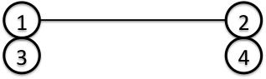

Nodes 1 and 2 for translational DOF, nodes 3 and 4 for rotational DOF.

(Triangular Shell Element)

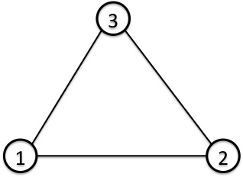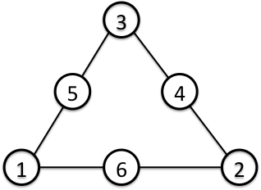

|  |  |  |
| --- | --- | --- |
| Surface No. | Linear | Quadratic |
| 1 | 1 – 2 – 3 [front] | 1 – 6 – 2 – 4 – 3 – 5 [front] |
| 2 | 3 – 2 – 1 [back] | 3 – 4 – 2 – 6 – 1 – 5 [back] |

(Triangular Shell Element with 3-dof nodes)

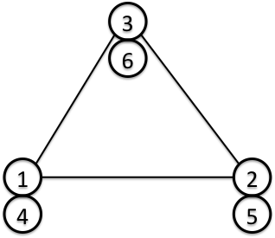

Nodes 1, 2 and 3 for translational DOF, nodes 4, 5 and 6 for rotational DOF.

|  |  |
| --- | --- |
| Surface No. | Linear |
| 1 | 1 – 2 – 3 [front] |
| 2 | 3 – 2 – 1 [back] |

(Quadrilateral Shell Element)

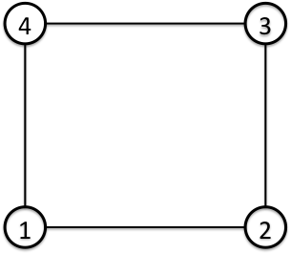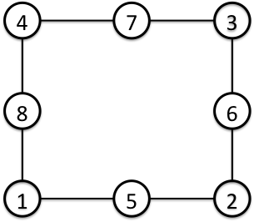

|  |  |  |
| --- | --- | --- |
| Surface No. | Linear | Quadratic |
| 1 | 1 – 2 – 3 – 4 [front] | 1 – 5 – 2 – 6 – 3 – 7 – 4 – 8 [front] |
| 2 | 4 – 3 – 2 – 1 [back] | 4 – 7 – 3 – 6 – 2 – 5 – 1 – 8 [back] |

(Quadrilateral Shell Element with 3-dof nodes)

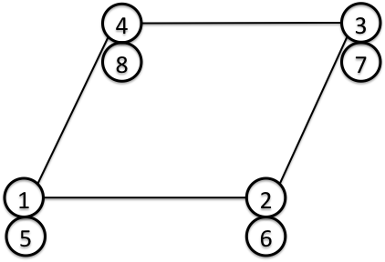

Nodes 1, 2, 3 and 4 for translational DOF, nodes 5, 6, 7 and 8 for rotational DOF.

|  |  |
| --- | --- |
| Surface No. | Linear |
| 1 | 1 – 2 – 3 – 4 [front] |
| 2 | 4 – 3 – 2 – 1 [back] |

Figure 4.1.2: Connectivity and Surface Number

## Material Data

### Elastic Static Analysis, Linear Dynamic Analysis and Eigenvalue Analysis

In the elastic static analysis and eigenvalue analysis of FrontISTR, it is necessary to use isotropic elastic material and define the Young's modulus, Poisson's ratio density and the coefficient of linear expansion for each element. The property values of these materials is defined in the header !SECTION and !MATERIAL of the mesh data. An example of the definition is shown in the following.

(Example)

!SECTION, TYPE=SOLID, EGRP=ALL, MATERIAL=M1　　----　Definition of SECTION

In the above !SECTION, the material data name of the element belonging to the “group name = ALL” in the solid type element is defined as M1.

Next, the definition method of the material data is shown in the following.

(Example)

!MATERIAL, NAME=M1, ITEM=3　　　---　Intention of defining three types of property values in the material of material name M1

!ITEM=1, SUBITEM=2 ---　Young's modulus and Poisson's ratio are defined in !ITEM=1 (mandatory)

4000., 0.3

!ITEM=2　　　　　　　　---　The mass density must be defined in !ITEM=2 (mandatory in the case of ITEM=3)

8.0102E‐10

!ITEM=3　　　　　　　 ---　The coefficient of linear expansion must be defined in !ITEM=3

1.0E‐5

As long as each item number and the type of physical property are compatible, and the ITEM number is correct, it can be defined in any order. However, ITEM=1 must be defined in the order of the Young's modulus and Poisson's ratio.

### Heat Conduction Analysis

In the heat conduction analysis of FrontISTR, isotropic material taking into consideration the temperature dependency can be used. Regarding the property values to be defined, the density, specific heat and thermal conductivity are defined for the link, plane surface, solid and shell element, and the gap heat transfer coefficient and the gap radiation factor are defined in the interface element. An example of the definition method of these property values is shown in the following.

##### In the case of link, plane surface and solid element

Defined in the !SECTION and !MATERIAL header.

(Example)

!SECTION, TYPE=SOLID, EGRP=ALL, MATERIAL=M1　---　Definition of section

In the above !SECTION, the material data name of the element belonging to the “group name = ALL” in the solid type element is defined as M1. The following shows the definition method of the material data.

(Example)

!MATERIAL, NAME=M1, ITEM=3　　　　---　Intention of defining three types of property values in the material of material name M1

!ITEM=1, SUBITEM=1　 ---　The density and temperature are defined in !ITEM=1 (mandatory)

7850., 300.

7790., 500.

7700., 800.

!ITEM=2　 ---　The specific heat and temperature are defined in !ITEM=2 (mandatory)

0.465, 300.

0.528, 500.

0.622, 800.

!ITEM=3　 ---　The thermal conductivity and temperature are defined in !ITEM=3 (mandatory)

43., 300.

38.6, 500.

27.7, 800.

Since the types of physical properties are identified by each item number in FrontISTR, it can be defined in any order as long as both are consistent.

##### In the case of an interface element

Defined in the !SECTION header. (Material data is not required)

(Example)

!SECTION, TYPE=INTERFACE, EGRP=GAP　 ---　Definition of section

1.0, 20.15, 8.99835E-9, 8.99835E-9

In the above !SECTION, the gap parameter of the element belonging to the "group name = GAP" in the interface element is defined.

1st parameter : Gap width

2nd parameter : Gap heat transfer coefficient

3rd parameter : Gap radiation factor 1

4th parameter : Gap radiation factor 2

##### In the case of a shell element

Defined in the !SECTION and MATERIAL header.

(Example)

!SECTION, TYPE=SHELL, EGRP=SH, MATERIAL=M2 ---　Definition of section

10.0, 5

In the above !SECTION, the shell characteristics of the element belonging to the "group name = SH" in the shell type element is defined.

1st parameter : Shell thickness

2nd parameter :Integration points in the thickness direction

This also means that the material data name of the material physical properties of the element which belong to this group is defined as M2.

For single layered isotropic shell, the definition method of the material physical properties is the same as in the case of the solid element. Refer to the description of the solid element.

In addition, another definition method stated below is available for multi-layered and/or orthotropic shell.

(Example) Isotropic, single-layered shell

!MATERIAL, NAME=M1, ITEM=1

!ITEM=1,SUBITEM=4

0, 200000, 0.3, 2.0

1st parameter : 0=isotropic

2nd parameter : Young’s modulus

3rd parameter : Poisson’s ratio

4th parameter : Shell thickness

(Example) Isotropic, double-layered shell

!MATERIAL, NAME=M1, ITEM=1

!ITEM=1,SUBITEM=7

0, 200000, 0.3, 2.0, 200000, 0.3, 2.0

1st parameter : 0=isotropic

2nd parameter : Young’s modulus (1st layer)

3rd parameter : Poisson’s ratio (1st layer)

4th parameter : Shell thickness (1st layer)

5th parameter : : Young’s modulus (2nd layer)

6th parameter : Poisson’s ratio (2nd layer)

7th parameter : Shell thickness (2nd layer)

By specifying as many material constants as needed for the number of layers, the material is automatically treated as multi-layered shell. The total thickness of the shell is the sum of the thickness of all the layers. The layers are ordered from the top surface of the shell with respect to the normal direction.

(Example) Orthotropic, single-layered shell

!MATERIAL, NAME=M1, ITEM=1

!ITEM=1, SUBITEM=9

1, 28600., 0.15, 32.3 , 28600., 12434., 12434., 12434., 0.0

1st parameter : 1=orthotropic

2nd parameter : Young’s modulus E1

3rd parameter : Poisson’s ratio n12

4th parameter : Shell thickness

5th parameter : : Young’s modulus E2

6th parameter : Shear modulus G12

7th parameter : Shear modulus G23

8th parameter : Shear modulus G13

9th parameter : Orthotropy angle 

Orthotropy angle is specified in [degree].

(Example) Orthotropic, double-layered shell

!MATERIAL, NAME=M1, ITEM=1

!ITEM=1, SUBITEM=17

1, 28600., 0.15, 32.3 , 28600., 12434., 12434., 12434., 0.0, 28600., 0.15, 32.3 , 28600., 12434., 12434., 12434., 0.0

1st parameter : 1=orthotropic

2nd parameter : Young’s modulus E1 (1st layer)

3rd parameter : Poisson’s ratio n12 (1st layer)

4th parameter : Shell thickness (1st layer)

5th parameter : : Young’s modulus E2 (1st layer)

6th parameter : Shear modulus G12 (1st layer)

7th parameter : Shear modulus G23 (1st layer)

8th parameter : Shear modulus G13 (1st layer)

9th parameter : Orthotropy angle  (1st layer)

10th parameter : Young’s modulus E1 (2nd layer)

11th parameter : Poisson’s ratio n12 (2nd layer)

12th parameter : Shell thickness (2nd layer)

13th parameter : Young’s modulus E2 (2nd layer)

14th parameter : Shear modulus G12 (2nd layer)

15th parameter : Shear modulus G23 (2nd layer)

16th parameter : Shear modulus G13 (2nd layer)

17th parameter : Orthotropy angle  (2nd layer)

### Nonlinear Static Analysis

In the nonlinear static analysis of FrontISTR, in addition to the method to define the !SECTION and !MATERIAL shown in item 4.2.1, !ELASTIC, !HYPERELASTIC, !PLASTIC and etc. in the analysis control data can also be defined. An example of the definition is shown in the following.

(Example) Definition of hyperelastic material

　!MATERIAL

!HYPERELASTIC, TYPE=NEOHOOKE　---　Definition of the Neo Hooke hyperelastic material

1000.0, 0.00005 ---　 C10 and D are defined (mandatory)

(Example) Definition of the elastoplastic material

!MATERIAL

!ELASTIC, TYPE=ISOTROPIC　　　　　---　Definition of the isotropic elastic material

21000.0, 0.3 　　　---　The Young's modulus and the Poisson's ratio are defined (mandatory)

!PLASTIC, TYPE=DRUCKER-PRAGER　---　Definition of the Drucker-Prager plastic material

500.0, 4.0, 10.0 　　　 ---　Viscosity, angle of friction and hardening factor are defined (mandatory)

# Overall Control Data

## Outline of Overall Control Data

The overall control data is for defining the file name of the input/output files for FrontISTR.

The features of the overall control data file are as follows.

・　This is an ASCII format file based on a free format.

・　This file consists of a header which starts with "!" and the data following this.

・　The order of description of the header is basically free.

・　A "," is used as a punctuation mark of the data.

## Input Rules

The overall control data file consists of a header line, data line and a comment line.

One header is always included in the header line.

<Header>

The meaning of the data and data block is specified in the overall control data file.

When the head of the term starts with a "!", it is considered to be a header.

<Header Line>

The header and the parameter accompanying this are described in this line.

The header line must start with a header. When a parameter is required, a "," must be used to continue after that. When the parameter takes on a value, use an "=" after the parameter and describe the value after that.

The header line can not be described in more than two lines.

<Data Line>

The data line starts from the next line of the header line, and the necessary data is described.

The data lines may be in multiple lines; however, this is determined according to the rules of the data description defined by each header.

There are cases where data lines are not required.

<Punctuation>

A comma ( , ) is used as a punctuation of the data.

<Handling of Blanks>

Blanks are disregarded.

<Name>

Regarding the characters which can be used for the name, there is the underscore "_", hyphen "-", and alphanumeric characters "a - z, A - Z, 0 - 9"; however, the first letter of the name must start with "_", or an alphabetic character "a - z, A - Z". There is no distinction between uppercase and lowercase letters, and all letters are internally handled as uppercase letters.

The maximum length of the name is 63 characters.

<File Name>

Regarding the characters which can be used for the file name, there are the underscore "_", hyphen "-", period ".", slash "/", and the alphanumeric characters "a - z, A - Z, 0 - 9".

As long as there is no specific description, a path can be included in the file name. Both the relative path and the absolute path can be specified.

The maximum length of the file name is 1,023 characters.

<Floating Point Data>

Exponents are optional. An "E" or "e" character must be added before the exponent.

The selection of "E" or "e" is optional. "D" or "d" can not be used.

<!!, # Comment Line>

Lines starting with "!!" or "#" are considered to be comment lines, and are disregarded.

A comment line can be inserted in any position in the file, and there are no restrictions on the number of lines.

## Header List

The overall control data consists of the following headers.

|  |  |
| --- | --- |
| Header Name | Contents |
| !CONTROL | Analysis control data definition |
| !MESH | Mesh data definition |
| !RESTART | Restart data definition |
| !RESULT | Analysis results data definition |
| !SUBDIR | Dividing to sub directories |

In each header, there are data items which are compatible to the parameter and each header.

Each of the above headers is described in the following with examples of data creation.

##### !CONTROL

Specifies the analysis control data file.

1st Line

!CONTROL, NAME=<name>

|  |  |
| --- | --- |
| Parameter |  |
| NAME | Identifier (mandatory) |

|  |  |  |
| --- | --- | --- |
| Parameter Name | Parameter Value | Contents |
| NAME | fstrCNT | Analysis control data |

2nd Line or later

(2nd Line) file

|  |  |
| --- | --- |
| Parameter Name | Contents |
| File | Analysis control data file name (both the relative path and the absolute path can be specified. When the relative path is specified, it becomes the path from the current directory.) |

Example of Use

!CONTROL, NAME=fstrCNT

myctrl.dat

##### !MESH

Specifies the mesh data file.

1st Line

!MESH, NAME=<name>, TYPE=<type> [,optional parameter]

|  |  |
| --- | --- |
| Parameter |  |
| NAME | Identifier (mandatory) |
| TYPE | Mesh type (mandatory) |
| IO | Input/output specification (omissible) |
| REFINE | Mesh subdivision specification (arbitrary) |

|  |  |  |
| --- | --- | --- |
| Parameter Name | Parameter Value | Contents |
| NAME | fstrMSH | Solver input data |
| part_in | Partitioner input data |
| part_out | Partitioner output data |
| TYPE | HECMW-DIST | HEC-MW distribution mesh data |
| HECMW-ENTIRE | HEC-MW single domain mesh data |
| IO | IN | For input (default) |
| OUT | For output |
| REFINE | <integer> | Number of mesh subdivisions |

2nd Line or later

(2nd Line) fileheader

|  |  |
| --- | --- |
| Parameter Name | Contents |
| fileheader | Header of the mesh data file name (both the relative path and the absolute path can be specified. When the relative path is specified, it becomes the path from the current directory.) |

Note:

The existence of IO parameters, or parameter values will have no affect on others.

When the TYPE is HECMW-DIST, the end of the file name ".<rank>" is excluded for the file header specified in the data line.

Example of Use

!MESH, NAME=fstrMSH, TYPE=HECMW-DIST, REFINE=1

Mesh.in

##### !RESTRAT

Specifies the restart data file.

1st Line

!RESTART, NAME=<name>, IO=<io>

|  |  |
| --- | --- |
| Parameter |  |
| NAME | Identifier (mandatory) |
| IO | Input/output specification (mandatory) |

|  |  |  |
| --- | --- | --- |
| Parameter Name | Parameter Value | Contents |
| NAME | <name> | Identifier |
| IO | IN | For input |
| OUT | For output |
| INOUT | Common to input/output |

2nd Line or later

(2nd Line) fileheader

|  |  |
| --- | --- |
| Parameter Name | Contents |
| fileheader | Header of the restart data file name (both the relative path and the absolute path can be specified. When the relative path is specified, it becomes the path from the current directory.) |

Note:

The file name created by this definition is the file header+.<rank>.

Example of Use

!RESTART, NAME=restart-in, IO=IN

restart.in

##### !RESULT

Specifies the analysis results data file.

1st Line

!RESULT, NAME=<name> [,optional parameter]

|  |  |
| --- | --- |
| Parameter |  |
| NAME | Identifier (mandatory) |
| IO | Input/output specification (mandatory) |
| TYPE | Output format (omissible) |

|  |  |  |
| --- | --- | --- |
| Parameter Name | Parameter Value | Contents |
| NAME | fstrRES | Solver output data  Visualizer input data |
| fstrTEMP | Temperature input data  (Result of heat analysis) |
| vis_out | Visualizer output data |
| IO | IN | For input |
| OUT | For output |
| TYPE | TEXT | Text format (default) |
| BINARY | Binary format |

2nd Line or later

(2nd Line) fileheader

|  |  |
| --- | --- |
| Parameter Name | Contents |
| fileheader | Header of the analysis results data file name (both the relative path and the absolute path can be specified. When the relative path is specified, it becomes the path from the current directory.) |

Note:

The file name created by this definition is the file header+.<rank>.

Example of Use

!RESULT, NAME=fstrRES, IO=OUT, TYPE=BINARY

result.out

##### !SUBDIR

Specifies storing input/output files into subdirectories

1st Line

!SUBDIR, ON [,optional parameter]

|  |  |
| --- | --- |
| Parameter |  |
| ON | Enable (mandatory) |
| LIMIT | Number of files (omissible) |

|  |  |  |
| --- | --- | --- |
| Parameter Name | Parameter Value | Contents |
| ON | N/A |  |
| LIMIT | <integer> | Maximum number of files per directory  (default:5000) |

2nd Line or later

N/A

Note:

The input/output data which are comprised of plural files are automatically stored into each subdirectory by this definition

Furthermore, if the number of ranks exceeds “LIMIT”, those files are divided to subdirectoris such as TRUNK0, TRUNK1.

Example of Use

!SUBDIR, ON, LIMIT=8000

# Single Domain Mesh Data

## Outline of Single Mesh Data

In order to acquire the mesh data of FrontISTR, there are two methods, such as the method to input the single domain mesh data file, and the method to input the distributed mesh data file to perform parallel processing. Single domain mesh data is described in this section.

The features of single domain mesh data are as follows.

・　This is an ASCII format file based on a free format.

・　This file consists of a header which starts with "!" and the data following this.

・　The order of description of the header is basically free.

・　A "," is used as a punctuation mark of the data.

## Input Rules

The single domain mesh data file consists of a header line, data line and a comment line.

One header is always included in the header line.

<Header>

The meaning of the data and data block is specified in the single domain mesh data file.

When the head of the term starts with a "!", it is considered to be a header.

<Header Line>

The contents of the header and the parameter accompanying this are described in this line.

The header line must start with a header. When a parameter is required, a "," must be used to continue after that. When the parameter takes on a value, use an "=" after the parameter and describe the value after that. The header line can not be described in more than two lines.

<Data Line>

The data line starts after the header line, and the necessary data is described.

The data lines may be in multiple lines; however, this is determined according to the rules of the data description defined by each header.

There are cases where data lines are not required.

<Punctuation>

A comma ( , ) is used as a punctuation of the data.

<Handling of Blanks>

Blanks are disregarded.

<Name>

Regarding the characters which can be used for the name, there is the underscore "_", hyphen "-", and alphanumeric characters "a - z, A - Z, 0 - 9"; however, the first letter of the name must start with "_", or an alphabetic character "a - z, A - Z". There is no distinction between uppercase and lowercase letters, and all letters are internally handled as uppercase letters.

The maximum length of the name is 63 characters.

<File Name>

Regarding the characters which can be used for the file name, there are the underscore "_", hyphen "-", period ".", slash "/", and the alphanumeric characters "a - z, A - Z, 0 - 9".

As long as there is no specific description, a path can be included in the file name. Both the relative path and the absolute path can be specified.

The maximum length of the file name is 1,023 characters.

<Floating Point Data>

Exponents are optional. An "E" or "e" character must be added before the exponent.

The selection of "E" or "e" is optional. "D" or "d" can not be used.

<!!, # Comment Line>

Lines starting with "!!" or "#" are considered to be comment lines, and are disregarded.

A comment line can be inserted in any position in the file, and there are no restrictions on the number of lines.

## Header List of Single Domain Mesh Data

The single domain mesh data consists of the following headers.

|  |  |  |
| --- | --- | --- |
| Header Name | Contents | Description No. |
| !AMPLITUDE | Unsteady load | M1-1 |
| !EGROUP | Element group | M1-2 |
| !ELEMENT | Element information | M1-3 |
| !EQUATION | Restricted point data | M1-4 |
| !HEADER | Title of mesh data | M1-5 |
| !INITIAL CONDITION | Initial conditions | M1-6 |
| !MATERIAL | Material information | M1-7 |
| !NGROUP | Node group | M1-8 |
| !NODE | Node information | M1-9 |
| !SECTION | Section information | M1-10 |
| !SGROUP | Surface group | M1-11 |
| !ZERO | Absolute zero-point | M1-12 |
| !CONTACT PAIR | Contact surface pair | M1-13 |
| !END | Read end | M1-14 |

In each header, there are data items which are compatible to the parameter and each header.

Each of the above headers is briefly described in the following with examples of data creation. The number indicated on the right end of the data creation is the description number of the above Table.

<Example of Mesh Data>

!HEADER M1-5

TEST MODEL CTLR10

!NODE M1-9

1, 0.00000E+00, 0.00000E+00, 0.00000E+00

2, 0.50000E+01, 0.00000E+00, 0.00000E+00

3, 0.10000E+02, 0.00000E+00, 0.00000E+00

・・・・　 ・・・・ 　　　　　・・・・

!ELEMENT,TYPE=351 M1-3

1, 1, 2, 4, 34, 35, 37

2, 2, 5, 4, 35, 38, 37

3, 2, 3, 5, 35, 36, 38

・・・・　　　　　　・・・・　　　　　・・・・

!SECTION, TYPE=SOLID, EGRP=ALL, MATERIAL=M1 M1-10

1.0

!MATERIAL, NAME=M1, ITEM=2 M1-7

!ITEM=1, SUBITEM=2

2.1E6, 0.3

!ITEM=2, SUBITEM=1

7.8e-3

!NGROUP, NGRP=FIX, GENERATE M1-8

2 , 2 , 1

3 , 3 , 1

1 , 1 , 1

69 , 69 , 1

67 , 67 , 1

!NGROUP, NGRP=CL1 M1-9

50

!END M1-14

##### !AMPLITUDE (M1-1)

Specifies the changes of time of the variables which provide the load conditions in the step.

1st Line

!AMPLITUDE, NAME=<name> [, optional parameter]

|  |  |
| --- | --- |
| Parameter |  |
| NAME | Name (mandatory) |
| DEFINITION | Type (omissible) |
| TIME | Type of time (omissible) |
| VALUE | Type of value (omissible) |
| INPUT | External file name (omissible) |

|  |  |  |
| --- | --- | --- |
| Parameter Name | Parameter Value | Contents |
| NAME | <name> | AMPLITUDE Name |
| DEFINITION | TABULAR | Default (default only in current version) |
| TIME | STEP TIME | Default (default only in current version) |
| VALUE | RELATIVE | Relative value (default) |
| ABSOLUTE | Absolute value |
| INPUT | <filename> | External file name (omissible), can also be use together with the 2nd line or later |

2nd Line or later

(2nd Line or later) VAL1, T1, VAL2, T2, VAL3, T3 ... (up to four items in one line)

Hereinafter repeated

|  |  |  |
| --- | --- | --- |
| Parameter Name | Attributions | Contents |
| VAL1 | R | Value at time T1 |
| T1 | R | Time T1 |
| VAL2 | R | Value at time T2 |
| T2 | R | Time T2 |
| VAL3 | R | Value at time T3 |
| T3 | R | Time T3 |

##### !EGROUP (M1-2）

Definition of element group

1st Line

!EGROUP, EGRP=<egrp> [, optional parameter]

|  |  |
| --- | --- |
| Parameter |  |
| EGRP | Element group name (mandatory) |
| GENERATE | Automatic generation of nodes belonging to the element group (omissible) |
| INPUT | External file name (omissible) |

|  |  |  |
| --- | --- | --- |
| Parameter Name | Parameter Value | Contents |
| EGRP | <egrp> | Element group name |
| GENERATE | N/A | Automatic generation of nodes belonging to the element group |
| INPUT | <filename> | External file name (omissible), can also be use together with the 2nd line or later |

2nd Line or later (when GENERATE is not used)

(2nd Line) elem1, elem2, elem3 ...

(Hereinafter the same)

|  |  |  |
| --- | --- | --- |
| Parameter Name | Attributions | Contents |
| elemX | I | Element number belonging to the element group |

2nd Line or later (when GENERATE is used)

(2nd Line) elem1, elem2, elem3

(Hereinafter the same)

|  |  |  |
| --- | --- | --- |
| Parameter Name | Attributions | Contents |
| elem1 | I | First element number in the element group |
| elem2 | I | Last element number in the element group |
| elem3 | I | Element number increment (omissible, number becomes elem3=1 when omitted) |

Note:

* Any number of elements can be inserted in one line. Any number of lines can be inserted until the next option starts.
* It is necessary to define the element to be specified before "!EGROUP".
* The element not defined in the "!ELEMENT" option will be excluded, and a warning message will be displayed.
* When the specified element exists in the same group, it will be ignored and a warning message will be displayed.
* All the elements belong to the element group named "ALL" (generated automatically).
* One group can be defined by dividing into multiple groups.

Example of Use

!EGROUP, EGRP=EA01

1, 2, 3, 4, 5, 6

101, 102

205

!EGROUP, EGRP=EA02

101, 102

!EGROUP, EGRP=EA01 "501, 505" are added to group "EA01".

501, 505

!EGROUP, EGRP=EA04,　GENERATE "301, 303, 305, 307, 309, 311, 312, 313" are added to

301, 309, 2 group "NA04".

311, 313

##### !ELEMENT（M1-3）

Definition of elements

1st Line

!ELEMENT, TYPE=<type> [, optional parameter]

|  |  |
| --- | --- |
| Parameter |  |
| TYPE | Element type (mandatory) |
| EGRP | Element group name (omissible) |
| MATITEM | Number of physical property items when defining the material physical properties for each element (not used when defining physical properties for each section) |
| INPUT | External file name (omissible) |

|  |  |  |
| --- | --- | --- |
| Parameter Name | Parameter Value | Contents |
| TYPE | 111 | Rod, link element (Linear) |
| 231 | Triangular element (Linear) |
| 232 | Triangular element (Quadratic) |
| 241 | Quadrilateral element (Linear) |
| 242 | Quadrilateral element (Quadratic) |
| 301 | Truss element (Linear) |
| 341 | Tetrahedral element (Linear) |
| 342 | Tetrahedral element (Quadratic) |
| 351 | Triangular prism element (Linear) |
| 352 | Triangular prism element (Quadratic) |
| 361 | Hexahedral element (Linear) |
| 362 | Hexahedral element (Quadratic) |
| 541 | Interface element (Quadrilateral cross section, Linear) |
| 611 | Beam element(Linear) |
| 641 | Beam element(Linear, with 3-dof nodes) |
| 731 | Triangular shell element (Linear) |
| 741 | Quadrilateral shell element (Linear) |
| 743 | Quadrilateral shell element (Quadratic) |
| 761 | Triangular shell element (Linear, with 3-dof nodes) |
| 781 | Quadrilateral shell element (Linear, with 3-dof nodes) |
| EGRP | <egrp> | Element group name (omissible) |
| INPUT | <filename> | External file name (omissible), can also be used together with the 2nd line or later |

2nd Line or later

(2nd Line) ELEM_ID, nod1, nod2, nod3, ..., MAT1, MAT2, ...

(Hereinafter the same)

|  |  |  |
| --- | --- | --- |
| Parameter Name | Attributions | Contents |
| ELEM_ID | I | Element number |
| nodX | I | Connectivity |
| MATy | R | Physical Property value for each element |

Note:

* For details of the element types and connectivity, refer to "Chapter 4 Element Library".
* The node specified by the connectivity must be defined before "!ELEMENT".
* The element numbers do not have to be continued.
* The "!ELEMENT" option can be defined any number of times.
* The element number must be a natural number. This can not be omitted.
* When the same element number is used repeatedly, the value input last will be used. In this case, a warning message will be output.
* Undefined nodes can not be used for connectivity.
* The definition of one element can be described in multiple lines.

Example of Use

!ELEMENT, TYPE=231

1, 1, 2, 3

2, 4, 8, 5

4, 6, 7, 8

!ELEMENT, TYPE=361, EGRP=A

101, 101, 102, 122, 121, 201, 202, 222, 221

102, 102, 103, 123, 122, 202, 203, 223, 222

103, 103, 104, 124, 123, 203, 204, 224, 223

##### !EQUATION（1-4）

Definition of restricted node group

1st Line

!EQUATION [, optional parameter]

|  |  |
| --- | --- |
| Parameter |  |
| INPUT | External file name (omissible) |

|  |  |  |
| --- | --- | --- |
| Parameter Name | Parameter Value | Contents |
| INPUT | <filename> | External file name (omissible), can also be used together with the 2nd line or later |

2nd Line or later

(2nd Line) NEQ, CONST

(3rd Line or later) nod1, DOF1, A1, nod2, DOF2, A2 ... (up to seven terms for one line)

Hereinafter repeated

|  |  |  |
| --- | --- | --- |
| Parameter Name | Attributions | Contents |
| NEQ | I | Number of equation terms |
| CONST | R | Constant term of equation (right value) |
| nod1 | I/C | 1st node or node group |
| DOF1 | I | Restricted degree of freedom of 1st node or node group |
| A1 | R | Factor of 1st node or node group |
| nod2 | I/C | 2nd node or node group |
| DOF2 | I | Restricted degree of freedom of 2nd node or node group |
| A2 | R | Factor of 2nd node or node group |

Note:

* When a node or a node group not defined by "!NODE" is specified, it will be ignored and a warning message will be displayed.
* In the case of "nod1=nod2", it will be ignored and a warning message will be displayed.
* When a node group is specified, if the number of nodes is not consistent an error will occur.
* The degree of freedom number differs by the type of analysis and elements. An inconsistent degree of freedom will be ignored, and a warning message will be displayed.

Example of Use

!EQUATION

3

101, 1, 1.0, 102, 1, -1.0, 103, 1, -1.0

2

NG1, 2, 1.0, NG5, 2, -1.0

##### !HEADER（M1-5）

Title of mesh data

1st Line

!HEADER

Parameter

N/A

2nd Line or later

(2nd Line) TITLE

|  |  |  |
| --- | --- | --- |
| Parameter Name | Attributions | Contents |
| TITLE | C | Header title |

Example of Use

!HEADER

Mesh for CFD Analysis

Note:

* Omissible
* Although the header can use multiple lines, it can be recognized as a header up to the 127th column of the first line.
* When "!HEADER" is defined multiple times, the contents will be updated and a warning message will be displayed.

##### !INITIAL CONDITION （M1-6）

Definition of temperature initial condition

1st Line

!INITIAL CONDITION, TYPE=<type> [, optional parameter]

|  |  |
| --- | --- |
| Parameter |  |
| TYPE | Type (mandatory) |
| INPUT | External file name (omissible) |

|  |  |  |
| --- | --- | --- |
| Parameter Name | Parameter Value | Contents |
| TYPE | TEMPERATURE | Temperature |
| INPUT | <filename> | External file name (omissible), can also be used together with the 2nd line or later |

2nd Line or later

(2nd Line or later) nod1, VAL1 (One group for one line)

Hereinafter repeated

|  |  |  |
| --- | --- | --- |
| Parameter Name | Attributions | Contents |
| nod1 | I/C | Node number or node group |
| VAL1 | R | Node value |

Example of Use

!INITIAL CONDITION，TYPE=TEMPERATURE

101, 25.0

NA01, 38.0

Note:

* When a node or a node group not defined by "!NODE" is specified, it will be ignored and a warning message will be displayed.
* When the same node is redefined, an error will occur.

##### !MATERIAL (M1-7)

Definition of material physical properties

When the physical properties depend on the temperature, table input can be performed for each compatible temperature.

The table input can also be performed for the relationship of the stress strain in a stress analysis.

1st Line

!MATERIAL, NAME=<name> [, optional parameter]

|  |  |
| --- | --- |
| Parameter |  |
| NAME | Material name (mandatory) |
| ITEM | Number of physical property items (omissible, becomes "1" when omitted) |
| INPUT | External file name (omissible) |

|  |  |  |
| --- | --- | --- |
| Parameter Name | Parameter Value | Contents |
| NAME | <name> | Material name |
| ITEM | <ITEMnum> | Number of physical property items by user definition |
| INPUT | <filename> | External file name (omissible), can also be used together with the 2nd line or later |

2nd Line or later

(2nd Line) !ITEM=1, SUBITEM=<k>

(3rd Line) VAL1-1-1, VAL1-1-2, … VAL1-1-k, TEMP1-1

(4th Line) VAL1-2-1，VAL1-2-2, … VAL1-2-k, TEMP1-2

・・

(L+2nd Line) VAL1-L-1，VAL1-L-2, … VAL1-L-k, TEMP1-L

Hereinafter, the definition is repeated until "!ITEM=<ITEMnum>".

|  |  |
| --- | --- |
| Subparameter (for "!ITEM") |  |
| SUBITEM | Number of sub physical property items defined in each of the physical property items (omissible, becomes "1" when omitted, used to define anisotropy and etc.) |

|  |  |  |
| --- | --- | --- |
| Subparameter Name | Parameter Value | Contents |
| SUBITEM | <subITEMnum> | Number of sub physical property items by user definition |

[When the m-th physical property depends on the temperature]

When the number of items of the temperature dependent table is N, input as follows:

!ITEM=m, SUBITEM=k

VALm1-1, ..., VALm1-k, TEMPm1

VALm2-1, ..., VALm2-k, TEMPm2

...

VALmN-1, ..., VALmN-k, TEMPm-N

|  |  |  |
| --- | --- | --- |
| Parameter Name | Attributions | Contents |
| VALmn-k | R | Physical property value (Temperature dependent) |
| TEMPmn | R | Compatible temperature |

Must be input as TEMPm1 < TEMPm2 < ... < TEMPmN.

VALm1 is used when the temperature is TEMPm1 or below, and VALmN is used when the temperature is TEMPmN or more.

[When the m-th physical property does not depend on the temperature]

!ITEM=m, SUBITEM=k

VALm1-1, ..., VALm1-k

VALm2-1, ..., VALm2-k

...

VALmN-1, ..., VALmN-k

|  |  |  |
| --- | --- | --- |
| Parameter Name | Attributions | Contents |
| VALmn-k | R | Physical property value (not temperature dependent) |

Note:

* When the material name is duplicated, an error will occur.
* When the MATERIAL referred to in the "!SECTION" option is not defined, an error will occur.
* The value used to input the physical property for each element using the parameter "MATITEM" in the "!ELEMENT" option, is used preferentially. In this case, the physical property value input using the "!MATERIAL" option will not be used.
* When the number of "!ITEM=m" suboptions and the number of parameters "ITEM" is not consistent, or when there is an undefined suboption, and error will occur.
* The "!ITEM=m" suboption does not have to be in order from the smaller m.
* When using the "!SUBITEM=k" suboption and the temperature dependency, the omitted value will become "0.0".
* When using the temperature dependency, it must be defined in order from the lower temperature.
* When using the temperature dependency, if the same temperature is used twice or more, an error will occur.

Example of Use

!MATERIAL, NAME= STEEL, ITEM= 2

!ITEM=1 No temperature dependency

35.0

!ITEM=2

40.0, 0.0

45.0, 100.0

50.0, 200.0

!MATERIAL, NAME= CUPPER Number of items = 1 (Default value)

!ITEM=1 No temperature dependency

80.0

Incorrect Example of Use

Example 1: [Number of parameter "ITEM" and "!ITEM=m" suboptions are not consistent -1]

!MATERIAL, NAME= STEEL, ITEM= 2

!ITEM=3

20.0

!ITEM=1

35.0

!ITEM= 2

40.0

Example 2: [Number of parameter "ITEM" and "!ITEM=m" suboptions are not consistent -2]

!MATERIAL, NAME= STEEL, ITEM= 3

!ITEM=3

20.0

!ITEM= 2

40.0

!MATERIAL, NAME= CUPPER

...

Elastic Static Analysis and Eigenvalue Analysis

!MATERIAL, NAME=<name>, ITEM=<ITEMnum>

!ITEM=1, SUBITEM=2

<Yang_modulus>, <Poisson_ratio>

!ITEM=2

<Density>

!ITEM=3

<Expansion_coeff>

|  |  |  |
| --- | --- | --- |
| Parameter Name | Parameter Value | Contents |
| NAME | <name> | Compatible to material name, and MATERIAL of !SECTION |
| ITEM | <ITEMnum> | Number of physical property items by user definition (1 or more)  <Yang_modulus> ... Young's modulus (mandatory)  <Poisson_ratio> ... Poisson's ratio (mandatory)  <Density> ... Mass density (mandatory when ITEMnum=3)  <Expansion_coeff> ... Coefficient of linear expansion (when ITEMnum=3) |

(Example)

!MATERIAL, NAME=M1, ITEM=3　　　---　 Intention of defining three types of property values in the material of material name M1

!ITEM=1, SUBITEM=2 ---　 The Young's modulus and Poisson's ratio is defined in !ITEM=1 (mandatory)

4000., 0.3

!ITEM=2　　　　　　　　---　 The mass density must be defined in !ITEM=2 (mandatory in the case of ITEM=3)

8.0102E‐10

!ITEM=3 ---　 The coefficient of linear expansion must be defined in !ITEM=3

1.0E‐5

Heat Conduction Analysis

In the case of link, plane surface, solid and three-dimensional plate elements

!MATERIAL, NAME=<name>, ITEM=3

!ITEM=1, SUBITEM=2

<Density>, <Temperature>

!ITEM=2, SUBITEM=2

<Specific_heat>, <Temperature>

!ITEM=3, SUBITEM=2

<Conductivity>, <Temperature>

|  |  |  |
| --- | --- | --- |
| Parameter Name | Parameter Value | Contents |
| NAME | <name> | Compatible to material name, and MATERIAL of !SECTION |
| ITEM | <ITEMnum> | Number of physical property items by user definition (**always 3**)  <Density> ... Density  <Specific_heat> ... Specific heat  <Conductivity> ... Thermal conductivity  <Temperature> ... Temperature |

(Example)

!MATERIAL, NAME=M1, ITEM=3　　　---　 Intention of defining three types of property values in the material of material name M1

!ITEM=1, SUBITEM=１　 　 ---　 The density and temperature are defined in !ITEM=1 (mandatory)

7850., 300.

7790., 500.

7700., 800.

!ITEM=2, SUBITEM=1 ---　 The specific heat and temperature are defined in !ITEM=2 (mandatory)

0.465, 300.

0.528, 500.

0.622, 800.

!ITEM=3 ---　 The thermal conductivity and temperature are defined in !ITEM=3 (mandatory)

43., 300.

38.6, 500.

27.7, 800.

In the case of interface element

Defined in the !SECTION header. (Material data is not required)

(Example)

!SECTION, TYPE=INTERFACE, EGRP=GAP　 ---　 Definition of section

1.0, 20.15, 8.99835E-9, 8.99835E-9

In the above !SECTION, the gap parameter of the element belonging to the "group name = GAP" in the interface element is defined.

1st parameter : Gap width

2nd parameter : Gap heat transfer coefficient

3rd parameter : Gap radiation factor 1

4th parameter : Gap radiation factor 2

Reference

program TEST

use hecmw

implicit REAL*8 (A-H,O-Z)

type (hecmwT_local_mesh) :: hecMESH

!C

!C !MATERIAL, NAME=SUS304, ITEM=3

!C !ITEM=1, SUBITEM= 3

!C 100.0, 200.0, 300.0, 0.00

!C 101.0, 210.0, 301.0, 1.00

!C 102.0, 220.0, 302.0, 2.00

!C 103.0, 230.0, 303.0, 3.00

!C !ITEM=3, SUBITEM= 2

!C 1000.0, , 0.00

!C 1001.0, 1., 1.00

!C 1002.0, 2., 2.00

!C 1003.0, 3., 3.00

!C !ITEM=2

!C 5000.0

!C

!C !MATERIAL, NAME=FEC, ITEM=2

!C !ITEM=1, SUBITEM= 3

!C 2100.0, 2200.0, 2300.0, 0.00

!C 2101.0, 2210.0, 2301.0, 1.00

!C 2102.0, 2220.0, 2302.0, 2.00

!C 2103.0, 2230.0, 2303.0, 3.00

!C 3103.0, 3230.0, 2304.0, 4.00

!C !ITEM=2

!C 6000.0, 10.0

!C 6500.0, 30.0

!C

hecMESH%material%n_mat = 2

nn= hecMESH%material%n_mat

allocate (hecMESH%material%mat_name(nn))

hecMESH%material%mat_name(1)= 'SUS304'

hecMESH%material%mat_name(2)= 'FEC'

nn= hecMESH%material%n_mat

allocate (hecMESH%material%mat_ITEM_index(0:nn))

hecMESH%material%mat_ITEM_index(0)= 0

hecMESH%material%mat_ITEM_index(1)= 3

hecMESH%material%mat_ITEM_index(2)= hecMESH%material%mat_ITEM_index(1) + 2

hecMESH%material%n_mat_ITEM= hecMESH%material%mat_ITEM_index(hecMESH%material%n_mat)

nn= hecMESH%material%n_mat_ITEM

allocate (hecMESH%material%mat_subITEM_index(0:nn))

hecMESH%material%mat_subITEM_index(0)= 0

hecMESH%material%mat_subITEM_index(1)= 3

hecMESH%material%mat_subITEM_index(2)= hecMESH%material%mat_subITEM_index(1) + 1

hecMESH%material%mat_subITEM_index(3)= hecMESH%material%mat_subITEM_index(2) + 2

hecMESH%material%mat_subITEM_index(4)= hecMESH%material%mat_subITEM_index(3) + 3

hecMESH%material%mat_subITEM_index(5)= hecMESH%material%mat_subITEM_index(4) + 1

hecMESH%material%n_mat_subITEM=

& hecMESH%material%mat_subITEM_index(hecMESH%material%n_mat_ITEM)

nn= hecMESH%material%n_mat_subITEM

allocate (hecMESH%material%mat_TABLE_index(0:nn))

hecMESH%material%mat_TABLE_index( 0)= 0

hecMESH%material%mat_TABLE_index( 1)= 4

hecMESH%material%mat_TABLE_index( 2)= hecMESH%material%mat_TABLE_index( 1) + 4

hecMESH%material%mat_TABLE_index( 3)= hecMESH%material%mat_TABLE_index( 2) + 4

hecMESH%material%mat_TABLE_index( 4)= hecMESH%material%mat_TABLE_index( 3) + 1

hecMESH%material%mat_TABLE_index( 5)= hecMESH%material%mat_TABLE_index( 4) + 4

hecMESH%material%mat_TABLE_index( 6)= hecMESH%material%mat_TABLE_index( 5) + 4

hecMESH%material%mat_TABLE_index( 7)= hecMESH%material%mat_TABLE_index( 6) + 5

hecMESH%material%mat_TABLE_index( 8)= hecMESH%material%mat_TABLE_index( 7) + 5

hecMESH%material%mat_TABLE_index( 9)= hecMESH%material%mat_TABLE_index( 8) + 5

hecMESH%material%mat_TABLE_index(10)= hecMESH%material%mat_TABLE_index( 9) + 2

hecMESH%material%n_mat_TABLE=

& hecMESH%material%mat_TABLE_index(hecMESH%material%n_mat_subITEM)

nn= hecMESH%material%n_mat_TABLE

allocate (hecMESH%material%mat_VAL (nn))

allocate (hecMESH%material%mat_TEMP(nn))

hecMESH%material%mat_VAL = 0.d0

hecMESH%material%mat_TEMP= 0.d0

hecMESH%material%mat_VAL ( 1)= 100.0d0

hecMESH%material%mat_TEMP( 1)= 0.0d0

hecMESH%material%mat_VAL ( 2)= 101.0d0

hecMESH%material%mat_TEMP( 2)= 1.0d0

hecMESH%material%mat_VAL ( 3)= 102.0d0

hecMESH%material%mat_TEMP( 3)= 2.0d0

hecMESH%material%mat_VAL ( 4)= 103.0d0

hecMESH%material%mat_TEMP( 4)= 3.0d0

hecMESH%material%mat_VAL ( 5)= 200.0d0

hecMESH%material%mat_TEMP( 5)= 0.0d0

hecMESH%material%mat_VAL (13)= 5000.0d0

hecMESH%material%mat_VAL (14)= 1000.0d0

hecMESH%material%mat_TEMP (14)= 0.0d0

hecMESH%material%mat_VAL (15)= 1001.0d0

hecMESH%material%mat_TEMP (15)= 1.0d0

hecMESH%material%mat_VAL (16)= 1002.0d0

hecMESH%material%mat_TEMP (16)= 2.0d0

hecMESH%material%mat_VAL (17)= 1003.0d0

hecMESH%material%mat_TEMP (17)= 3.0d0

hecMESH%material%mat_VAL (18)= 0.0d0

hecMESH%material%mat_TEMP (18)= 0.0d0

hecMESH%material%mat_VAL (19)= 1.0d0

hecMESH%material%mat_TEMP (19)= 1.0d0

hecMESH%material%mat_VAL (20)= 2.0d0

hecMESH%material%mat_TEMP (20)= 2.0d0

hecMESH%material%mat_VAL (21)= 3.0d0

hecMESH%material%mat_TEMP (21)= 3.0d0

hecMESH%material%mat_VAL (22)= 2100.0d0

hecMESH%material%mat_TEMP (22)= 0.0d0

hecMESH%material%mat_VAL (23)= 2101.0d0

hecMESH%material%mat_TEMP (23)= 1.0d0

hecMESH%material%mat_VAL (24)= 2102.0d0

hecMESH%material%mat_TEMP (24)= 2.0d0

hecMESH%material%mat_VAL (25)= 2103.0d0

hecMESH%material%mat_TEMP (25)= 3.0d0

hecMESH%material%mat_VAL (26)= 3103.0d0

hecMESH%material%mat_TEMP (26)= 4.0d0

write (*,'(a,i10)') '%n_mat_ITEM ', hecMESH%material%n_mat_ITEM

write (*,'(a,i10)') '%n_mat_subITEM', hecMESH%material%n_mat_subITEM

write (*,'(a,i10)') '%n_mat_TABLE ', hecMESH%material%n_mat_TABLE

end program TEST

##### !NGROUP (M1-8)

Definition of node group

1st Line

!NGROUP, NGRP=<ngrp> [, optional parameter]

|  |  |
| --- | --- |
| Parameter |  |
| NGRP | Node group name (mandatory) |
| GENERATE | Automatic generation of nodes belonging to the node group (omissible) |
| INPUT | External file name (omissible) |

|  |  |  |
| --- | --- | --- |
| Parameter Name | Parameter Value | Contents |
| NGRP | <ngrp> | Node group name |
| GENERATE | N/A | Automatic generation of nodes belonging to the node group |
| INPUT | <filename> | External file name (omissible), can also be used together with the 2nd line or later |

2nd Line or later (when GENERATE is not used)

(2nd Line) nod1, nod2, nod3

(Hereinafter the same)

|  |  |  |
| --- | --- | --- |
| Parameter Name | Attributions | Contents |
| nodX | I | Node number belonging to the node group |

2nd Line or later (when GENERATE is used)

(2nd Line) nod1, nod2, nod3

(Hereinafter the same)

|  |  |  |
| --- | --- | --- |
| Parameter Name | Attributions | Contents |
| nod1 | I | First node number in the node group |
| nod2 | I | Last node number in the node group |
| nod3 | I | Node number increment (omissible, number becomes nod3=1 when omitted) |

Note:

* Any number of nodes can be inserted in one line. Any number of lines can be inserted until the next option starts.
* It is necessary to define the nodes to be specified before "!NGROUP".
* The node not defined in the "!NODE" option will be excluded, and a warning message will be displayed.
* When the specified node exists in the same group, it will be ignored and a warning message will be displayed.
* All the nodes belong to the node group named "ALL" (generated automatically).
* One group can be defined by dividing into multiple groups.

Example of Use

!NGROUP, NGRP= NA01

1, 2, 3, 4, 5, 6

101, 102

!NGROUP, NGRP= NA02

101, 102

!NGROUP, NGRP= NA01 "501 and 505" are added to group "NA01".

501, 505

!NGROUP, NGRP= NA02 "501 and 505" are added to group "NA02".

501, 505

!NGROUP, NGRP= NA04,GENERATE "301, 303, 305, 307, 309, 311, 312, 313" are added to

301, 309, 2 group "NA04".

311, 313

##### !NODE (M1-9)

Definition of node coordinates

1st Line

!NODE [, optional parameter]

|  |  |
| --- | --- |
| Parameter |  |
| SYSTEM | Coordinate system (omissible) |
| NGRP | Node group name (omissible) |
| INPUT | External file name (omissible) |

|  |  |  |
| --- | --- | --- |
| Parameter Name | Parameter Value | Contents |
| SYSTEM | R | Cartesian coordinate system (Default value) |
| C | Cylindrical coordinate system |
| NGRP | <ngrp> | Node group name (omissible) |
| INPUT | <filename> | External file name (omissible), can also be used together with the 2nd line or later |

2nd Line or later

(2nd Line) NODE_ID, Xcoord, Ycoord, Zcoord

(Hereinafter the same)

|  |  |  |
| --- | --- | --- |
| Parameter Name | Attributions | Contents |
| NODE_ID | I | Node number |
| Xcoord | R | X coordinate |
| Ycoord | R | Y coordinate |
| Zcoord | R | Z coordinate |

Note:

* When node coordinates including the punctuation mark is omitted, the value will become "0.0".
* When an already defined node is redefined, the contents will be updated and a warning message will be displayed.
* The node which is not referred to in "!ELEMENT" will be excluded.
* The node defined in "!ELEMENT" must be defined before "!ELEMENT".

Example of Use

!NODE, NGRP=TEST

1, 0.0, 0.0, 0.5

2, 0.0, 0.0, 1.0

3, 0.0,,1.5 Y coordinate is "0.0"

4, X, Y and Z coordinates are "0.0"

##### !SECTION (M1-10)

Definition of section

1st Line

!SECTION, TYPE=<type>, EGRP=<egrp> [, optional parameter]

|  |  |
| --- | --- |
| Parameter |  |
| TYPE | Section type (mandatory) |
| EGRP | Element group name (mandatory) |
| MATERIAL | User defined material name (mandatory) |
| SECOPT | Auxiliary parameter for the element type (omissible, becomes =0 when omitted) |
| INPUT | External file name (omissible) |

|  |  |  |
| --- | --- | --- |
| Parameter Name | Parameter Value | Contents |
| TYPE | SOLID | Rod, triangular, quadrilateral, tetrahedral, pentahedral, hexadedral elements |
| SHELL | Shell element |
| BEAM | Beam element |
| INTERFACE | Interface element |
| EGRP | <egrp> | Element group name |
| MATERIAL | <material > | Material name defined by user |
| SECOPT | <secopt> | = 0: Not specified, plane stress |
| = 1: Plane strain |
| = 2: Axial symmetry |
| = 10: 0 + reduced integration |
| = 11: 1 + reduced integration |
| = 12: 2 + reduced integration |
| INPUT | <filename> | External file name (omissible), can also be used together with the 2nd line or later |

2nd Line or later

In the case of [TYPE=SOLID]

(2nd Line) THICKNESS

|  |  |  |
| --- | --- | --- |
| Parameter Name | Attributions | Contents |
| THICKNESS | R | Element thickness, cross-sectional area |

In the case of "TYPE=SOLID", the "THICKNESS" can be omitted, and default value (1.0) is inserted.

In the case of [TYPE=SHELL]

(2nd Line) THICKNESS, INTEGPOINTS

|  |  |  |
| --- | --- | --- |
| Parameter Name | Attributions | Contents |
| THICKNESS | R | Shell cross section thickness |
| INTEGPOINTS | I | Integral point in shell cross sectional direction |

In the case of [TYPE=BEAM]

(2nd Line) vx,vy,vz,area,Iyy,Iz,Jx

|  |  |  |
| --- | --- | --- |
| Parameter Name | Attributions | Contents |
| vx,vy,vz | R | Direction cosine of reference axis |
| area | R | Area of cross section |
| Iyy, Izz | R | Second moment of cross section |
| Jx | R | Torsion constant of cross section |

In the case of [TYPE=INTERFACE]

(2nd Line) THICKNESS, GAPCON, GAPRAD1, GAPRAD2

|  |  |  |
| --- | --- | --- |
| Parameter Name | Attributions | Contents |
| THICKNESS | R | Cross-sectional thickness |
| GAPCON | R | Gap heat transfer coefficient (0 when omitted) |
| GAPRAD1 | R | Gap radiant heat transfer factor-1 (0 when omitted) |
| GAPRAD2 | R | Gap radiant heat transfer factor-2 (0 when omitted) |

Note:

* When the parameter "TYPE" is not consistent with the element type, an error will occur.
* When there is an element without SECTION information, an error will occur.
* When the section name is duplicated, an error will occur.

Example of Use

!SECTION, EGRP=SOLID1, TYPE=SOLID, MATERIAL=STEEL

!SECTION, EGRP=SHELL2, TYPE=SHELL, MATERIAL=STEEL

1.0, 5

##### !SGROUP (M1-11)

Definition of surface group

1st Line

!SGROUP, SGRP=<sgrp> [, optional parameter]

|  |  |
| --- | --- |
| Parameter |  |
| SGRP | Surface group name (mandatory) |
| INPUT | External file name (omissible) |

|  |  |  |
| --- | --- | --- |
| Parameter Name | Parameter Value | Contents |
| SGRP | <sgrp> | Surface group name |
| INPUT | <filename> | External file name (omissible), can also be used together with the 2nd line or later |

2nd Line or later

(2nd Line) elem1, lsuf1, elem2, lsuf2, elem3, lsuf3, ...

(Hereinafter the same)

|  |  |  |
| --- | --- | --- |
| Parameter Name | Attributions | Contents |
| elemX | I | Element number belonging to the surface group |
| lsufX | I | Local surface number of the element belonging to the surface group |

Note:

* For the element type and surface number, refer to "Chapter 4 Element Library".
* The surface consists of a combination of (elements and local surface numbers). Any number of surfaces can be inserted in one line. Any number of lines can be inserted until the next option starts. The combination of (elements and local surface numbers) must be in the same line.
* It is necessary to define the element to be specified before "!SGROUP".
* The element not defined in "!ELEMENT" option will be excluded, and a warning message will be displayed.
* The surface which includes the element not defined in "!ELEMENT" option will be excluded, and a warning message will be displayed.
* The surface where the element type and the surface number are not consistent will be excluded, and a warning message will be displayed.
* One group can be defined by dividing into multiple groups.

Example of Use

!SGROUP, SGRP= SUF01

101, 1, 102, 1, 103, 2, 104, 2

201, 1, 202, 1

501, 1

!SGROUP, SGRP= SUF02

101, 2, 102, 2

!SGROUP, SGRP= EA01 "(601,1) and (602 2)" are added to group "SUF01".

601, 1

602, 2

Incorrect Example of Use

Example 1: [When (elements, and local surface numbers) group exists in multiple lines]

!SGROUP, SGRP= SUF01

101, 1, 102, 1, 103

1, 104, 1

Example 2: [Local surface numbers and element type are not consistent]

!ELEMENT, TYPE= 211, SECTION= A

101, 1, 2, 3

102, 2, 3, 4

...

!SGROUP, SGRP= SUF01

101, 1

101, 2

101, 4 Since a 4th surface does not exist in a triangular element, this combination

will be disregarded.

##### !ZERO (M1-12)

Absolute zero-point

1st Line

!ZERO

Parameter

N/A

2nd Line or later

(2nd Line) ZERO

|  |  |  |
| --- | --- | --- |
| Parameter Name | Attributions | Contents |
| ZERO | R | Absolute zero-point |

Note:

* Omissible. Becomes "absolute zero-point = 0" when omitted.
* When "!ZERO" is defined multiple times, the contents will be updated and a warning message will be displayed.

Example of Use

!ZERO

-273.16

##### !CONTACT PAIR　(M1-13)

Definition of contact surface pair used for contact analysis

1st Line

!CONTACT PAIR, NAME=<name> [,optional parameter]

|  |  |
| --- | --- |
| Parameter |  |
| NAME | Contact pair name (mandatory) |
| TYPE | Type (omissible) |

|  |  |  |
| --- | --- | --- |
| Parameter Name | Parameter Value | Contents |
| NAME | <name> | Contact pair name |
| TYPE | NODE-SURF | Slave surface is the node group  Master surface is the surface group (default) |
| SURF-SURF | Both the slave surface and master surface are the surface group |

2nd Line or later

(2nd Line or later) SLAVE_GRP, MASTER_GRP

(Hereinafter the same)

|  |  |  |
| --- | --- | --- |
| Parameter Name | Attributions | Contents |
| SLAVE_GRP | C | Slave surface node / surface group name |
| MASTER_GRP | C | Surface group name of the master surface |

##### !END （M1-14）

End of mesh data

When this header is displayed, the reading of the mesh data is completed.

1st Line

!END

Parameter

N/A

2nd Line or later

N/A

# Analysis Control Data

## Outline of Analysis Control Data

In FrontISTR, an analysis control data file is input to acquire the computing control data, solver control data and post process (visualization) control data as shown in the following figure, in order to implement the analytical calculations.

POST CONTROL

(Setting of Post Process)

* After all the data is input, completed with !END

* The order of entry is arbitrary

Computing Control Data

(Setting of Analysis Conditions)

SOLVER CONTROL

(Setting of Solver Type)

Analysis Control Data

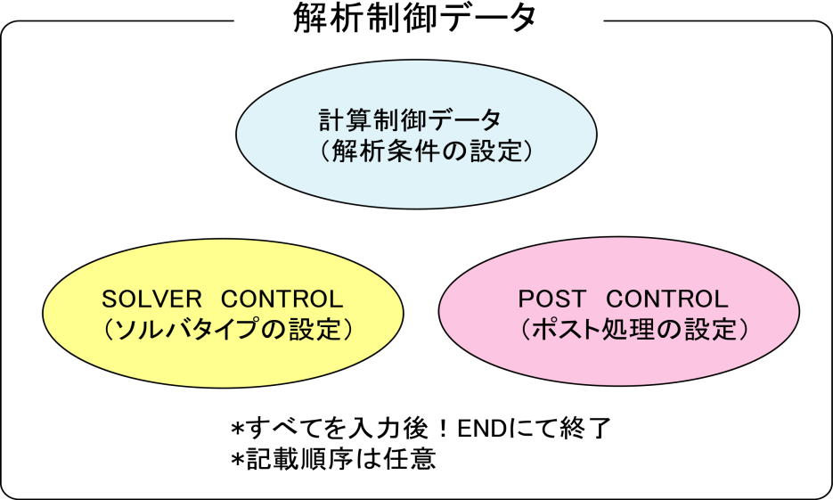

The features of the analysis control data file are as follows.

・This is an ASCII format file based on a free format.

・This file consists of a header which starts with "!" and the data following this.

・The order of description of the header is basically free.

・A "," is used as a punctuation mark of the data.

・The inside of the file is briefly divided into three zones.

・"!END" is input at the end of the file for completion.

<Example of Analysis Control Data>

### Control File for HEAT solver

!SOLUTION,TYPE=HEAT

!FIXTEMP

XMIN, 0.0

XMAX, 500.0　　　　　　　　　　　　　　　　　　　**(1) Computing control data portion**

-------------------------------------------------------------------------------------

### Solver Control

!SOLVER,METHOD=1,PRECOND=2,ITERLOG=NO,TIMELOG=NO

100, 2

1.0e-8,1.0,0.0　　　　　　　　　　　　　　　　　　　**(2) Solver control data portion**

-------------------------------------------------------------------------------------

### Post Control

!WRITE,RESULT

!WRITE,VISUAL

!VISUAL, method=PSR

!surface_num = 1

!surface 1

!surface_style = 1

!display_method 1

!color_comp_name = TEMPERATURE

!color_subcomp = 1

!output_type = BMP

!x_resolution = 500

!y_resolution = 500

!num_of_lights = 1

!position_of_lights = -20.0, 5.8, 80.0

!viewpoint = -20.0 10.0 8.0

!up_direction = 0.0 0.0 1.0

!ambient_coef= 0.3

!diffuse_coef= 0.7

!specular_coef= 0.5

!color_mapping_style= 1

!!interval_mapping= -0.01, 0.02

!color_mapping_bar_on = 1

!scale_marking_on = 1

!num_of_scale = 5

!font_size = 1.5

!font_color = 1.0 1.0 1.0

!END **(3) Post control (visualization) data portion**

-------------------------------------------------------------------------------------

## Input Rules

The analysis control data consists of a header line, data line and a comment line.

One header is always included in the header line.

<Header>

The header specifies the meaning of the data and the data block in the analysis control data.

When the head of the term starts with a "!", it is considered to be a header.

<Header Line>

The header and the parameter accompanying this are described in this line.

The header line must start with a header. When a parameter is required, a "," must be used to continue after that. When the parameter takes on a value, use an "=" after the parameter and describe the value after that.

The header line can not be described in more than two lines.

<Data Line>

The data line starts after the header line, and the necessary data is described.

The data lines may be in multiple lines; however, this is determined according to the rules of the data description defined by each header.

There are cases where data lines are not required.

<Punctuation>

A comma ( , ) is used as a punctuation of the data.

<Handling of Blanks>

Blanks are disregarded.

<Name>

Regarding the characters which can be used for the name, there is the underscore "_", hyphen "-", and alphanumeric characters "a - z, A - Z, 0 - 9"; however, the first letter of the name must start with "_", or an alphabetic character "a - z, A - Z". There is no distinction between uppercase and lowercase letters, and all letters are internally handled as uppercase letters.

The maximum length of the name is 63 characters.

<File Name>

Regarding the characters which can be used for the file name, there are the underscore "_", hyphen "-", period ".", slash "/", and the alphanumeric characters "a - z, A - Z, 0 - 9".

As long as there is no specific description, a path can be included in the file name. Both the relative path and the absolute path can be specified.

The maximum length of the file name is 1,023 characters.

<Floating Point Data>

Exponents are optional. An "E" or "e" character must be added before the exponent.

The selection of "E" or "e" is optional.

<!!, # Comment Line>

Lines starting with "!!" or "#" are considered to be comment lines, and are disregarded.

A comment line can be inserted in any position in the file, and there are no restrictions on the number of lines.

<!END>

End of mesh data

When this header is displayed, the reading of the mesh data is completed.

## Analysis Control Data

### Header List of Computing Control Data

In FrontISTR, the following items can be mentioned as the boundary conditions which can be used for the computing control data.

・Distributed load conditions (body force, pressure loading, gravity, centrifugal force)

・Concentrated load conditions

・Heat load

・Single point restriction conditions (SPC conditions)

・Spring boundary conditions

・Contact

・Concentrated heat flux

・Distributed heat flux

・Convective heat transfer boundary

・Radiant heat transfer boundary

・Specified temperature boundary

The same as the mesh data, the !HEADER format is used as the definition method of the above boundary conditions.

The header list of the common control data is shown in the following Table 7.3.1, and the header list for each analysis type is shown in Table 7.3.2.

Table 7.3.1: Control Data Common to All Analyses

|  |  |  |  |
| --- | --- | --- | --- |
| Header | Meaning | Remarks | Description  No. |
| !VERSION | Solver version number |  | 1-1 |
| !SOLUTION | Specification of analysis type | Mandatory | 1-2 |
| !WRITE,VISUAL | Specification of visualization output |  | 1-3 |
| !WRITE,RESULT | Specification of results output |  | 1-4 |
| !WRITE,LOG | Specification of results output |  | 1-5 |
| !OUTPUT_VIS | Control of visualization output items |  | 1-6 |
| !OUTPUT_RES | Control of results output items |  | 1-7 |
| !RESTART | Control of restarting |  | 1-8 |
| !ECHO | Echo output |  | 1-9 |
| !ORIENTATION | Definition of local coordinate system |  | 1-10 |
| !SECTION | Definition of local coordinate system the sction correspondent to |  | 1-11 |
| !END | Ending specification of control data |  | 1-12 |

Table 7.3.2: Control Data for Static Analysis

|  |  |  |  |
| --- | --- | --- | --- |
| Header | Meaning | Remarks | Description  No. |
| !STATIC | Static analysis control |  | 2-1 |
| !MATERIAL | Material name |  | 2-2 |
| !ELASTIC | Elastic material physical properties |  | 2-2-1 |
| !PLASTIC | Plastic material physical properties |  | 2-2-2 |
| !HYPERELASTIC | Hyperelastic material physical properties |  | 2-2-3 |
| !VISCOELASTIC | Viscoelastic material physical properties |  | 2-2-4 |
| !CREEP | Creep material physical properties |  | 2-2-5 |
| !DENSITY | Mass density |  | 2-2-6 |
| !EXPANSION_COEFF | Coefficient of linear expansion |  | 2-2-7 |
| !USE_MATERIAL | User defined material |  | 2-2-8 |
| !BOUNDARY | Displacement boundary conditions |  | 2-3 |
| !SPRING | Spring boundary conditions |  | 2-3-1 |
| !CLOAD | Concentrated load |  | 2-4 |
| !DLOAD | Distributed load |  | 2-5 |
| !ULOAD | User defined external load |  | 2-6 |
| !CONTACT_ALGO | Contact analytic algorithm |  | 2-7 |
| !CONTACT | Contact |  | 2-8 |
| !TEMPERATURE | Nodal temperature in thermal stress analysis |  | 2-9 |
| !REFTEMP | Reference temperature in thermal stress analysis |  | 2-10 |
| !STEP | Analysis step control |  | 2-11 |
| !TRS | Tempearture dependent behaviour of viscoelastic material |  | 2-12 |

Table 7.3.3: Control Data for Eigenvalue Analysis

|  |  |  |  |
| --- | --- | --- | --- |
| Header | Meaning | Remarks | Description  No. |
| !EIGEN | Eigenvalue analysis control | Mandatory in eigenvalue analysis | 3-1 |

Table 7.3.4: Control Data for Heat Conduction Analysis

|  |  |  |  |
| --- | --- | --- | --- |
| Header | Meaning | Remarks | Description  No. |
| !HEAT | Heat conduction analysis control | Mandatory in heat conduction analysis | 4-1 |
| !FIXTEMP | Nodal temperature |  | 4-2 |
| !CFLUX | Concentrated heat flux given to node |  | 4-3 |
| !DFLUX | Distributed heat flux / internal heat generation given to element surface |  | 4-4 |
| !SFLUX | Distributed heat flux by surface group |  | 4-5 |
| !FILM | Heat transfer coefficient given to boundary plane |  | 4-6 |
| !SFILM | Heat transfer coefficient by surface group |  | 4-7 |
| !RADIATE | Radiation factor given to boundary plane |  | 4-8 |
| !SRADIATE | Radiation factor by surface group |  | 4-9 |
| !WELD_LINE | Weld line |  | 4-10 |

Table 7.3.5: Control Data for Dynamic Analysis

|  |  |  |  |
| --- | --- | --- | --- |
| Header | Meaning | Remarks | Description  No. |
| !DYNAMIC | Dynamic analysis control | Mandatory in dynamic analysis | 5-1 |
| !VELOCITY | Velocity boundary conditions |  | 5-2 |
| !ACCELERATION | Acceleration boundary conditions |  | 5-3 |
| !COUPLE | Coupled surface definition | Required in coupled analysis | 5-4 |
| !EIGENREAD | Specification of eigenvalues and eigenvactors | Mandatory in frequency response analysis | 5-5 |
| !FLOAD | Definition of concentrated load for frequency response analysis |  | 5-6 |

In each header, there are data items which comply with the parameter and each header.

Each of the above headers is described in the following with examples of data creation for each analysis type. The description number in the above Table is the number indicated on the right end of the example of the data creation.

##### Control data common to all analyses

<Example of Analysis Control Data>

### Control File for FISTR

!VERSION 1-1

3

!SOLUTION, TYPE=STATIC 1-2

!WRITE, VISUAL 1-3

!WRITE, RESULT 1-4

!ECHO 1-9

!BOUNDARY　　 2-3

FIX, 1, 3, 0.0

!CLOAD 2-4

CL1, 3, -1.0

!END 1-12

<Description of Header>

1-1　!VERSION

Refers to the solver version.

1-2　!SOLUTION, TYPE=STATIC

◆TYPE = analysis type

1-3　!WRITE, VISUAL

◆Output of data by visualizer via memory

Outputs the file just by entering

1-4　!WRITE, RESULT

◆Output of analysis results file

Outputs the file just by entering

1-6　!ECHO

◆Output of node data, element data and material data to log file

Outputs to the file just by entering

1-8　!END

◆Indicates the end of control data

##### Static analysis control data

<Example of Static Analysis Control Data>

### Control File for FISTR

!SOLUTION, TYPE=STATIC 1-2

!WRITE, VISUAL 1-3

!WRITE, RESULT 1-4

!ECHO 1-9

!MATERIAL, NAME=M1 2-2

!ELASTIC, TYPE=ISOTROPIC 2-2-1

210000.0, 0.3

!BOUNDARY　　 2-3

FIX, 1, 3, 0.0

!SPRING 2-3-1

200, 1, 0.03

!CLOAD 2-4

CL1, 3, -1.0

!DLOAD 2-5

1, P1, 1.0

!TEMPERATURE 2-9

1, 10.0

!REFTEMP 2-10

!STEP, CONVERG=1.E-5, MAXITER=30 2-11

!END 1-12

<Description of Header>

* Red figures are the values indicated in the example.

* Alphabetic characters in the 2nd line of the table express the parameter name.

2-1　!STATIC

◆Setting of static analysis method

2-2　!MATERIAL

◆Definition of material physical properties

NAME = name of material physical properties

2-2-1 !ELASTIC, TYPE=ISOTROPIC

◆Definition of elastic substance

TYPE = elastic type

|  |  |
| --- | --- |
| Young's Modulus | Poisson's Ratio |
| YOUNG_MODULUS | POISSON_RATIO |
| 210000.0 | 0.3 |

2-3 !BOUNDARY

◆Definition of displacement boundary conditions

|  |  |  |  |
| --- | --- | --- | --- |
| Node ID or  Node Group Name | Start No. of Restricted Degree of Freedom | End No. of Restricted Degree of Freedom | Restricted Value |
| NODE_ID | DOF_idS | DOF_idE | Value |
| FIX, | 1, | 3, | 0.0 |

2-3-1 !SPRING

◆Definition of spring boundary conditions

|  |  |  |
| --- | --- | --- |
| Node ID or  Node Group Name | Restricted  Degree of Freedom | Spring Constant |
| NODE_ID | DOF_id | Value |
| 200, | 1, | 0.03 |

2-4　!CLOAD

◆Definition of concentrated load

|  |  |  |
| --- | --- | --- |
| Node ID or Node Group Name | Degree of  Freedom No. | Load Value |
| NODE_ID | DOF_id | Value |
| CL1, | 3, | -1.0 |

2-5　!DLOAD

◆Definition of distributed load

|  |  |  |
| --- | --- | --- |
| Element ID or  Element Group Name | Load Type No. | Load Parameter |
| ELEMENT_ID | LOAD_type | param |
| 1, | P1, | 1.0 |

2-9　!TEMPERATURE

◆Specification of nodal temperature used for thermal stress analysis

|  |  |
| --- | --- |
| Node ID or Node Group Name | Temperature |
| NODE_ID | Temp_Value |
| 1, | 10 |

2-10　!REFTEMP

◆Definition of reference temperature in thermal stress analysis

2-11 !STEP

◆Control of nonlinear static analysis (Omissible in the case of linear analysis)

|  |  |  |  |
| --- | --- | --- | --- |
| Convergence Value Judgment Threshold  (Default: 1.0E-06) | No. of Sub Steps  (When AMP exists, AMP has priority) | Max No. of Iterative Calculations | Time Function Name  (Specified in !AMPLITUDE) |
| CONVERG | SUBSTEPS | MAXITER | AMP |
| 1.E-5 | 10 | 30 |  |

##### Eigenvalue analysis control data

<Example of Eigenvalue Analysis Control Data>

### Control File for FISTR

!SOLUTION, TYPE=EIGEN 1-2

!WRITE, VISUAL 1-3

!WRITE, RESULT 1-4

!ECHO 1-9

!EIGEN 3-1

3, 1.0E-8, 60

!BOUNDARY 2-3

FIX, 1, 2, 0.0

!END 1-12

<Description of Header>

* Red figures are the values indicated in the example.

3-1　!EIGEN

◆Parameter settings of eigenvalue analysis

|  |  |  |
| --- | --- | --- |
| No. of Eigenvalue | Allowance | Max No. of Iterations |
| NSET | LCZTOL | LCZMAX |
| 3, | 1.0E-8, | 60 |

2-3 !BOUNDARY (Same items as in Static Analysis)

◆Definition of displacement boundary conditions

|  |  |  |  |
| --- | --- | --- | --- |
| Node ID or  Node Group Name | Start No. of Restricted  Degree of Freedom | End No. of Restricted  Degree of Freedom | Restricted Value |
| NODE_ID | DOF_idS | DOF_idE | Value |
| FIX, | 1, | 3, | 0.0 |

##### Heat conduction analysis control data

<Example of Heat Conduction Analysis Control Data>

### Control File for FISTR

!SOLUTION, TYPE=HEAT 1-2

!WRITE, VISUAL 1-3

!WRITE, RESULT 1-4

!ECHO 1-9

!HEAT 4-1

!FIXTEMP 4-2

XMIN, 0.0

XMAX, 500.0

!CFLUX 4-3

　ALL, 1.0E-3

!DFLUX 4-4

　ALL, S1, 1.0

!SFLUX 4-5

　SURF, 1.0

!FILM 4-6

FSURF, F1, 1.0, 800

!SFILM 4-7

　SFSURF, 1.0, 800.0

!RADIATE 4-8

　RSURF, R1, 1.0E-9, 800.0

!SRADIATE 4-9

　RSURF, R1, 1.0E-9, 800.0

!END 1-12

<Description of Header>

* Red figures are the values indicated in the example.

4-1　!HEAT

◆Definition of control data for calculation

!HEAT

(No data) --- Steady calculation

!HEAT

0.0 --- Steady calculation

!HEAT

10.0, 3600.0 --- Fixed time increment unsteady calculation

!HEAT

10.0, 3600.0, 1.0 --- Automatic time increment unsteady calculation

!HEAT

10.0, 3600.0, 1.0, 20.0 --- Automatic time increment unsteady calculation

4-2　!FIXTEMP

◆Node group name, or node ID and fixed temperature

4-3　!CFLUX

◆Definition of concentrated heat flux given to node

|  |  |
| --- | --- |
| Node Group Name or Node ID | Heat Flux Value |
| NODE_GRP_NAME | Value |
| ALL, | 1.0E-3 |

4-4　!DFLUX

◆Definition of distributed heat flux and internal heat generation given to surface of element

|  |  |  |
| --- | --- | --- |
| Element Group Name or  Element ID | Load Type No. | Heat Flux Value |
| ELEMENT_GRP_NAME | LOAD_type | Value |
| ALL, | S1, | 1.0 |

Load Parameter

|  |  |  |
| --- | --- | --- |
| Load Type No. | Applied Surface | Parameter |
| BF | Element Overall | Calorific value |
| S1 | Surface No. 1 | Heat flux value |
| S2 | Surface No. 2 | Heat flux value |
| S3 | Surface No. 3 | Heat flux value |
| S4 | Surface No. 4 | Heat flux value |
| S5 | Surface No. 5 | Heat flux value |
| S6 | Surface No. 6 | Heat flux value |
| S0 | Shell surface | Heat flux value |

4-5 !SFLUX

◆Definition of distributed heat flux by surface group

|  |  |
| --- | --- |
| Surface Group Name | Heat Flux Value |
| SURFACE_GRP_NAME | Value |
| SURF, | 1.0 |

4-6　!FILM

◆Definition of heat transfer coefficient given to boundary plane

|  |  |  |  |
| --- | --- | --- | --- |
| Element Group Name or  Element ID | Load Type No. | Heat Transfer  Coefficient | Ambient  Temperature |
| ELEMENT_GRP_NAME | LOAD_type | Value | Sink |
| FSURF, | F1, | 1.0, | 800.0 |

Load Parameter

|  |  |  |
| --- | --- | --- |
| Load Type No. | Applied Surface | Parameter |
| F1 | Surface No. 1 | Heat transfer coefficient and ambient temperature |
| F2 | Surface No. 2 | Heat transfer coefficient and ambient temperature |
| F3 | Surface No. 3 | Heat transfer coefficient and ambient temperature |
| F4 | Surface No. 4 | Heat transfer coefficient and ambient temperature |
| F5 | Surface No. 5 | Heat transfer coefficient and ambient temperature |
| F6 | Surface No. 6 | Heat transfer coefficient and ambient temperature |
| F0 | Shell surface | Heat transfer coefficient and ambient temperature |

4-7　!SFILM

◆Definition of heat transfer coefficient by surface group

|  |  |  |
| --- | --- | --- |
| Surface Group Name | Heat Transfer Rate | Ambient Temperature |
| SURFACE_GRP_NAME | Value | Sink |
| SFSURF, | 1.0, | 800.0 |

4-8　!RADIATE

◆Definition of radiation factor given to boundary plane

|  |  |  |  |
| --- | --- | --- | --- |
| Element Group Name or  Element ID | Load Type No. | Radiation  Factor | Ambient  Temperature |
| ELEMENT_GRP_NAME | LOAD_type | Value | Sink |
| RSURF, | R1, | 1.0E-9, | 800.0 |

Load Parameter

|  |  |  |
| --- | --- | --- |
| Load Type No. | Applied Surface | Parameter |
| R1 | Surface No. 1 | Radiation factor and ambient temperature |
| R2 | Surface No. 2 | Radiation factor and ambient temperature |
| R3 | Surface No. 3 | Radiation factor and ambient temperature |
| R4 | Surface No. 4 | Radiation factor and ambient temperature |
| R5 | Surface No. 5 | Radiation factor and ambient temperature |
| R6 | Surface No. 6 | Radiation factor and ambient temperature |
| R0 | Shell surface | Radiation factor and ambient temperature |

4-9　!SRADIATE

◆Definition of radiation factor by surface group

|  |  |  |
| --- | --- | --- |
| Surface Group Name | Radiation Factor | Ambient Temperature |
| SURFACE_GRP_NAME | Value | Sink |
| SRSURF, | 1.0E-9, | 800.0 |

##### Dynamic analysis control data

<Example of Dynamic Analysis Control Data>

### Control File for FISTR

!SOLUTION, TYPE=DYNAMIC 1-2

!DYNAMIC, TYPE=NONLINEAR 5-1

1 , 1

0.0, 1.0, 500, 1.0000e-5

0.5, 0.25

1, 1, 0.0, 0.0

100, 5, 1

0, 0, 0, 0, 0, 0

!BOUNDARY, AMP=AMP1 2-3

FIX, 1, 3, 0.0

!CLOAD, AMP=AMP1 2-4

CL1, 3, -1.0

!COUPLE, TYPE=1 5-4

SCOUPLE

!STEP, CONVERG=1.E-6, ITMAX=20 2-11

!END 1-12

<Description of Header>

* Red figures are the values indicated in the example.

* Alphabetic characters in the 2nd line of the table express the parameter name.

5-1　!DYNAMIC

◆Controlling the linear dynamic analysis

|  |  |
| --- | --- |
| Solution of  Equation of Motion | Analysis Types |
| idx_eqa | idx_resp |
| 11 | 1 |

|  |  |  |  |
| --- | --- | --- | --- |
| Analysis Start Time | Analysis End Time | Overall No. of  STEPS | Time Increment |
| t_start | t_end | n_step | t_delta |
| 0.0 | 1.0 | 500 | 1.0000e-5 |

|  |  |
| --- | --- |
| Parameterγof Newmark-β Method | Parameter β of Newmark-β Method |
| ganma | beta |
| 0.5 | 0.25 |

|  |  |  |  |
| --- | --- | --- | --- |
| Type of Mass Matrix | Type of Damping | Parameter Rm of  Rayleigh Damping | Parameter Rk of  Rayleigh Damping |
| idx_mas | idx_dmp | ray_m | ray_k |
| 1 | 1 | 0.0 | 0.0 |

|  |  |  |
| --- | --- | --- |
| Results Output  Interval | Monitoring Node ID or  Node Groupe Name | Results Output Interval of  Displacement Monitoring |
| nout | node_monit_1 | nout_monit |
| 100 | 55 | 1 |

|  |  |  |  |  |  |
| --- | --- | --- | --- | --- | --- |
| Output Control Displacement | Output Control Velocity | Output Control Acceleration | Output Control Reaction Force | Output Control Strain | Output Control Stress |
| iout_list(1) | iout_list(2) | iout_list(3) | iout_list(4) | iout_list(5) | iout_list(6) |
| 0 | 0 | 0 | 0 | 0 | 0 |

2-3 !BOUNDARY (Same items as in Static Analysis)

◆Definition of displacement boundary conditions

|  |  |  |  |
| --- | --- | --- | --- |
| Node ID or  Node Group Name | Start No. of Restricted Degree of Freedom | End No. of Restricted Degree of Freedom | Restricted Value |
| NODE_ID | DOF_idS | DOF_idE | Value |
| FIX, | 1, | 3, | 0.0 |

2-4 !CLOAD (Same items as in Static Analysis)

◆Definition of concentrated load

|  |  |  |
| --- | --- | --- |
| Node ID or Node Group Name | Degree of  Freedom No. | Load Value |
| NODE_ID | DOF_id | Value |
| CL1, | 3, | -1.0 |

5-4　!COUPLE, TYPE=1

◆Definition of coupled surface

|  |
| --- |
| Coupling Surface Group Name |
| COUPLING_SURFACE_ID |
| SCOUPLE |

2-11　!STEP, CONVERG=1.E-10, ITMAX=20

◆Control of nonlinear static analysis

(Omissible in the case of linear analysis, and unnecessary for explicit method)

|  |  |  |
| --- | --- | --- |
| Convergence Value Judgment Threshold  (Default: 1.0E-06) | No. of Sub Steps  (When AMP exists, AMP has priority) | Max No. of Iterative Calculations |
| CONVERG | SUBSTEPS | ITMAX |
| 1.E-10 |  | 20 |

##### Dynamic analysis　(Frequency Response Analysis) Control Data

＜Example of Dynamic analysis(Frequency Reseponse Analysis＞

!SOLUTION, TYPE=DYNAMIC　　　　　　　　　　　　　　　　　　　　　　1-2

!DYNAMIC　　　　　　　　　　　　　　　　　　　　　　　　　　　　　　　 5-1

　11 , 2

　14000, 16000, 20, 15000.0

　0.0, 6.6e-5

　1, 1, 0.0, 7.2E-7

　10, 2, 1

　1, 1, 1, 1, 1, 1

!EIGENREAD　　　　　　　　　　　　　　　　　　　　　　　　　　　　　 5-5

　eigen0.log

　1, 5

!FLOAD, LOAD CASE=2 5-6

_PickedSet5, 2, 1.

!FLOAD, LOAD CASE=2

_PickedSet6, 2, 1.

<Description of Header>

* Red figures are the values indicated in the example.

* Alphabetic characters in the 2nd line of the table express the parameter name.

5-1　!DYNAMIC

◆Controlling the frequency response analysis

|  |  |
| --- | --- |
| Solution of  Equation of Motion | Analysis Types |
| idx_eqa | idx_resp |
| 11 | 2 |

|  |  |  |  |
| --- | --- | --- | --- |
| Minimum Frequency | Maximum Frequency | Number of divisions for the frequency range | Frequency to obtain displacement |
| f_start | f_end | n_freq | f_disp |
| 14000 | 16000 | 20 | 15000.0 |

|  |  |  |  |
| --- | --- | --- | --- |
| Analysis Start Time | | Analysis End Time | |
| t_start | | t_end | |
| 0.0 | | 6.6e-5 | |
|  | |  | |
| Type of Mass Matrix | Type of Damping | Parameter Rm of  Rayleigh Damping | Parameter Rk of  Rayleigh Damping |
| idx_mas | idx_dmp | ray_m | ray_k |
| 1 | 1 | 0.0 | 7.2E-7 |

|  |  |  |
| --- | --- | --- |
| Results Output  Interval in Time Domain | Visualization Type  (1-Mode shapes, 2-Time history results at f_disp) | Monitoring Node ID in Frequency Domain |
| nout | vistype | nodeout |
| 10 | 2 | 1 |

|  |  |  |  |  |  |
| --- | --- | --- | --- | --- | --- |
| Output Control Displacement | Output Control Velocity | Output Control Acceleration | Output Control  ignored | Output Control  ignored | Output Control  ignored |
| iout_list(1) | iout_list(2) | iout_list(3) | iout_list(4) | iout_list(5) | iout_list(6) |
| 1 | 1 | 1 | 1 | 1 | 1 |

5-5　!EIGENREAD

◆Controlling the input file for frequency response analysis

|  |
| --- |
| The name of eigenvalue analysis log |
| eigenlog_filename |
| eigen0.log |

|  |  |
| --- | --- |
| lowest mode to be used in frequency response analysis | highest mode to be used frequency response analysis |
| start_mode | end_mode |
| 1 | 5 |

5-6　 !FLOAD

◆Defining external forces applied in frequency response analysis

|  |  |  |
| --- | --- | --- |
| Node ID,  Node Group Name or  Surface Group Name | Degree of  Freedom No. | Load Value |
| NODE_ID | DOF_id | Value |
| _PickedSet5 | 2 | 1. |

### Solver Control Data

<Example of Solver Control Data>

### SOLVER CONTROL

!SOLVER, METHOD=CG, PRECOND=1, ITERLOG=YES, TIMELOG=YES 6-1

10000, 2 6-2

1.0e-8, 1.0, 0.0 6-3

<Description of Header>

* Red figures are the values indicated in the example.

6-1　!SOLVER

METHOD = method

(DIRECT is the direct method, in addition there are CG, BiCGSTAB, GMRES, GPBiCG, etc.)

DUMPTYPE = type of matrix dumping

DUMPEXIT = whether program exits right after dumping matrix

The following parameters will be disregarded when a direct solver is selected in the method.

PRECOND = preconditioner

ITERLOG = whether solver convergence history is output

TIMELOG = whether solver computation time is output

SCALING = whether matrix is scaled so that each diagonal element becomes 1

USEJAD = whether matrix ordering optimized for vector processors is performed

MPCMETHOD= method for multipoint constraints

(1: Penalty method, 2: MPC-CG method, 3: Explicit master-slave elimination)

ESTCOND= frequency for estimating condition number

(Estimation performed at every specified number of iterations and at the last iteration. No estimation when 0 is specified.)

6-2

|  |  |  |  |
| --- | --- | --- | --- |
| No. of Iterations | Iteration Count of  Priconditioning | No. of Krylov  Subspaces | No. of Colors for  Multi-Color ordering |
| NIER | iterPREMAX | NREST | NCOLOR_IN |
| 10000 | 2 |  |  |

6-3

|  |  |  |
| --- | --- | --- |
| Truncation Error | Scale Factor for Diagonal  Elements when computing  Preconditioning Matrix | Not Used |
| RESID | SIGMA_DIAG | SIGMA |
| 1.0e-8, | 1.0, | 0.0 |

### Post Process (Visualization) Control Data

An example of the post process (visualization) control data and the contents are shown in the following.

<Example of Visualization Control Data>

・Each description number (P1-0, P1-1, etc.) is linked to the number of the detailed descriptions in the following.

・P1-○ expresses the common data, and P2-○ expresses the parameter for the purpose of the rendering.

In addition, the rendering will become valid only when the output_type=BMP.

・When the surface_style is !surface_style = 2 (isosurface) !surface_style = 3 (user specified curved surface), a separate setting is required. The data is indicated collectively after the common data.

(P3-○ is a description of the isosurface in !surface_style = 2. P4-○ is a description of the user specified curved surface in !surface_style = 3.)

・The items indicated with two ! like "!!", will be recognized as a comment and will not affect the analysis.

### Post Control 　Description No.

!VISUAL, method=PSR P1-0

!surface_num = 1 P1-1

!surface 1 P1-2

!surface_style = 1 P1-3

!display_method = 1 P1-4

!color_comp_name = STRESS P1-5

!colorsubcomp_name P1-6

!color_comp 7 P1-7

!!color_subcomp = 1 P1-8

!iso_number P1-9

!specified_color P1-10

!deform_display_on = 1 P1-11

!deform_comp_name P1-12

!deform_comp P1-13

!deform_scale = 9.9e-1 P1-14

!initial_style = 1 P1-15

!deform_style = 3 P1-16

!initial_line_color P1-17

!deform_line_color P1-18

!output_type = BMP P1-19

!x_resolution = 500 P2-1

!y_resolution = 500 P2-2

!num_of_lights = 1 P2-3

!position_of_lights = -20.0, 5.8, 80.0 P2-4

!viewpoint = -20.0 -10.0 5.0 P2-5

!look_at_point P2-6

!up_direction = 0.0 0.0 1.0 P2-7

!ambient_coef= 0.3 P2-8

!diffuse_coef= 0.7 P2-9

!specular_coef= 0.5 P2-10

!color_mapping_style= 1 P2-11

!!interval_mapping_num P2-12

!interval_mapping= -0.01, 0.02 P2-13

!rotate_style = 2 P2-14

!rotate_num_of_frames P2-15

!color_mapping_bar_on = 1 P2-16

!scale_marking_on = 1 P2-17

!num_of_scale = 5 P2-18

!font_size = 1.5 P2-19

!font_color = 1.0 1.0 1.0 P2-20

!background_color P2-21

!isoline_color P2-22

!boundary_line_on P2-23

!color_system_type P2-24

!fixed_range_on = 1 P2-25

!range_value = -1.E-2, 1.E-2 P2-26

Common Data List <P1-1 - P1-19>

|  |  |  |  |
| --- | --- | --- | --- |
| No. | Keywords | Types | Contents |
| P1-0 | !VISUAL |  | Specification of the visualization method |
| P1-1 | surface_num |  | No. of surfaces in one surface rendering |
| P1-2 | surface |  | Setting of the contents of surface |
| P1-3 | surface_style | integer | Specification of the surface type (Default: 1) |
|  |  |  | 1: Boundary surface |
|  |  |  | 2: Isosurface  3: Curved surface defined by user based on the equation |
| P1-4 | display_method | integer | Display method (Default: 1)  1. Color code display  2. Boundary line display  3. Color code and boundary line display  4. Display of 1 specified color  5. Isopleth line display by classification of color |
| P1-5 | color_comp_name | character(100) | Compatible with parameter name and color map  (Default: 1st parameter name) |
| P1-6 | color_subcomp_name | character(4) | When the parameter is a vector, specifies the component to be displayed. (Default: x)  norm: Norm of the vector  x: x component  y: y component  z: z component |
| P1-7 | color_comp | integer | Provides an ID number to the parameter name  (Default: 0) |
| P1-8 | color_subcomp | integer | When the degree of freedom of the parameter is 1 or more, specifies the degree of freedom number to be displayed.  0: Norm  (Default: 1) |
| P1-9 | iso_number | integer | Specifies the number of isopleth lines. (Default: 5) |
| P1-10 | specified_color | real | Specifies the color when the display_method = 4. |
|  |  |  | 0.0 <specified_color < 1.0 |
| P1-11 | !deform_display_on | integer | Specifies the existence of deformation.  1: On, 0: Off (Default: 0) |
| P1-12 | !deform_ comp_name | character(100) | Specifies the attribution to be adopted when specifying deformation.  (Default: Parameter called DISPLCEMENT) |
| P1-13 | !deform_ comp | integer | ID number of the parameter when specifying deformation.  (Default: 0) |
| P1-14 | !deform_scale | real | Specifies the displacement scale when displaying deformation.  Default: Auto  　 standard_scale = 0.1 * */max_deform*  user_defined: real_scale= standard_scale * deform_scale |
| P1-15 | !initial_style | integer | Specifies the type of deformation display. (Default: 1)  0: Not specified  1: Solid line mesh (Displayed in blue if not specified)  2: Gray filled pattern  3: Shading  (Let the physical attributions respond to the color)  4: Dotted line mesh (Displayed in blue if not specified) |
| P1-16 | !deform_style | integer | Specifies the shape display style after the initial deformation. (Default: 4)  0: Not specified  1: Solid line mesh (Displayed in blue if not specified)  2: Gray filled pattern  3: Shading  (Let the physical attributions respond to the color)  4: Dotted line mesh (Displayed in blue if not specified) |
| P1-17 | !initial_line_color | real (3) | Specifies the color when displaying the initial mesh. This includes both the solid lines and dotted lines.  (Default: Blue (0.0, 0.0, 1.0)) |
| P1-18 | !deform_line_color | real (3) | Specifies the color when displaying the deformed mesh. This includes both the solid lines and dotted lines.  (Yellow (1.0, 1.0, 0.0)) |
| P1-19 | output_type | character(3) | Specifies the type of output file. (Default: AVS)  AVS: UCD data for AVS (only on object surface)  BMP: Image data (BMP format)  COMPLETE_AVS: UCD data for AVS  COMPLETE_REORDER_AVS: Rearranges the node and element ID  SEPARATE_COMPLETE_AVS: For each decomposed domain  COMPLETE_MICROAVS: Outputs the physical value scalar  FSTR_FEMAP_NEUTRAL: Neutral file for FEMAP |

Rendering Data List <P2-1 - P2-26>

(Valid only when the output_type = BMP)

|  |  |  |  |
| --- | --- | --- | --- |
|  | Keywords | Types | Contents |
| P2-1 | x_resolution | integer | Specifies the width of final figure. (Default: 512) |
| P2-2 | y_resolution | integer | Specifies the height of final figure. (Default: 512) |
| P2-3 | num_of_lights | integer | Specifies the number of lights. (Default: 1) |
| P2-4 | position_of_lights | real(:) | Specifies the position of the lights by coordinates. (Default: Directly above front)  Specification method  !position_of_lights= x, y, z, x, y, z, …  Ex: !position_of_lights=100.0, 200,0, 0.0 |
| P2-5 | viewpoint | real(3) | Specifies the viewpoint position by coordinates.  (Default: x = (xmin + xmax)/2.0  y = ymin + 1.5 *( ymax – ymin)  z = zmin + 1.5 *( zmax – zmin)) |
| P2-6 | look_at_point | real(3) | Specifies the look at point position.  (Default: Center of data) |
| P2-7 | up_direction | real(3) | Defines the view frame at the Viewpoint, look_at_point and up_direction. (Default: 0.0, 0.0, 1.0) |
| P2-8 | ambient_coef | real | Specifies the peripheral brightness. (Default: 0.3) |
| P2-9 | diffuse_coef | real | Specifies the intensity of the diffused reflection light by coefficient. (Default: 0.7) |
| P2-10 | specular_coef | real | Specifies the intensity of specular reflection by coefficient. (Default: 0.6) |
| P2-11 | color_mapping_style | integer | Specifies the color mapping style. (Default: 1)  1: Complete linear mapping (Maps overall color in RGB linear)  2: Clip linear mapping (Maps from mincolor to maxcolor in the RGB color space)  3: Nonlinear color mapping (Patitions all domains into multiple sections, and performs linear mapping for each section)  4. Optimum auto adjustment (Performs a statistical process of the data distribution to determine the color mapping) |
| P2-12 | interval_  mapping_num | integer | Specifies the number of sections when the color_mapping_style = 3. |
| P2-13 | interval_mapping | real(:) | Specifies the section position and color number when the color_mapping_style = 2 or 3.  If the color_mapping_style = 2;  !interval_mapping = [minimum color], [maximum color]  If the color_mapping_style = 3;  !interval_mapping = [section, compatible color value] . . . repeats number specified  Note: Must be described in one line. |
| P2-14 | rotate_style | integer | Specifies the rotating axis of animation.  1: Rotates at x-axis.  2: Rotates at y-axis.  3: Rotates at z axis.  4: Particularly, specifies the viewpoint to perform animation. (8 frames) |
| P2-15 | rotate_num_of  _frames | integer | Specifies the cycle of animation. (rotate_style = 1, 2, 3)  (Default: 8) |
| P2-16 | color_mapping  _bar_on | integer | Specifies the existence of color mapping bar.  0: Off, 1: On, Default: 0 |
| P2-17 | scale_marking_on | integer | Specifies whether to display the value on the color mapping bar.  0: Off; 1: On; Default: 0 |
| P2-18 | num_of_scale | integer | Specifies the number of memories of the color bar. (Default: 3) |
| P2-19 | font_size | real | Specifies the font size when displaying the value of the color mapping bar.  Range: 1.0 - 4.0 (Default: 1.0) |
| P2-20 | font_color | real(3) | Specifies the display color when displaying the value of the color mapping bar.  (Default: 1.0, 1.0, 1.0 (White)) |
| P2-21 | background  _color | real(3) | Specifies the background color.  (Default: 0.0, 0.0, 0.0 (Black)) |
| P2-22 | isoline_color | read (3) | Specifies the color of the isopleth line. (Default: Same color as the value) |
| P2-23 | boundary_line_on | integer | Specifies whether to display the zone of the data.  0: Off; 1: On; Default: 0 |
| P2-24 | color_system  _type | integer | Specifies the color mapping style. (Default: 1)  1: (Blue - Red) (in ascending order)  2: Rainbow mapping (Ascending order from red to purple)  3: (Black - White) (in ascending order) |
| P2-25 | fixed_range_  on | integer | Specifies whether to maintain the color mapping style for other time steps.  0: Off; 1: On (Default: 0) |
| P2-26 | range_value | real (2) | Specifies the section. |

Data List by Setting Values of surface_style

(In the case of isosurface (surface_style=2))

|  |  |  |  |
| --- | --- | --- | --- |
|  | Keywords | Types | Contents |
| P3-1 | data_comp_name | character(100) | Provides the name to the attribution of the isosurface. |
| P3-2 | data_subcomp_name | character(4) | When the parameter is a vector, specifies the component to be displayed. (Default: x)  norm: Norm of the vector  x: x component  y: y component  z: z component |
|  |  |  |
| P3-3 | data_comp | integer | Provides an ID number to the parameter name (Default: 0) |
| P3-4 | data_subcomp | integer | When the degree of freedom of the parameter is 1 or more, specifies the degree of freedom number to be displayed.  0: Norm  (Default: 1) |
| P3-5 | iso_value | real | Specifies the value of the isosurface. |

(In the case of a curved surface (surface_sytle = 3) specified by the equation of the user)

|  |  |  |  |
| --- | --- | --- | --- |
|  | Keywords | Types | Contents |
| P4-1 | method | integer | Specifies the attribution of the curved surface.  (Default: 5)  1. Spherical surface  2. Ellipse curved surface  3. Hyperboloid  4. Paraboloid  5. General quadric surface |
| P4-2 | point | real(3) | Specifies the coordinates of the center when method = 1, 2, 3 or 4. (Default: 0.0, 0.0, 0.0) |
| P4-3 | radius | real | Specifies the radius when method = 1. (Default: 1.0) |
| P4-4 | length | real | Specifies the length of the diameter when method = 2, 3, or 4.  Note: The length of one diameter in the case the ellipse curved surface is 1.0. |
| P4-5 | coef | real | Specifies the coefficient of a quadric surface when method=5.  coef[1]x2 + coef[2]y2 + coef[3]z2 + coef[4]xy + coef[5]xz  + coef[6]yz + coef[7]x + coef[8]y + coef[9]z + coef[10]=0  Example: coef=0.0, 0.0, 0.0, 0.0, 0.0, 0.0, 0.0, 1.0, 0.0, -10.0  This means the plane surface of y=10.0. |

## Details of Analysis Control Data Parameters

The details of each parameter explained in item 7.3 are described in the following.

The analysis control data is classified as follow.

(1) Common control data

(2) Control data for static analysis

(3) Control data for eigenvalue analysis

(4) Control data for heat conduction analysis

(5) Control data for dynamic analysis

(6) Solver control data

(7) Post process (visualization) control data

### Common Control Data

##### !VERSION (1-1)

Specifies the solver version number. The current version number is 3.

Example of Use

　　!VERSION

3

##### !SOLUTION (1-2)

Specifies the type of analysis.

Parameter

TYPE = STATIC : Linear static analysis

NLSTATIC : Nonlinear static analysis

HEAT : Heat conduction analysis

EIGEN : Eigenvalue analysis

DYNAMIC : Dynamic analysis

STATICEIGEN: Nonlinear static analysis → Eigenvalue analysis

ELEMCHECK : Element shape check

Example of Use

　　!SOLUTION, TYPE=STATIC

##### !WRITE, VISUAL (1-3)

Specifies the output data by the visualizer via memory.

Parameter

FREQUENCY = step interval of output ( Default:1)

Example of Use

　　!WRITE, VISUAL, FREQUENCY=2

##### !WRITE, RESULT (1-4)

Specifies the output of the analysis results file.

Parameter

FREQUENCY = step interval of output ( Default:1)

Example of Use

　　!WRITE, RESULT, FREQUENCY=2

##### !WRITE, LOG (1-5)

Specifies the step interval for output to the log file.

Parameter

FREQUENCY = step interval of output ( Default:1)

Example of Use

　　!WRITE, LOG, FREQUENCY=2

##### !OUTPUT_VIS (1-6)

Output item control of the visualization

!WRITE, VISUAL must be specified

Parameter

N/A

2nd Line or later

(2nd line or later) Parameter name, ON/OFF

The following parameter names can be specified.

Parameter Names Physical Values

DISP Displacement (Default output)

ROT Rotation (Only for 781,761 shell)

REACTION Reaction force of nodes

NSTRAIN Strain of nodes

NSTRESS Stress of nodes (Default output)

NMISES Mises stress of nodes (Default output)

TH_NSTRAIN Thermal strain of nodes (Not included)

VEL Velocity

ACC Acceleration

Example of Use

!OUTPUT_VIS

NSTRAIN, ON

NSTRESS, OFF

##### !OUTPUT_RES　(1-7)

Output item control of the result

!WRITE, RESULT must be specified

Parameter

N/A

2nd Line or later

(2nd line or later) Parameter name, ON/OFF

The following parameter names can be specified.

Parameter Names Physical Values

DISP Displacement (Default output)

ROT Rotation (Only for 781,761 shell)

REACTION Reaction force of nodes

NSTRAIN Strain of nodes

NSTRESS Stress of nodes (Default output)

NMISES Mises stress of nodes (Default output)

ESTRAIN Strain of elements

ESTRESS Stress of elements (Default output)

EMISES Mises stress of elements (Default output)

ISTRAIN Strain of integration points

ISTRESS Stress of integration points

PL_ISTRAIN Plastic strain of integration points

TH_NSTRAIN Thermal strain of nodes (Not included)

TH_ESTRAIN Thermal strain of elements (Not included)

TH_ISTRAIN Thermal strain of integration points (Not included)

VEL Velocity

ACC Acceleration

Example of Use

! OUTPUT_RES

ESTRESS, OFF

ISTRESS, ON

##### !RESTART　(1-8)

Controls the writing of the restart file. When not specified, the restart file can not be written.

Parameter

FREQUENCY = n : step interval of output (Default: 0)

n>0 : Output for each n step

n<0 : First, reads the restart file, then outputs for each n step

Example of Use

!RESTART, FREQUENCY=-2,

##### !ECHO (1-9)

Outputs the node data, element data and material data to the log file.

Parameter

N/A

##### !ORIENTATION (1-10)

Definition of local coordinate system

Parameter

NAME = Name of lcoal coordinate system

DEFINITION = COORDINATE (Default) / NODES

2nd Line or later

・In case of DEFINTION=COORDINATES

(2nd line or later) a1, a2, a3, b1, b2, b3, c1, c2, c3

・In case of DEFINTIION=NODES

(2nd line or later) a, b, c

Parameter Name Attributions Contents

a1, a2, a3 R coodinate of point a

b1, b2, b3 R coodinate of point b

c1, c2, c3 R coodinate of point c

a,b,c I Node ID of a,b,c, respectively

a

b

X(global)

Y(global)

Z(global)

X

c

Y

Z

##### !SECTION (1-11)

Definition of local coordinate system the sction correspondent to.

Parameter

SECNUM = Index of section defined in M1-10 in chapter 6.3.

ORIENTATION = Name of local coordinate system defined in (1-10) above.

2nd Line or later

N/A

##### !END (1-12)

Displays the end of the control data.

Parameter

N/A

### Control Data for Static Analysis

##### !STATIC (2-1)

Performs the static analysis. (Default: omissible)

Parameter

N/A

##### !MATERIAL (2-2)

Definition of material physical properties

The definition of the material physical properties is used in a set with the !MATERIAL and the !ELASTICITY, !PLASTICITY and etc. entered next. The !ELASTICITY, !PLASTICTY and etc. entered before !MATERIAL will be disregarded.

Note: When the !MATERIAL is defined in the analysis control data, the !MATERIAL definition in the mesh data will be disregarded. When the !MATERIAL is not defined in the analysis control data, the !MATERIAL definition in the mesh data is used.

Parameter

NAME = Material name

##### !ELASTIC (2-2-1)

Definition of elastic material

Parameter

TYPE = ISOTROPIC (Default)/ ORTHOTROPIC / USER

DEPENDENCIES = 0 (Default)/1

2nd Line or later

・In the case of TYPE = ISOTROPIC

(2nd Line) YOUNGS, POISSION, Temperature

Parameter Name Attributions Contents

YOUNGS 　 R Young's Modulus

POISSON 　 R Poisson's Ratio

Temperature R Temperature (required when DEPENDENCIES = 1)

In case of TYPE=ORTHOTROPIC

(2nd Line) E1, E2, E3, ν12, ν13, ν23, G12, G13, G23, Temperature

$$\left[\begin{matrix}ε_{11} \\ ε_{22} \\ ε_{33} \\ 2 ε_{12} \\ 2 ε_{23} \\ 2 ε_{31}\end{matrix}\right]=\left[\begin{matrix}1/E_{1} & -ν_{12}/E_{1} & -ν_{13}/E_{1} & 0 & 0 & 0 \\ & 1/E_{2} & -ν_{23}/E_{2} & 0 & 0 & 0 \\ & & 1/E_{3} & 0 & 0 & 0 \\ & & & 1/G_{12} & 0 & 0 \\ & Symmetric & & & 1/G_{23} & 0 \\ & & & & & 1/G_{31}\end{matrix}\right]\left[\begin{matrix}σ_{11} \\ σ_{22} \\ σ_{33} \\ σ_{12} \\ σ_{23} \\ σ_{31}\end{matrix}\right]$$

・In the case of TYPE = USER

(2nd line - 10th line) v1, v2, v3, v4, v5, v6, v7, v8, v9, v10

##### !PLASTIC (2-2-2)

Definition of plastic material

Parameter

YIELD　 = 　MISES (Default), Mohr-Coulomb, DRUCKER-PRAGER, USER

HARDEN = BILINEAR (Default), MULTILINEAR, SWIFT, RAMBERG-OSGOOD,

KINEMATIC, COMBINED

DEPENDENCIES = 0 (Default)/1

2nd Line or later

・In case of YIELD = MISES (Default)

＊In case of HARDEN = BILINEAR (Default)

(2nd line)　YIELD0, H

・In case of HARDEN = MULTILINEAR

(2nd line)　YIELD, PSTRAIN, Temperature

(3rd line)　YIELD, PSTRAIN, Temperature

...continues

・In case of HARDEN = SWIFT

(2nd line)　ε0, K, n

・In case of HARDEN = RAMBERG-OSGOOD

(2nd line)　ε0, D, n

・In case of HARDEN = KINEMATIC

(2nd line)　YIELD0, C

・In case of HARDEN = COMBINED

(2nd line)　YIELD0, H, C

・In case of YIELD = Mohr-Coulomb or Drucker-Prager

・In case of HARDEN = BILINEAR, (Default)

(2nd line)　c, FAI, H

・In case of HARDEN = MULTILINEAR

(2nd line)　FAI

(3rd line)　PSTRAIN, c

(4th line)　PSTRAIN, c

... continues

HARDEN = others will be disregarded, and becomes the default (BILINEAR).

Parameter Name Attributions Contents

YIELD0 R Initial yield stress

H R Hardening factor

PSTRAIN R Plastic strain

YIELD R Yield stress

ε0, K, n R



ε0, D, n R $ε=\frac{σ}{E}+ε_{0}{\left(\frac{σ}{D}\right)}^{n}$

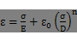

FAI R Internal frictional angle

c R Viscosity

C R Linear motion hardening factor

Tempearture R Temperature (required when DEPENDENCIES = 1)

v1, v2...v10 R Material constant

・In the case of YIELD = USER

(2nd Line or later)　v1, v2, v3, v4, v5, v6, v7, v8, v9, v10

Example of Use

!PLASTIC, YIELD=MISES, HARDEN=MULTILINEAR, DEPENDENCIES=1

276.0, 0.0, 20.

296.0, 0.0018, 20.

299.0, 0.0053, 20.

303.0, 0.008, 20.

338.0, 0.0173, 20.

372.0, 0.0271, 20.

400.0, 0.037, 20.

419.0, 0.0471, 20.

437.0, 0.0571, 20.

450.0, 0.0669, 20.

460.0, 0.0767, 20.

469.0, 0.0867, 20.

477.0, 0.0967, 20.

276.0, 0.0, 100.

276.0, 0.0018, 100.

282.0, 0.0053, 100.

295.0, 0.008, 100.

330.0, 0.0173, 100.

370.0, 0.0271, 100.

392.0, 0.037, 100.

410.0, 0.0471, 100.

425.0, 0.0571, 100.

445.0, 0.0669, 100.

450.0, 0.0767, 100.

460.0, 0.0867, 100.

471.0, 0.0967, 100.

128.0, 0.0, 400.

208.0, 0.0018, 400.

243.0, 0.0053, 400.

259.0, 0.008, 400.

309.0, 0.0173, 400.

340.0, 0.0271, 400.

366.0, 0.037, 400.

382.0, 0.0471, 400.

396.0, 0.0571, 400.

409.0, 0.0669, 400.

417.0, 0.0767, 400.

423.0, 0.0867, 400.

429.0, 0.0967, 400.

The work hardening coefficient will be calculated by inserting the data from the above input data, regarding the specified temperature or plastic strain. It is necessary to input the same PSTRAIN array for each temperature.

##### !HYPERELASTIC (2-2-3)

Definition of hyperelastic material

Parameter

TYPE = NEOHOOKE (Default)

MOONEY-RIVLIN

ARRUDA-BOYCE

USER

2nd Line or later

・In case of TYPE = NEOHOOKE

(2nd line)　C10, D

Parameter Name Attributions Contents

C10 R Material constant

D R Material constant

・In case of TYPE = MOONEY-RIVLIN

(2nd line)　C10, C01, D

Parameter Name Attributions Contents

C10  R Material constant

C01  R Material constant

D R Material constant

・In case of TYPE = ARRUDA-BOYCE

(2nd line)　mu, lambda_m, D

Parameter Name Attributions Contents

mu R Material constant

lambda_m R Material constant

D R Material constant

・In case of TYPE = USER

(2nd line ~ 10th line)　v1, v2, v3, v4, v5, v6, v7, v8, v9, v10

##### !VISCOELASTIC (2-2-4)

Definition of viscoelastic material

Parameter

DEPENDENCIES = the number of parameters depended upon (Not included)

2nd Line or later

(2nd line)　g, t

Parameter Name Attributions Contents

g R Shear relaxation modulus

t R Relaxation time

##### !CREEP (2-2-5)

Definition of creep material

Parameter

TYPE = NORTON (Default)

DEPENDENCIES = 0 (Default)/1

2nd Line or later

(2nd line)　A, n, m, Tempearature

Parameter Name Attributions Contents

A R material modulus

n R material modulus

m R material modulus

Tempearture R Temperature (required when DEPENDENCIES = 1)

##### !DENSITY (2-2-6)

Definition of mass density

Parameter

DEPENDENCIES = the number of parameters depended upon (Not included)

2nd Line or later

(2nd line)　density

Parameter Name Attributions Contents

density 　 R Mass density

##### !EXPANSION_COEFF (2-2-7)

Definition of coefficient of linear expansion

Parameter

TYPE = ISOTROPIC (Default) / ORTHOTROPIC

DEPENDENCIES = 0 (Default)/1

2nd Line or later

・In case of TYPE=ISOTROPIC

(2nd line)　expansion, Temperature

・In case of TYPE=PRTHPTROPIC

(2nd line)　α11, α22, α33, Temperature

Parameter Name Attributions Contents

expansion 　 R Coefficient of thermo expansion

α11, α22, α33 　 R Coefficient of thermo expansion

Temperature R Temperature (required when DEPENDENCIES = 1)

##### !USER_MATERIAL (2-2-8)

Input of user defined material

Parameter

NSTATUS = Specifies the number of state variables of material (Default: 1)

2nd Line or later

(2nd line ~ 10th line)　v1, v2, v3, v4, v5, v6, v7, v8, v9, v10

##### !BOUNDARY (2-3)

Definition of displacement boundary conditions

Parameter

GRPID = Group ID

AMP = Time function name (Specified in !AMPLITUDE, valid in dynamic analysis)

2nd Line or later

(2nd line)　NODE_ID, DOF_idS, DOF_idE, Value

Parameter Name Attributions Contents

NODE_ID I/C Node ID or node group name

DOF_idS I Start No. of restricted degree of freedom

DOF_idE I End No. of restricted degree of freedom

Value R Restricted value (Default: 0)

Example of Use

!BOUNDARY, GRPID=1

1, 1, 3, 0.0

ALL, 3, 3,

※Restricted value is 0.0

##### !SPRING (2-3-1)

Definition of spring boundary conditions

Parameter

GRPID = Group ID

2nd Line or later

(2nd line)　NODE_ID, DOF_id, Value

Parameter Name Attributions Contents

NODE_ID I/C Node ID or node group name

DOF_id I Restricted degree of freedom

Value R Spring constant

Example of Use

!SPRING, GRPID=1

1, 1, 0.5

##### !CLOAD (2-4)

Definition of concentrated load

Parameter

GRPID = Group ID

AMP = Time function name (Specified in !AMPLITUDE, valid in dynamic analysis)

2nd Line or later

(2nd line)　NODE_ID, DOF_id, Value

Parameter Name Attributions Contents

NODE_ID I/C Node ID or node group name

DOF_id I Degree of freedom No.

Value R Load value

Example of Use

!CLOAD, GRPID=1

1, 1, 1.0e3

ALL, 3, 10.0

##### !DLOAD (2-5)

Definition of distributed load

Parameter

GRPID = Group ID

AMP = Time Function Name (Specified in !AMPLITUDE, valid in dynamic analysis)

FOLLOW = YES (Default) / NO

(whether pressure load follow deformation, valid in finite displacement analysis)

2nd Line or later

(2nd line)　ID_NAME, LOAD_type, param1, param2,…

Parameter Name Attributions Contents

ID_NAME I/C Surface group name, element group name, or element ID

LOAD_type C Load type No.

param* R Load parameter (refer to following)

Load Parameters

|  |  |  |  |
| --- | --- | --- | --- |
| Load Type No. | Types | No. of Parameters | Parameter Array & Meaning |
| S | Applies pressure to surface specified in the surface group | 1 | Pressure value |
| P0 | Applies pressure to shell element | 1 | Pressure value |
| PX | Pressure to shell element along X direction | 1 | Pressure value |
| PY | Pressure to shell element along Y direction | 1 | Pressure value |
| PZ | Pressure to shell element along Z direction | 1 | Pressure value |
| P1 | Applies pressure to 1st surface | 1 | Pressure value |
| P2 | Applies pressure to 2nd surface | 1 | Pressure value |
| P3 | Applies pressure to 3rd surface | 1 | Pressure value |
| P4 | Applies pressure to 4th surface | 1 | Pressure value |
| P5 | Applies pressure to 5th surface | 1 | Pressure value |
| P6 | Applies pressure to 6th surface | 1 | Pressure value |
| BX | Body force in X direction | 1 | Body force value |
| BY | Body force in Y direction | 1 | Body force value |
| BZ | Body force in Z direction | 1 | Body force value |
| GRAV | Gravity | 4 | Gravitaional acceleration, gravity direction cosine |
| CENT | Centrifugal force | 7 | Angular velocity, position vector at a point on the rotation axis, vector in the rotating axis direction |

Example of Use

!DLOAD, GRPID=1

1, P1, 1.0

ALL, BX, 1.0

ALL, GRAV, 9.8, 0.0, 0.0, -1.0

ALL, CENT, 188.495, 0.0, 0.0, 0.0, 0.0, 0.0, 1.0

##### !ULOAD (2-6)

Input of user definition load

Parameter

FILE = file name (Mandatory)

##### !CONTACT_ALGO (2-7)

Specification of the contact analysis algorithm

Parameter

TYPE = SLAGRANGE　 : Lagrange multiplier method

ALAGRANGE　 : Extended Lagrange multiplier method

##### !CONTACT (2-8)

Definition of contact conditions

Parameter

GRPID = Boundary conditions group ID

INTERACTION = SSLID (Default)

FSLID

NTOL = Contact normal direction convergence threshold (Default: 1.e-5)

TTOL = Contact tangential direction convergence threshold (Default: 1.e-3)

NPENALTY = Contact normal direction Penalty (Default: stiffness matrix x1.e3)

TPENALTY = Contact tangential direction Penalty (Default: 1.e3)

2nd Line or later

(2nd line)　PAIR_NAME, fcoef, factor

Parameter Name Attributions Contents

PAIR_NAME 　 C Contact pair name (Defined in !CONTACT PAIR)

fcoef 　 R Friction coefficient (Default: 0.0)

factor 　 R Friction penalty stiffness

Example of Use

! CONTACT_ALGO, TYPE=SLAGRANGE

! CONTACT, GRPID=1, INTERACTION=FSLID

CP1, 0.1, 1.0e+5

##### !TEMPERATURE (2-9)

Specification of nodal temperature used for thermal stress analysis

Parameter

READRESULT = Number of result steps of heat conduction analysis.

When specified, the temperature is sequentially input from the results file of the heat conduction analysis, and the 2nd line and later will be disregarded.

SSTEP = First step number that performs the reading of the heat conduction analysis results (Default: 1)

INTERVAL = Step interval that performs the reading of the heat conduction analysis results (Default: 1)

2nd Line or later

(2nd line)　NODE_ID, Temp_Value

Parameter Name Attributions Contents

NODE_ID I/C Node ID or node group name

Temp_Value R Temperature (Default: 0)

Example of Use

!TEMPERATURE

1, 10.0

2, 120.0

3, 330.0

!TEMPERATURE

ALL, 20.0

!TEMPERATURE, READRESULT=1, SSTEP=1

##### !REFTEMP (2-10)

Definition of reference temperature in thermal stress analysis

Parameter

N/A

2nd Line or later

(2nd line)　Value

Parameter Name Attributions Contents

Value R Reference temperature (Default: 0)

##### !STEP　(2-11)

Setting of analysis steps

Setting is mandatory in the nonlinear static analysis and nonlinear dynamic analysis.

When this definition is omitted in analyses other than the above, all the boundary conditions will become valid and is calculated in 1 step.

When the material characteristics have viscoelasticity and creep, specify TYPE=VISCO and set the computation time conditions.

Parameter

TYPE = STATIC (default)/VISCO (semi-static analysis)

SUBSTEPS = Number of substeps of the boundary conditions (Default: 1)

CONVERG = Convergence judgment threshold (Default: 1.0e-6)

MAXITER = Maximum number of iterative calculations in nonlinear analysis (Default: 50)

AMP = Time function name (specified in !AMPLITUDE)

2nd Line or later

(2nd line) DTIME, ETIME (specified when TYPE=VISCO)

Parameter Name Attributions Contents

DTIME R Time increment value (Default: 1)

ETIME R End value of time increment in this step (Default: 1)

(3rd line and later)

BOUNDARY, id GRPID defined in id=!BOUNDARY

LOAD, id GRPID defined in id=!CLOAD, !DLOAD, !TEMPERATURE

CONTACT, id GRPID defined in id=!CONTACT

Example of Use

! STEP, CONVERG=1.E-8

0.1, 1.0

BOUNDARY, 1

LOAD, 1

CONTACT, 1

##### !TRS (2-12)

Thermorheological Simplicity description on temperature behavior of viscoelastic materials

Parameter

DEFINITION = WLF(Default) /ARRHENUS

2nd Line or later

(2nd line) θ0, C1, C2

Parameter Name Attributions Contents

θ0 R Reference temperature

C1, C2 R Material constants

### Control Data for Eigenvalue Analysis

##### !EIGEN (3-1)

Parameter settings of eigenvalue analysis

Parameter

N/A

2nd Line or later

(2nd line)　NGET, LCZTOL, LCZMAX

Parameter Name Attributions Contents

NSET I No. of eigenvalue

LCZTOL R Allowance (Default: 1.0e-8)

LCZMAX I Max No. of iterations (Default: 60)

Example of Use

　　　!EIGEN

　3, 1.0e-10, 40

### Control Data for Heat Conduction Analysis

##### !HEAT (4-1)

Definition of control data regarding calculation

Parameter

N/A

2nd Line or later

(2nd line)　DT, ETIME, DTMIN, DELTMX, ITMAX, ESP

Parameter Name Attributions Contents

DT R Initial time increment

≦0: Steady calculation

>0: Unsteady calculation

ETIME R Unsteady calculation time (mandatory for unsteady

calculation)

DTMIN R Minimum time increment

≦0: Fixed time increment

>0: Auto time increment

DELTMX R Allowable change in temperature

ITMAX I Maximum number of iterations of nonlinear

calculation (Default: 20)

EPS R Convergence judgment value (Default: 1.0e-6)

Example of Use

!HEAT

　　　 (No data) --- Steady calculation

!HEAT

　　　 0.0 --- Steady calculation

!HEAT

　　 10.0, 3600.0 --- Fixed time increment unsteady calculation

!HEAT

　　 10.0, 3600.0, 1.0 --- Auto time increment unsteady calculation

!HEAT

　　 10.0, 3600.0, 1.0, 20.0 --- Auto time increment unsteady calculation

##### !FIXTEMP (4-2)

Definition of fixed temperature

Parameter

AMP = Flux history table name (specified in !AMPLITUDE)

2nd Line or later

(2nd line)　NODE_GRP_NAME, Value

Parameter Name Attributions Contents

NODE_GRP_NAME　　C/I Node group name or node ID

Value 　R Temperature (Default: 0)

Example of Use

!FIXTEMP

ALL, 20.0

!FIXTEMP, AMP=FTEMP

ALL, 1.0

##### !CFLUX (4-3)

Definition of centralized heat flux given to the node

Parameter

AMP = Flux history table name (specified in !AMPLITUDE)

2nd Line or later

(2nd line)　NODE_GRP_NAME, Value

Parameter Name Attributions Contents

NODE_GRP_NAME C/I Node group name or node ID

Value R Heat flux value

Example of Use

!CFLUX

ALL, 1.0E-3

!CFLUX, AMP=FUX1

ALL, 1.0

##### !DFLUX (4-4)

Definition of distributed heat flux and internal heat generation given to surface of element

Parameter

AMP = Flux history table name (specified in !AMPLITUDE)

2nd Line or later

(2nd line)　ELEMENT_GRP_NAME, LOAD_type, Value

Parameter Name Attributions Contents

ELEMENT_GRP_NAME　　　 C/I Element group name or element ID

LOAD_type 　C Load type No.

Value 　R Heat flux value

Example of Use

!DFLUX

ALL, S1, 1.0

!DFLUX, AMP=FLUX2

ALL, S0, 1.0

Load Parameters

|  |  |  |
| --- | --- | --- |
| Load Type No. | Applied Surface | Parameter |
| BF | Element overall | Calorific value |
| S1 | Surface No. 1 | Heat flux value |
| S2 | Surface No. 2 | Heat flux value |
| S3 | Surface No. 3 | Heat flux value |
| S4 | Surface No. 4 | Heat flux value |
| S5 | Surface No. 5 | Heat flux value |
| S6 | Surface No. 6 | Heat flux value |
| S0 | Shell surface | Heat flux value |

##### !SFLUX (4-5)

Definition of distributed heat flux by surface group

Parameter

AMP = Flux history table name (specified in !AMPLITUDE)

2nd Line or later

(2nd line)　SURFACE_GRP_NAME, Value

Parameter Name Attributions Contents

SURFACE_GRP_NAME C Surface group name

Value R Heat flux value

Example of Use

!SFLUX

SURF, 1.0

!SFLUX, AMP=FLUX3

SURF, 1.0

##### !FILM (4-6)

Definition of heat transfer coefficient given to the boundary plane

Parameter

AMP1 = Heat transfer coefficient history table name (specified in !AMPLITUDE)

AMP2 = Ambient temperature history table name (specified in !AMPLITUDE)

2nd Line or later

(2nd line)　ELEMENT_GRP_NAME, LOAD_type, Value, Sink

Parameter Name Attributions Contents

ELEMENT_GRP_NAME C/I Element group name or element ID

LOAD_type C Load type No.

Value R Heat transfer coefficient

Sink R Ambient temperature

Example of Use

!FILM

FSURF, F1, 1.0, 800.0

!FILM, AMP1=TFILM

FSURF, F1, 1.0, 1.0

Load Parameters

|  |  |  |
| --- | --- | --- |
| Load Type No. | Applied Surface | Parameter |
| F1 | Surface No. 1 | Heat transfer coefficient and ambient temperature |
| F2 | Surface No. 2 | Heat transfer coefficient and ambient temperature |
| F3 | Surface No. 3 | Heat transfer coefficient and ambient temperature |
| F4 | Surface No. 4 | Heat transfer coefficient and ambient temperature |
| F5 | Surface No. 5 | Heat transfer coefficient and ambient temperature |
| F6 | Surface No. 6 | Heat transfer coefficient and ambient temperature |
| F0 | Shell surface | Heat transfer coefficient and ambient temperature |

##### !SFILM (4-7)

Definition of heat transfer coefficient by surface group

Parameter

AMP1 = Heat transfer coefficient history table name (specified in !AMPLITUDE)

AMP2 = Ambient temperature history table name (specified in !AMPLITUDE)

2nd Line or later

(2nd line)　SURFACE_GRP_NAME, Value, Sink

Parameter Name Attributions Contents

SURFACE_GRP_NAME C Surface group name

Valu R Heat Transfer Rate

Sink R Ambient Temperature

Example of Use

!SFILM

SFSURF, 1.0, 800.0

!SFILM, AMP1=TSFILM, AMP2=TFILM

SFSURF, 1.0, 1.0

##### !RADIATE (4-8)

Definition of radiation factor given to boundary plane

Parameter

AMP1 = Radiation factor history table name (specified in !AMPLITUDE)

AMP2 = Ambient temperature history table name (specified in !AMPLITUDE)

2nd Line or later

(2nd Line)　ELEMENT_GRP_NAME, LOAD_type, Value, Sink

Parameter Name Attributions Contents

ELEMENT_GRP_NAME C/I Element group name or element ID

LOAD_type C Load type No.

Value R Rdiation factor

Sink R Ambient temperature

Example of Use

!RADIATE

RSURF, R1, 1.0E-9, 800.0

!RADIATE, AMP2=TRAD

RSURF, R1, 1.0E-9, 1.0

Load Parameters

|  |  |  |
| --- | --- | --- |
| Load Type No. | Applied Surface | Parameter |
| R1 | Surface No. 1 | Radiation factor and ambient temperature |
| R2 | Surface No. 2 | Radiation factor and ambient temperature |
| R3 | Surface No. 3 | Radiation factor and ambient temperature |
| R4 | Surface No. 4 | Radiation factor and ambient temperature |
| R5 | Surface No. 5 | Radiation factor and ambient temperature |
| R6 | Surface No. 6 | Radiation factor and ambient temperature |
| R0 | Shell surface | Radiation factor and ambient temperature |

##### !SRADIATE (4-9)

Definition of radiation factor by surface group

Parameter

AMP1 = Radiation factor history table name (specified in !AMPLITUDE)

AMP2 = Ambient temperature history table name (specified in !AMPLITUDE)

2nd Line or later

(2nd Line)　SURFACE_GRP_NAME, Value, Sink

Parameter Name Attributions Contents

SURFACE_GRP_NAME C Surface group name

Value R Radiation factor

Sink R Ambient temperature

Example of Use

!SRADIATE

RSURF, 1.0E-9, 800.0

!SRADIATE, AMP2=TSRAD

RSURF, 1.0E-9, 1.0

##### !WELD_LINE (4-10)

Definition of weld line (Linear)

Parameter

N/A

2nd Line

(2nd line)　I, U, Coef, H,V

Parameter Name Attributions Contents

I R Current

U R Voltage

Coef R Heat input coefficient

V R Movement speed of the welding torch

3rd Line

(3rd line)　EGROUP, XYZ, C1, C2,H, tstart

Parameter Name Attributions Contents

EGROUP C Element group name for heat input

XYZ I Movement direction of welding torch (Degree of freedom No.)

C1 R Starting point coordinates of welding torch

C2 R Ending point coordinates of welding torch

H R Width of welding torch, inside which thermo energy inputted

tstart R Welding start time

### Control Data for Dynamic Analysis

##### !DYNAMIC (5-1)

Dynamic analysis control

Time t for each !AMPLITUDE specified in !BOUNDARY, !CLOAD and !DLOAD must be started from 0.0.

Parameter

TYPE = LINEAR / NONLINEAR (Linear dynamic analysis/Nonlinear dynamic analysis)

2nd Line or later

(2nd line)　idx_eqa, idx_resp

Parameter Name Attributions Contents

idx_eqa I Solution of equation of motion (Direct time

integration)

(Default: 1)

1: Implicit method (Newmark-β method)

11: Explicit method (Center difference method)

idx_resp I Analysis type (Default: 1)

1: Time history response analysis

2: Frequency response analysis (Not included)

idx_resp=1 (Time history response analysis)

(3rd line)　t_start , t_end , n_step, t_delta

Parameter Name Attributions Contents

t_start R Analysis start time (Default: 0.0), not used

t_end R Analysis end time (Default: 1.0), not used

n_step I Overall No. of steps (Default: 1)

t_delta R Time increment (Default: 1.0)

(4th line)　ganma , beta

Parameter Name Attributions Contents

ganma R Parameterγof Newmark-β method (Default: 0.5)

beta R Parameterβof Newmark-β method (Default: 0.25)

(5th line)　idx_mas ,idx_dmp , ray_m ,ray_k

Parameter Name Attributions Contents

idx_mas I Type of mass matrix (Default: 1)

1: Lumped mass matrix

2: Consistent mass matrix

idx_dmp I 1: Rayleigh damping (Default: 1)

ray_m R Parameter Rm of Rayleigh damping (Default: 0.0)

ray_k R Parameter Rk of Rayleigh damping (Default: 0.0)

(6th line)　nout, node_monit_1, nout_monit

Parameter Name Attributions Contents

nout I not used

node_monit_1 I Monitoring node ID (Global) or node group name

nout_monit I Results output interval of displacement monitoring

(Default: 1)

Note: Regarding the information of the monitoring node specified in this line, the displacement is output to the file <dyna_disp_*NID*.txt>, where *NID* is the global ID of the monitoring node, and each line includes the step number, time of the step, *NID*, u1, u2, and u3 in this order. The velocity and acceleration are also output to <dyna_velo_*NID*.txt> and <dyna_acce_*NID*.txt>, respectively, in the same format as the displacement. The nodal strain is output to <dyna_strain_*NID*.txt> and each line includes the step number, time of the step, *NID*, e11, e22, e33, e12, e23, and e13 in this order. The nodal stress is output to <dyna_stress_*NID*.txt> and each line includes the step number, time of the step, *NID*, s11, s22, s33, s12, s23, s13, and s_mises in this order. When monitoring nodes are specified by a node group, each of the files stated above is separately output for each node. When this output is specified, the kinetic energy, deformation energy and the overall energy of the overall analytic model will also be output to <dyna_energy.txt>.

(7th line)　iout_list(1), iout_list(2), iout_list(3), iout_list(4), iout_list(5), iout_list(6)

Parameter Name Attributions Contents

iout_list(1) I Displacement output specification (Default: 0)

0: Not output, 1: Output

iout_list(2) I Velocity output specification (Default: 0)

0: Not output, 1: Output

iout_list(3) I Acceleration output specification (Default: 0)

0: Not output, 1: Output

iout_list(4) I Reaction force output specification (Default: 0)

0: Not output, 1: Output

iout_list(5) I Strain output specification (Default: 0)

0: Not output (Element base and node base),

1: Output

2: Output (Node base)

3: Output (Element base)

iout_list(6) I Stress output specification (Default: 0)

0: Not output (Element base and node base),

1: Output

2: Output (Node base)

3: Output (Element base)

Example of Use

!DYNAMIC, TYPE=NONLINEAR

1 , 1

0.0, 1.0, 500, 1.0000e-5

0.5, 0.25

1, 1, 0.0, 0.0

100, 55, 1

0, 0, 0, 0, 0, 0

idx_resp=2 (Frequency response analysis)

(3rd line) f_start, f_end, n_freq, f_disp

Parameter Name Attributions Contents

f_start R Minimum frequency

f_end R Maximum frequency

n_freq I Number of divisions for the frequency range

f_disp R Frequency to obtain displacement

(4th line) t_start, t_end

Parameter Name Attributions Contents

t_start R Analysis start time

t_end R Analysis end time

(5th line) idx_mas, idx_dmp, ray_m ,ray_k

Parameter Name Attributions Contents

idx_mas I Type of mass matrix (Default: 1)

1: Lumped mass matrix

idx_dmp I 1: Rayleigh damping (Default: 1)

ray_m R Parameter Rm of Rayleigh damping (Default: 0.0)

ray_k R Parameter Rk of Rayleigh damping (Default: 0.0)

(6th line) nout, vistype, nodeout

Parameter Name Attributions Contents

nout I Results output interval in time domain

vistype I Visuzalization type

1:Mode shapes

2:Time history results at f_disp

nodeout I Monitoring NODE ID in frequency domain

(7th line) iout_list(1), iout_list(2), iout_list(3), iout_list(4), iout_list(5), iout_list(6)

Parameter Name Attributions Contents

iout_list(1) I Displacement output specification (Default: 0)

0: Not output, 1: Output

iout_list(2) I Velocity output specification (Default: 0)

0: Not output, 1: Output

iout_list(3) I Acceleration output specification (Default: 0)

0: Not output, 1: Output

iout_list(4) I not used

iout_list(5) I not used

iout_list(6) I not used

Example of Use

!DYNAMIC

11 , 2

14000, 16000, 20, 15000.0

0.0, 6.6e-5

1, 1, 0.0, 7.2E-7

10, 2, 1

1, 1, 1, 1, 1, 1

##### !VELOCITY (5-2)

Definition of velocity boundary conditions

Parameter

TYPE = INITIAL (Initial velocity boundary conditions)

= TRANSIT (Time history velocity boundary conditions specified in !AMPLITUDE; Default)

AMP = Time function name (specified in !AMPLITUDE)

　　　　 Provides the relationship between time t and factor f(t) in !AMPLITUDE.

The time multiplied by factor f(t) to the following Value becomes the restrained value of that time (when not specified: time and factor relationship becomes f(t) = 1.0).

2nd Line or later

(2nd line)　NODE_ID, DOF_idS, DOF_idE, Value

Parameter Name Attributions Contents

NODE_ID I/C Node ID or node group name

DOF_idS I Start No. of restricted degree of freedom

DOF_idE I End No. of restricted degree of freedom

Value R Restricted value (Default: 0)

Example of Use

!VELOCITY, TYPE=TRANSIT, AMP=AMP1

1, 1, 1, 0.0

ALL, 3, 3

※Restricted value is 0.0

!VELOCITY, TYPE=INITIAL

1, 3, 3, 1.0

2, 3, 3, 1.0

3, 3, 3, 1.0

Note: The velocity boundary conditions are different than the displacement boundary conditions, and the multiple degrees of freedom can not be defined collectively. Therefore, the same number must be used for DOF_idS and DOF_idE.

When the TYPE is INITIAL, AMP becomes invalid.

##### !ACCELERATION (5-3)

Definition of acceleration boundary conditions

Parameter

TYPE = INITIAL (Initial acceleration boundary conditions)

= TRANSIT (Time history acceleration boundary conditions specified in

AMPLITUDE; Default)

AMP = Time function name (specified in !AMPLITUDE)

　　　　 Provides the relationship between time t and factor f(t) in !AMPLITUDE.

The time multiplied by factor f(t) to the following Value becomes the restrained value of that time (when not specified: time and factor relationship becomes f(t) = 1.0).

2nd Line or later

(2nd Line)　NODE_ID, DOF_idS, DOF_idE, Value

Parameter Name Attributions Contents

NODE_ID I/C Node ID or node group name

DOF_idS I Start No. of restricted degree of freedom

DOF_idE I End No. of restricted degree of freedom

Value Restricted value (Default: 0)

Example of Use

!ACCELERATION, TYPE=TRANSIT, AMP=AMP1

1, 1, 3, 0.0

ALL, 3, 3

※Restricted value is 0.0

! ACCELERATION, TYPE=INITIAL

1, 3, 3, 1.0

2, 3, 3, 1.0

3, 3, 3, 1.0

Note: The acceleration boundary conditions are different than the displacement boundary conditions, and the multiple degrees of freedom can not be defined collectively. Therefore, the same number must be used for DOF_idS and DOF_idE.

When the TYPE is INITIAL, AMP becomes invalid.

##### !COUPLE (5-4)

Definition of coupled surface (Used only in coupled analysis)

Parameter

TYPE = 1: One-way coupled (FrontISTR starts from receiving data)

2: One-way coupled (FrontISTR starts from sending data)

3: Staggered two-way coupled (FrontISTR starts from receiving data)

4: Staggered Two-way coupled (FrontISTR starts from sending data)

5: Iterative partitioned two-way coupled (FrontISTR starts from receiving data)

6: Iterative partitioned two-way coupled (FrontISTR starts from sending data)

ISTEP = Step No.

From the beginning of analysis to the step specified here, a linearly increasing function from 0 to 1 is multiplied to the input fluid traction. After this step, the input fluid traction is directly applied.

WINDOW = >0 : Multiply window function(*) to input fluid traction

(*) $\frac{1}{2}\left(1-\cos{\frac{2πi}{N}}\right), i : current step, N :no. of steps of current analysis$

2nd Line or later

(2nd Line)　COUPLING_SURFACE_ID

Parameter Name Attributions Contents

SURFACE_ID C Surface group name

Example of Use

!COUPLE , TYPE=1

SCOUPLE1

SCOUPLE2

##### !EIGENREAD(5-5)

Controlling the input file for frequency response analysis

Parameter

N/A

2nd Line

(2nd line)　 eigenlog_filename

Parameter Name Attributions Contents

eigenlog_filename C The name of eigenvalue analysis log

(3rd line)　 start_mode, end_mode

Parameter Name Attributions Contents

start_mode I lowest mode to be used in frequency

response analysis

end_mode I highest mode to be used in frequency

response analysis

Example of Use

!EIGENREAD

eigen_0.log

1, 5

##### !FLOAD(5-6)

Defining external forces applied in frequency response analysis

Parameter

LOAD CASE = (1:Real part, 2:Imaginary part)

2nd Line or later

(2nd line) NODE_ID,DOF_id,Value

Parameter Name Attributions Contents

NODE_ID I/C Node ID, node group name or surface group name

DOF_id I Degree of freedom No.

Value R Load value

Example of Use

!FLOAD, LOAD CASE=2

_PickedSet5, 2, 1.0

### Solver Control Data

##### !SOLVER　(6-1)

Control of solver

Mandatory control data

Parameter

METHOD = Method（CG, BiCGSTAB, GMRES, GPBiCG, DIRECT, DIRECTmkl, MUMPS）

DIRECT: Direct method other than contact analysis (serial processing only)

DIRECTmkl: Direct method by Intel MKL in contact analysis

(serial processing only)

MUMPS: Parallel direct method by MUMPS

When any of direct methods is selected, the data lines will be disregarded.

In 1D and 2D problems, only CG, DIRECT and MUMPS are valid.

In shell problems, only DIRECT and MUMPS are valid.

Thread-parallel computation by OpenMP is available in iterative methods

for 3D problems.

PRECOND = Preconditioner（1, 2, 3, 5, 10, 11, 12）

1, 2: (Block) SSOR

3: (Block) Diagonal Scaling

5: AMG by multigrid preconditioner package ML (experimental)

10: Block ILU(0)

11: Block ILU(1)

12: Block ILU(2)

10, 11, and 12 are available only in 3D problems.

In thread-parallel computation, SSOR or Diagonal Scaling is recommended.

ITERLOG = Whether solver convergence history is output (YES/NO) (Default: NO)

TIMELOG = Whether solver computation time is output (YES/NO) (Default: NO)

USEJAD = Whether matrix ordering optimized for vector processors are performed

(YES/NO) (Default: NO)

Valid only in 3D problems with iterative solvers.

SCALING = Whether matrix is scaled so that each diagonal element becomes 1 (YES/NO)

(Default: NO)

Valid only in 3D problems with iterative solvers.

DUMPTYPE = Type of matrix dumping (NONE, MM, CSR, BSR) (Mainly for debugging)

NONE: no dumping (Default)

MM: matrix is dumped in Matrix Market format

CSR: matrix is dumped in Compressed Sparse Row (CSR) format

BSR: matrix is dumped in Blocked CSR format

DUMPEXIT = Whether the program terminates right after matrix dumping (YES/NO)

(Default: NO)

MPCMETHOD = Method for multipoint constraints

1: Penalty method

2: MPC-CG method

3: Explicit master-slave elimination (Default)

Valid only in 3D problems with iterative solvers.

(Penalty method is always used for direct solvers and 1D and 2D iterative solvers, and MPC-CG method is always used for 4D and 6D iterative solvers.)

ESTCOND = Frequency of condition number estimation (experimental)

Estimation is performed at every specified number of iterations and at the last iteration. No estimation when 0 is specified.

2nd Line or later

(2nd Line) NIER, iterPREmax, NREST

Parameter Name Attributions Contents

NIER 　 I No. of iterations (Default: 100)

iterPREmax 　 I No. of iteration of preconditioning based on Additive

Schwarz (Default: 1)

(recommended value : 1 for serial computation, parallel computation with Diagonal scaling, and serial/parallel computation of problems with MPC, 2 for other parallel computation)

NREST 　 I No. of Krylov subspaces (Default: 10)

(Valid only when GMRES is selected as the solution)

NCOLOR_IN 　 I No. of Colors for Multi-Color ordering (Default: 10)

(Valid only when no. of OpenMP threads >= 2)

(3rd Line) RESID, SIGMA_DIAG, SIGMA

Parameter Name Attributions Contents

RESID 　　R Truncation error (Default: 1.0e-8)

SIGMA_DIAG 　　R Scale factor for diagonal elements when computing

preconditioning matrix (Default: 1.0)

SIGMA 　　R Not used (Default: 0.0)

Example of Use

!SOLVER, METHOD=CG, PRECOND=1, ITER=YES, TIME=YES

10000, 2

1.0e-8, 1.0, 0.0

### Post Process (Visualization) Control Data

##### !VISUAL (P1-0)

Specifies the visualization method.

METHOD = PSR : Surface rendering

visual_start_step : Specification of time step number which starts the visualization process (Default: 1)

visual_end_step : Specification of time step number which ends the visualization process (Default: All)

visual_interval_step : Specification of time step interval which performs the visualization process (Default: 1)

##### !surface_num, !surface, !surface_style (P1-1～3)

!surface_num (P1-1)

No. of surfaces in one surface rendering

Ex.: There are four surfaces in Figure 7.4.1, which includes two isosurfaces pressure = 1000.0 and pressure = -1000.0, and two cut end plane surfaces z = -1.0 and z = 1.0.

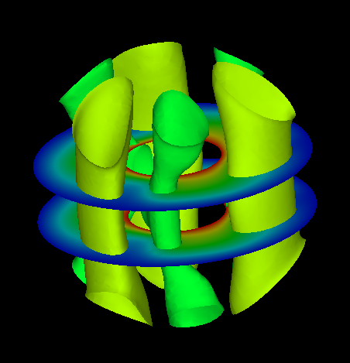

Figure 7.4.1: Example of surface_num Setting

!surface (P1-2)

Sets the contents of the surface.

Ex.: The contents of the four surfaces in Figure 4.1.2 are as follows.



Figure 7.4.2: Example of Surface Setting

!surface_num = 2

!SURFACE

!surface_style=2

!data_comp_name = press

!iso_value = 1000.0

!display_method = 4

!specified_color = 0.45

!output_type = BMP

!SURFACE

!surface_style=2

!data_comp_name = press

!iso_value = -1000.0

!display_method = 4

!specified_color = 0.67

!surface_style (P1-3)

Specifies the style of the surface.

1: Boundary plane

2: Isosurface

3: Arbitrary quadric surfaces

coef[1]x2 + coef[2]y2 + coef[3]z2 + coef[4]xy + coef[5]xz

+ coef[6]yz + coef[7]x + coef[8]y + coef[9]z + coef[10]=0

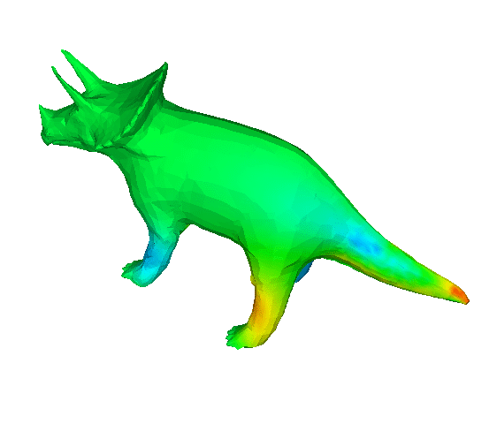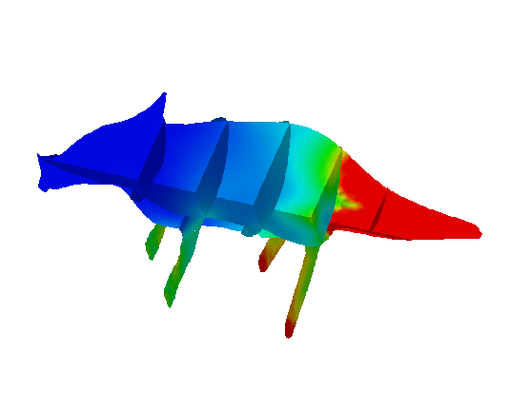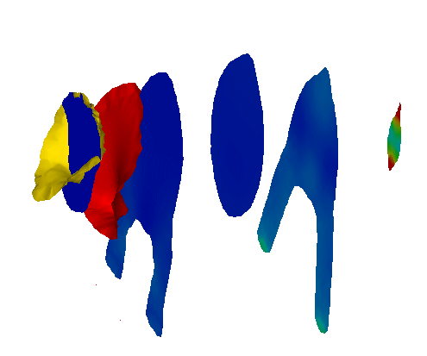

!surface_style=1

!surface_style=2

!surface_style=3

Figure 7.4.3: Example of surface_style Setting

##### !display_method (P1-4)

Display method (Default: 1)

1. Color code display

2. Boundary line display

3. Color code and boundary line display

4. Display of 1 specified color

5. Isopleth line display by classification of color

!display_method=1

!display_method=2

!display_method=3

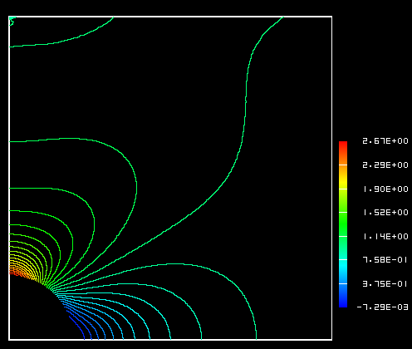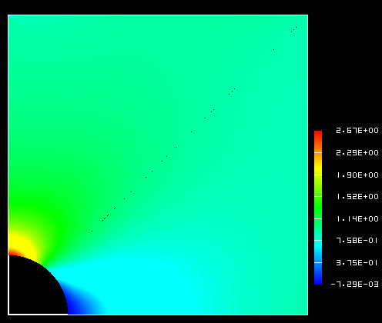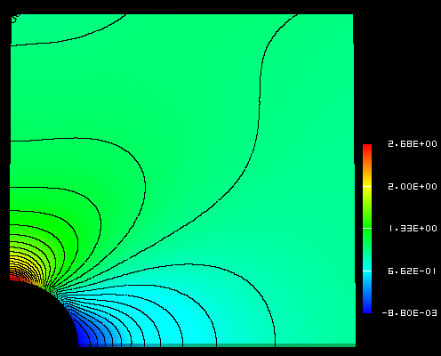

!display_method=4

!display_method=5

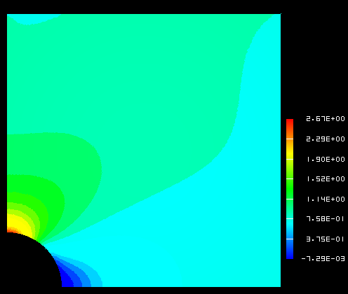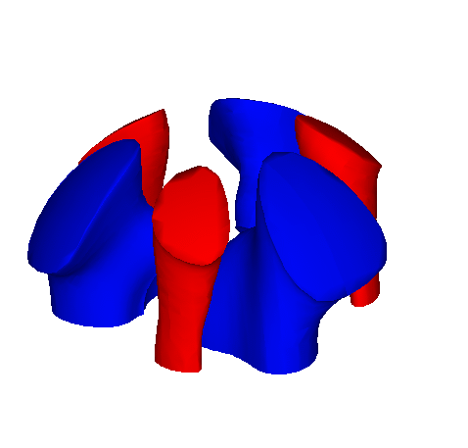

Figure 7.4.4: Example of display_method Setting

##### !color_comp_name　!color_comp　!color_subcomp (P1-5　P1-7　P1-8)

Specifies the selections for the color map from the physical values. Provides the names to the necessary physical values and the degree of freedom numbers. Accordingly, the names will be entered for the structure node_label(:) and nn_dof(:) of the results data.

Then you can define which one you hope to map into color by

!color_comp_name (Character string, default: 1st parameter)

Example: !color_comp_name = pressure

In static analysis; =DISPLACEMENT: Specification of the results displacement data

　　　　　　　　　= STRAIN: Specification of strain data

　　　　　　　　　= STRESS: Specification of stress data

In heat transfer analysis; =TEMPERATURE: Specification of the results temperature data

!color_comp (Integer, default: 0)

Physical value ID number (Integers above 0)

Example:!color_comp = 2

This is the specification of the ID number and component name of the results data type; however, this is not included.

!color_subcomp (Integer, default: 0)

When the physical value is 1 degree of freedom or more like the vector quantity, it’s the number of the degree of freedom.

Example: !color_subcomp = 0

　　　When !color_comp_name=DISPLACEMENT is specified

1: X Component 2: Y Component 3: Z Component

　　　When !color_comp_name=STRAIN is specified

1 : εx 2 : εy 3 : εz

4 : εxy 5 : εyz 6 : εzx

　　　When !color_comp_name=STRESS is specified

1 : σx 2 : σy 3 : σz

4 : τxy 5 : τyz 6 : τzx

　　　When !color_comp_name=TEMPERATURE is specified

1: Temperature

In the structural analysis, for example;

Physical Value Displacement Strain Stress

No. of degrees of freedom 3 6 7

!color_comp_name=displacement

!color_subcomp = 1

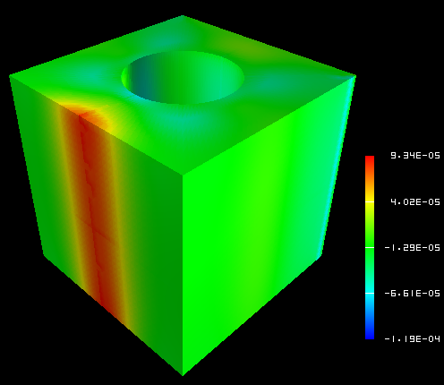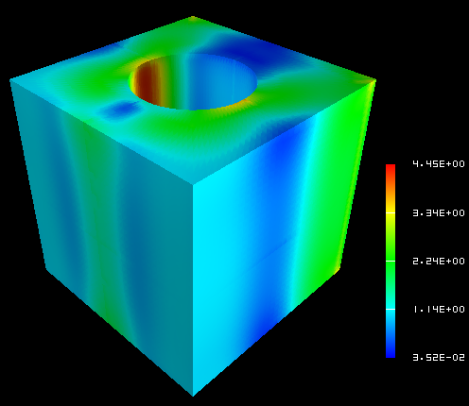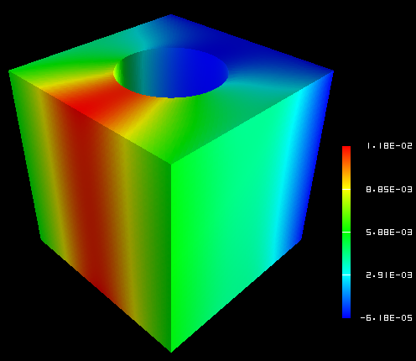

!color_comp_name=strain

!color_subcomp_name = 1

!color_comp = 3

!color_subcomp = 7

Figure 7.4.5: Example of color_comp, color_subcomp and color_comp_name Setting

##### !isoline_number　!isoline_color (P1-9　P2-22)

When display_method=2, 3 or 5

!isoline_number = 30

!isoline_color = 0.0, 0.0, 0.0

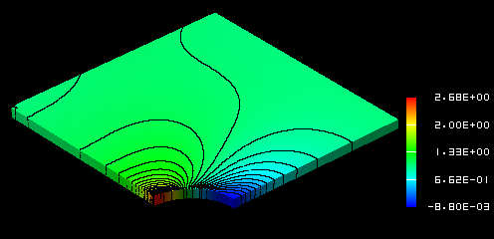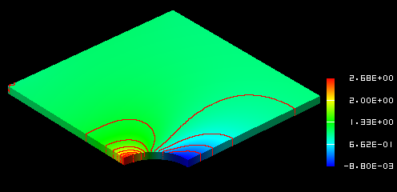

!isoline_number = 10

!isoline_color = 1.0, 0.0, 0.0

Figure 7.4.6: Example of isoline_number and isoline_color Setting

##### !initial_style　!deform_style (P1-15　P1-16)

Specifies the display style of the initial shape and the deformed shape.

0: Not specified

1: Solid line mesh (Displayed in blue if not specified)

2: Gray filled pattern

3: Shading

(Let the physical attributions respond to the color)

4: Dotted line mesh (Displayed in blue if not specified)

##### !deform_scale (P1-14)

Specifies the displacement scale when displaying deformation.

Default: Auto

　 standard_scale = 0.1 * */max_deform*



!initial_style=2

!deform_style = 0

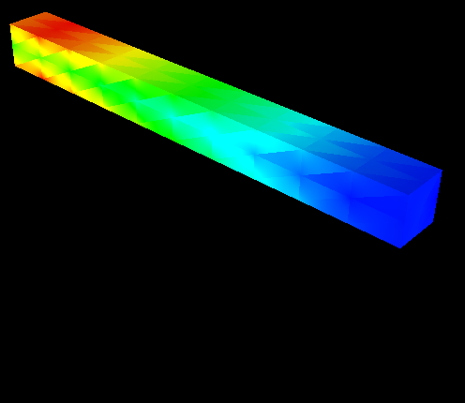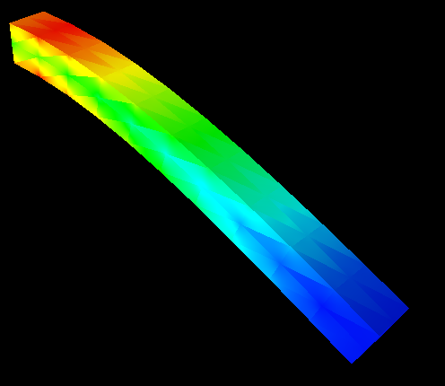

!initial_style=0

!deform_style = 2

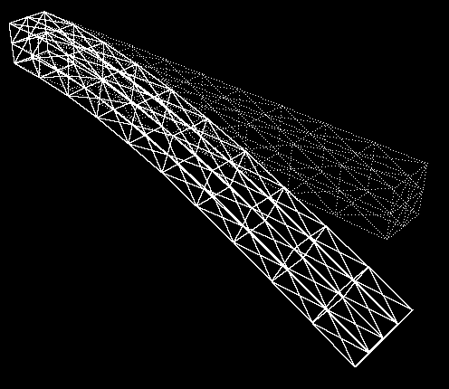

!initial_style=4

!deform_style = 1

!initial_line_color = 1.0, 1.0, 1.0

!deform_line_color = 1.0, 1.0, 1.0

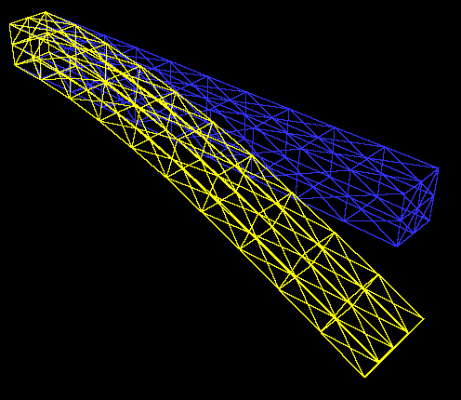

!initial_style=1

!deform_style = 1 **NASTRAN style**

!initial_line_color = default

!deform_line_color = default

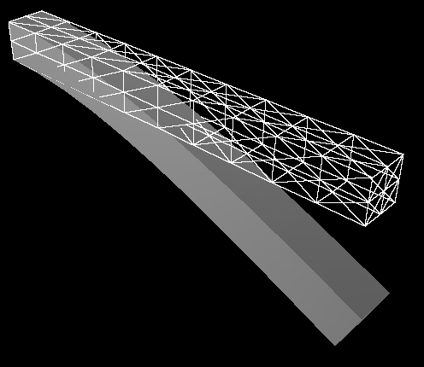

!initial_style=1

!deform_style = 2

!initial_line_color = 1.0, 1.0, 1.0

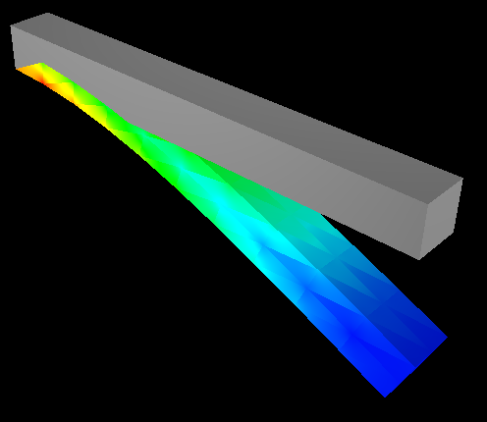

!initial_style=2

!deform_style = 3

!initial_line_color = 1.0, 1.0, 1.0

Figure 7.4.7: Example of Display Styles Setting

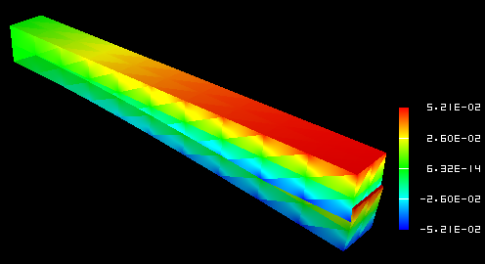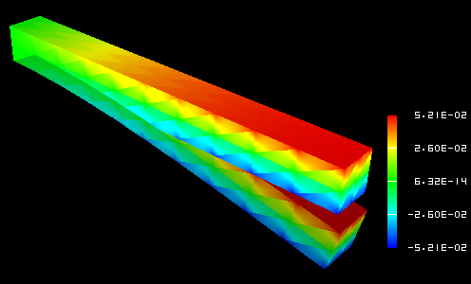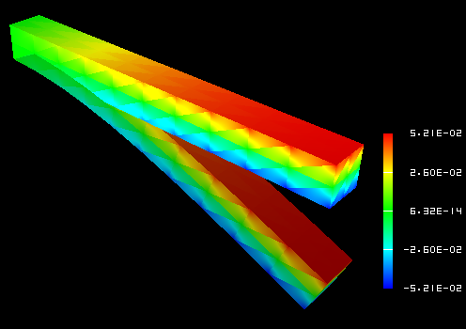

!deform_scale=1.0

!deform_scale=2.0

!deform_scale=4.0

Figure 7.4.8: Example of deform_scale Setting

##### !output_type (P1-19)

Specifies the type of output file. (Default: AVS)

AVS: UCD data for AVS (only on object surface)

BMP: Image data (BMP format)

COMPLETE_AVS: UCD data for AVS

COMPLETE_REORDER_AVS: Rearranges the node and element ID in the UCD data for AVS

SEPARATE_COMPLETE_AVS: UCD data for AVS for each decomposed domain

COMPLETE_MICROAVS: Outputs the physical values in the scalar in the UCD data for AVS

BIN_COMPLETE_AVS: Outputs COMPLETE_AVS in binary format

FSTR_FEMAP_NEUTRAL: Neutral file for FEMAP

!output_type = AVS !output_type=BMP

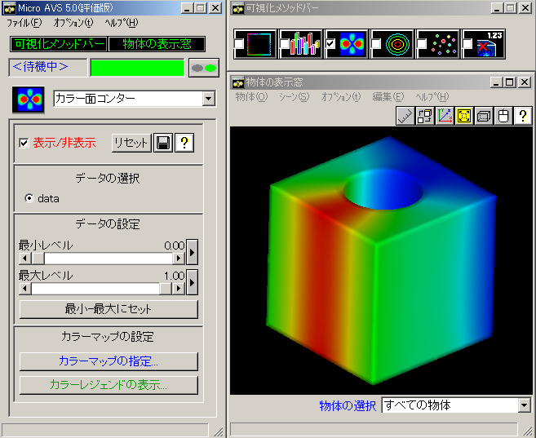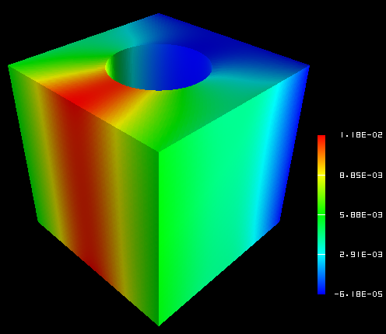

Figure 7.4.9: Example of output_type

##### !x_resolution　!y_resolution (P2-1　P2-2)

Specifies the resolution when output_type=BMP.

!x_resolution=500 !x_resolution=300

!y_resolution=500 !y_resolution=300



Figure 7.4.10: Example of x_resolution and y_resolution Setting

##### !viewpoint　!look_at_point　!up_direction (P2-5　P2-6　P2-7)

viewpoint: Specifies the viewpoint position by coordinates.

Default: x = (xmin + xmax)/2.0,

y = ymin + 1.5 *( ymax – ymin),

z = zmin + 1.5 *( zmax – zmin)

Look_at_point: Specifies the look at point position.

(Default: Center of data)

up_direction: Specifies the view frame in viewpoint, look_at_point and up_direction.

default: 0.0 0.0 1.0

View coordinate frame:

Origin: look_at_point

Z-axis: viewpoint – look_at_point

X-axis:up × z axis

Y-axis:z axis × x axis

up_direction

viewpoint

look_at_point

Figure 7.4.11: View Frame Determination Method

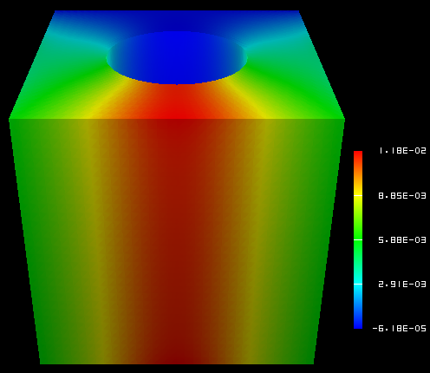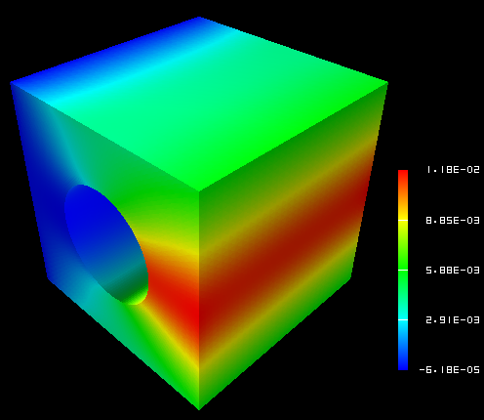

!viewpoint=200.0, 200.0,200.0

!up_direction=0.0, 0.0, 1.0

!viewpoint= **300.0, 50.0**, 200.0

!up_direction=0.0, 0.0, 1.0

!viewpoint=200.0, 200.0, 200.0

!up_direction=0.0, **1.0, 0.0**

Figure 7.4.12: Example of !viewpoint, look_at_point and up_direction Setting

##### !ambient_coef　!diffuse_coef　!specular_coef (P2-8　P2-9　P2-10)

Coefficient setting of lighting model

When the ambient_coef is increased, information on the 3D depth direction is impaired.

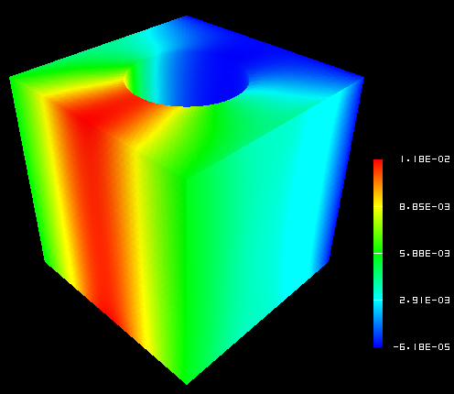

!ambient_coef = 0.3 !ambient_coef = 0.9

!diffuse_coef = 0.7 !diffuse_coef = 0.1

Figure 7.4.13: Example of Lighting Model Parameter Setting

##### !color_mapping_bar_on !scale_marking_on !num_of_scales (P2-16 P2-17 P2-18)

!color_mapping_bar_on: Specifies whether to display the color mapping bar.

0: off 1: on (Default: 0)

!scale_marking_on: Specifies the existence of memory of the color mapping bar.

0: off 1: on (Default： 0)

!num_of_scales: Specifies the number of memory. (Default: 3)

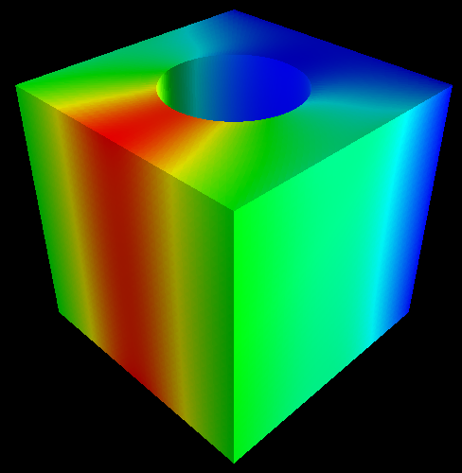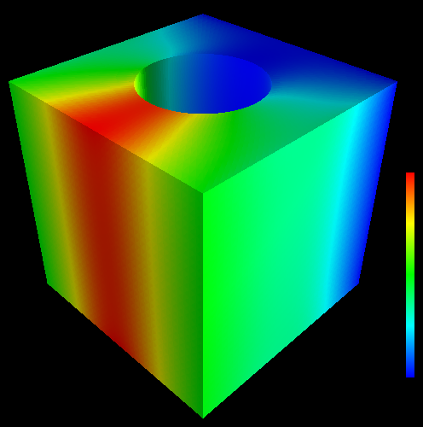

!color_mapping_bar_on=0 !color_mapping_bar_on =1 !color_mapping_bar_on =1

!scale_marking_on =0 !scale_markig_on =0 !scale_marking_on=1

!num_of_scale = 5

Figure 7.4.14: Example of Color Mapping Bar Display

##### !font_size !font_color !backgroud_color (P2-19　P2-20　P2-21)

Specifies the background color and character font.

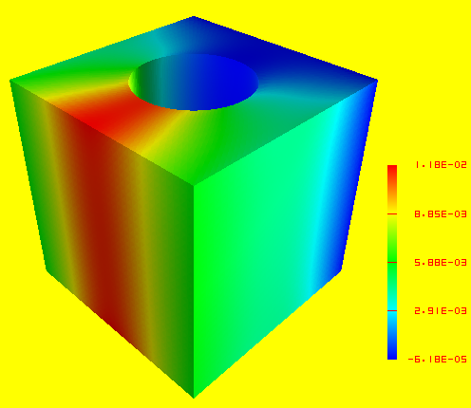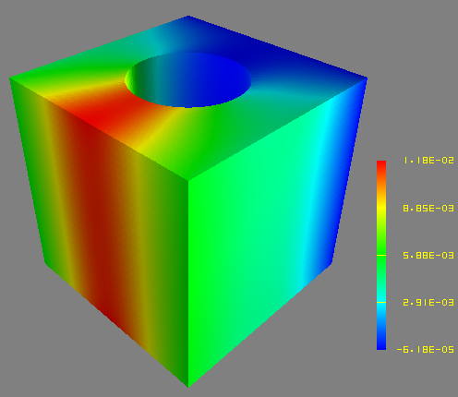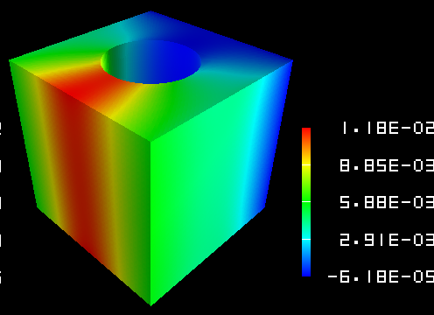

!background_color =1.0,1.0,0.0 !background_color =0.5, 0.5, 0.5 !background_color =0.0, 0.0,0.0

!font_color=1.0, 0.0, 0.0 !font_color=1.0, 1.0, 0.0 !font_color=1.0, 1.0, 1.0

!font_size=1.5 !font_size =1.5 !font_size=2.5

Figure 7.4.15: Example of Background and Font Setting

##### !data_comp_name　!data_comp　!data_subcomp (P3-1　P3-3　P3-4)

Specifies the physical values of the isosurface to be visualized when surface_style=2.

!data_comp_name=pressure

!data_comp_name=vorticity

!data_subcomp=3

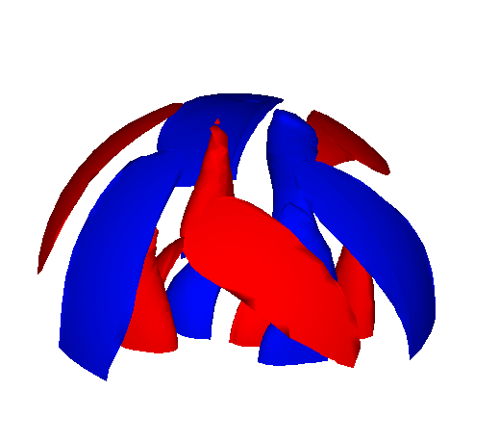

Figure 7.4.16: Example of data_comp, data_subcomp and data_comp_name Setting

##### !method (P4-1)

When specifying the surfaces and cut end, specifies the setting method of the surface.

!surface_num =2

!surface

!surface_style = 3

!method=5

!coef=0.0, 0.0, 0.0, 0.0, 0.0, 0.0, 0.0, 0.0, 1.0, -0.35

!color_comp_name = temperature

!surface

!surface_style = 3

!method=5

!coef=0.0, 0.0, 0.0, 0.0, 0.0, 0.0, 0.0, 0.0, 1.0, 0.35

!color_comp_name = temperature

Figure 7.4.17: Example of Setting Method

Accordingly, the cut end of the plane surface z = 0.35 and z = -0.35 will be visualized.

# User Subroutines

An interface is provided for users to expand the FrontISTR functions by programming. These interfaces are basically FORTRAN subroutines which include the subroutine header, and are a description of the I/O parameters and the declaration statement of these parameters. The main portion of the routine must be written by the user.

FrontISTR provides the following user subroutine interfaces.

## Input of User Defined Material

When using user defined materials, up to a maximum of 100 material constants defined by the user can be used. As shown in the following, up to 10 values per line and a maximum of 10 lines of material constants can be input in the control data file.

2nd line - 10th line maximum

v1, v2, v3, v4, v5, v6, v7, v8, v9, v10

　......

## Subroutine regarding Elastoplasticity Deformation (Uyield.F90)

The subroutines are provided in order to calculate the elastoplasticity stiffness matrix and stress return mapping. When using the user defined yield function, first, it is necessary to set the !PLASTIC, TYPE=USER in the input file, input the required material constants and then, create the subroutines uElastoPlasticMatrix and uBackwardEuler.

(1) Calculation subroutines of elastoplasticity stiffness matrix

subroutine uElastoPlasticMatrix( matl, stress, istat, fstat, D )

REAL(KIND=kreal), INTENT(IN) :: matl(:)

REAL(KIND=kreal), INTENT(IN) :: stress(6)

INTEGER, INTENT(IN) :: istat

REAL(KIND=kreal), INTENT(IN) :: fstat(:)

REAL(KIND=kreal), INTENT(OUT) :: D(:,:)

matl: Array to save the material constants (100 max)

stress: 2nd Piola-Kirchhoff stress

istat: Yield state (0: not yielded; 1: yielded)

fstat: State variable, fstat(1) = plastic strain, fstat(2:7) = back stress (while moving or complex hardening)

D: Elastoplasticity matrix

(2) Return mapping calculation subroutine of stress

subroutine uBackwardEuler ( matl, stress, istat, fstat )

REAL(KIND=kreal), INTENT(IN) :: matl(:)

REAL(KIND=kreal), INTENT(INOUT) :: stress(6)

INTEGER, INTENT(INOUT) :: istat

REAL(KIND=kreal), INTENT(IN) :: fstat(:)

matl: Array to save the material constants (100 max)

stress: 2nd Piola-Kirchhoff stress acquired by assuming trial stress elastic deformation

istat: Yield state (0: not yielded; 1: yielded)

fstat: State variable, fstat(1) = plastic strain, fstat(2:7) = back stress (while moving or complex hardening)

## Subroutine regarding Elastic Deformation (Uelastic.F90)

The subroutines are provided in order to perform update calculations of the elastic stiffness matrix and stress of the elasticity and hyperelasticity problems. When using the user elasticity, or a hyperelasticity constitutive equation, first, it is necessary to set the !ELASTIC, TYPE=USER or the !HYPERELASTIC, TYPE=USER in the input file, input the required material constants and then, create the subroutines uElasticMatrix and uElasticUpdate.

(1) Calculation subroutine of elastic stiffness matrix

subroutine uElasticMatrix( matl, strain, D )

REAL(KIND=kreal), INTENT(IN) :: matl(:)

REAL(KIND=kreal), INTENT(IN) :: strain(6)

REAL(KIND=kreal), INTENT(OUT) :: D(6,6)

matl: Array to save the material constants (100 max)

strain: Green-Lagrange strain

D: Elastic matrix

(2) Calculation subroutine of stress

subroutine uElasticUpdate ( matl, strain, stress )

REAL(KIND=kreal), INTENT(IN) :: matl(:)

REAL(KIND=kreal), INTENT(IN) :: strain(6)

REAL(KIND=kreal), INTENT(OUT) :: stress(6)

matl: Array to save the material constants (100 max)

strain: Green-Lagrange strain

stress: Stress

## Subroutine regarding User Defined Materials (umat.f)

The interface of the deformation analysis of general materials is provided irrespective of elastic, hyperelastic and elastoplastic materials.

(1) Calculation subroutine of stiffness matrix

subroutine uMatlMatrix( mname, matl, ftn, stress, fstat, D, temperature, dtime )

CHARACTER(len=*), INTENT(IN) :: mname

REAL(KIND=kreal), INTENT(IN) 　 :: matl(:)

REAL(KIND=kreal), INTENT(IN) 　:: ftn(3,3)

REAL(KIND=kreal), INTENT(IN) 　 :: stress(6)

REAL(KIND=kreal), INTENT(IN) 　:: fstat(:)

REAL(KIND=kreal), INTENT(OUT)　:: D(:,:)

REAL(KIND=kreal), optional 　　 :: temperature

REAL(KIND=kreal), optional :: dtime

mname: Material name

matl: Array to save the material constants (100 max)

ftn: Deformation gradient tensor

stress: 2nd Piola-Kirchhoff stress

fstat: State variable

D: Constitutive equation

temperature: Temperature

dtime: Time increment

(2) Update calculation subroutine of strain and stress

subroutine uUpdate( mname, matl, ftn, strain, stress, fstat, temperature, dtime )

character(len=*), intent(in) :: mname

real(KIND=kreal), intent(in) :: matl

real(kind=kreal), intent(in) 　 :: ftn(3,3)

real(kind=kreal), intent(inout) :: strain(6)

real(kind=kreal), intent(inout) :: stress(6)

real(kind=kreal), intent(inout) :: fstat(:)

real(KIND=kreal), optional :: temperature

real(KIND=kreal), optional :: dtime

mname: Material name

matl: Array to save the material constants (100 max)

ftn: Deformation gradient tensor

strain: Strain

stress: 2nd Piola-Kirchhoff stress

fstat: State variable

temperature: Temperature

dtime: Time increment

## Process Subroutine of User Defined External Load (uload.f)

An interface is provided to process the external load defined by the user.

In order to use the external load defined by the user, first, numerical structure tULoad is defined in order to define the external load, and the definition is read using the !ULOAD of the input file. Subsequently, the external load is incorporated using the following interfaces.

(1) Subroutine for reading external load

integer function ureadload( fname )

character(len=*), intent(in) :: fname

fname: External file name. The user defined external load is read from this file.

(2) Subroutine for incorporating the external load into the overall load vector

subroutine uloading( cstep, factor, exForce )

integer, INTENT(IN) :: cstep

　　REAL(KIND=kreal), INTENT(IN) :: factor

REAL(KIND=kreal), INTENT(INOUT) :: exForce(:)

cstep: Current number of analysis steps

factor: Load factor of current step

exForce: Overall load vector

(3) Calculation subroutine of residual stress

subroutine uResidual( cstep, factor, residual )

integer, INTENT(IN) :: cstep

REAL(KIND=kreal), INTENT(IN) :: factor

REAL(KIND=kreal), INTENT(INOUT) :: residual(:)

cstep: Current number of analysis steps

factor: Load factor of current step

residual: Overall residual stress vector

# Example Verification

## Verification by Simple Geometric Model

##### Elastic static analysis

The subject in this verification was a cantilever beam with mesh partitioning as shown in Figure 9.1.1. Regarding the verification conditions, the analysis was performed with 7 conditions from exA - exG where the load conditions were changed as shown in Figure 9.1.2. In addition, this is a verification case where a direct method solver was used, with the same load conditions as exA being applied to exG.

The verification results for each case are shown in Table 9.1.1 ~ Table 9.1.7.

Figure 9.1.1: Example of Mesh Partitioned Cantilever Beam (Hexahedral Element)

L



(a) exA, G: Concentrated load 　　　　　　(b) exD: Gravity



(c) exB: Surface distributed load (d) exE: Centrifugal force



(e) exC: Volumetric load (f) exF: Heat load

Young's Modulus: E = 4000.0 kgf/mm2 Length: L = 10.0 mm

Poisson's Ratio: ν = 0.3 Cross-sectional area: A = 1.0 mm2

Mass density: ρ=8.0102x10-10 kgs2/mm4

Geometrical moment of inertia: I = 1.0/12.0mm4

Gravitational acceleration: g = 9800.0 mm/s2

Linear thermal expansion coefficient: α= 1.0x10-5

Figure 9.1.2: Verification Conditions of Cantilever Beam Model

Table 9.1.1: exA: Verification Results of Concentrated Load Problem

|  |  |  |  |  |  |
| --- | --- | --- | --- | --- | --- |
| Case Name | No. of  Elements | Predicted Value: δmax = -1.000 | | | Remarks |
| NASTRAN | ABAQUS | FrontISTR |
| A231 | 40 | -0.338 | -0.371 | -0.371 | 33 nodes / plane  stress problem |
| A232 | 40 | -0.942 | -1.002 | -1.002 | 105 nodes / plane  stress problem |
| A241 | 20 | -0.720 | -0.711 | -0.711 | 33 nodes / plane  stress problem |
| A242 | 20 | -0.910 | -1.002 | -1.002 | 85 nodes / plane  stress problem |
| A341 | 240 | -0.384 | -0.384 | -0.386 | 99 nodes |
| A342 | 240 | -0.990 | -0.990 | -0.999 | 525 nodes |
| A351 | 80 | -0.353 | -0.355 | -0.351 | 99 nodes |
| A352 | 80 | -0.993 | -0.993 | -0.992 | 381 nodes |
| A361 | 40 | -0.954 | -0.985 | -0.984 | 99 nodes |
| A362 | 40 | -0.994 | -0.993 | -0.993 | 330 nodes |
| A731 | 40 | - | - | -0.991 | 33 nodes / direct method |
| A741 | 20 | - | - | -0.996 | 33 nodes / direct method |

Table 9.1.2: exB: Verification Results of Surface Distributed Load Problem

|  |  |  |  |  |  |
| --- | --- | --- | --- | --- | --- |
| Case Name | No. of  Elements | Predicted Value:δmax=-3.750 | | | Remarks |
| NASTRAN | ABAQUS | FrontISTR |
| B231 | 40 | -1.281 | -1.403 | -1.403 | 33 nodes / plane  stress problem |
| B232 | 40 | -3.579 | -3.763 | -3.763 | 105 nodes / plane  stress problem |
| B241 | 20 | -3.198 | -2.680 | -2.680 | 33 nodes / plane  stress problem |
| B242 | 20 | -3.426 | -3.765 | -3.765 | 85 nodes / plane  stress problem |
| B341 | 240 | -1.088 | -1.449 | -1.454 | 99 nodes |
| B342 | 240 | -3.704 | -3.704 | -3.748 | 525 nodes |
| B351 | 80 | -3.547 | -1.338 | -1.325 | 99 nodes |
| B352 | 80 | -.3717 | -3.716 | -3.713 | 381 nodes |
| B361 | 40 | -3.557 | -3.691 | -3.688 | 99 nodes |
| B362 | 40 | -3.726 | -3.717 | -3.717 | 330 nodes |
| B731 | 40 | - | - | -3.722 | 33 nodes / direct method |
| B741 | 20 | - | - | -3.743 | 33 nodes / direct method |

Table 9.1.3: exC: Verification Results of Volumetric Load Problem

|  |  |  |  |  |  |
| --- | --- | --- | --- | --- | --- |
| Case Name | No. of  Elements | Predicted Value: δmax= -2.944e-5 | | | Remarks |
| NASTRAN | ABAQUS | FrontISTR |
| C231 | 40 | - | -1.101e-5 | -1.101e-5 | 33 nodes / plane  stress problem |
| C232 | 40 | - | -2.951e-5 | -2.951e-5 | 105 nodes / plane  stress problem |
| C241 | 20 | - | -2.102e-5 | -2.102e-5 | 33 nodes / plane  stress problem |
| C242 | 20 | - | -2.953e-5 | -2.953e-5 | 85 nodes / plane  stress problem |
| C341 | 240 | - | -1.136e-5 | -1.140e-5 | 99 nodes |
| C342 | 240 | - | -2.905e-5 | -2.937e-5 | 525 nodes |
| C351 | 80 | - | -1.050e-5 | -1.039e-5 | 99 nodes |
| C352 | 80 | - | -2.914e-5 | -2.911e-5 | 381 nodes |
| C361 | 40 | - | -2.895e-5 | -2.893e-5 | 99 nodes |
| C362 | 40 | - | -2.915e-5 | -2.915e-5 | 330 nodes |
| C731 | 40 | - | - | -2.922e-5 | 33 nodes / direct method |
| C741 | 20 | - | - | -2.938e-5 | 33 nodes / direct method |

Table 9.1.4: exD: Verification Results of Gravity Problem

|  |  |  |  |  |  |
| --- | --- | --- | --- | --- | --- |
| Case Name | No. of  Elements | Predicted Value: δmax= -2.944e-5 | | | Remarks |
| NASTRAN | ABAQUS | FrontISTR |
| D231 | 40 | -1.101e-5 | -1.101e-5 | -1.101e-5 | 33 nodes / plane  stress problem |
| D232 | 40 | -2.805e-5 | -2.951e-5 | -2.951e-5 | 105 nodes / plane  stress problem |
| D241 | 20 | -2.508e-5 | -2.102e-5 | -2.102e-5 | 33 nodes / plane  stress problem |
| D242 | 20 | -2.684e-5 | -2.953e-5 | -2.953e-5 | 85 nodes / plane  stress problem |
| D341 | 240 | -1.172e-5 | -1.136e-5 | -1.140e-5 | 99 nodes |
| D342 | 240 | -2.906e-5 | -2.905e-5 | -2.937e-5 | 525 nodes |
| D351 | 80 | -1.046e-5 | -1.050e-5 | -1.039e-5 | 99 nodes |
| D352 | 80 | -2.917e-5 | -2.914e-5 | -2.911e-5 | 381 nodes |
| D361 | 40 | -2.800e-5 | -2.895e-5 | -2.893e-5 | 99 nodes |
| D362 | 40 | -2.919e-5 | -2.915e-5 | -2.915e-5 | 330 nodes |
| D731 | 40 | - | - | -2.922e-5 | 33 nodes / direct method |
| D741 | 20 | - | - | -2.938e-5 | 33 nodes / direct method |

Table 9.1.5: exE: Verification Results of Centrifugal Force Problem

|  |  |  |  |  |  |
| --- | --- | --- | --- | --- | --- |
| Case Name | No. of  Elements | Predicted Value: δmax= 2.635e-3 | | | Remarks |
| NASTRAN | ABAQUS | FrontISTR |
| E231 | 40 | 2.410e-3 | 2.616e-3 | 2.650e-3 | 33 nodes / plane  stress problem |
| E232 | 40 | 2.447e-3 | 2.627e-3 | 2.628e-3 | 105 nodes / plane  stress problem |
| E241 | 20 | 2.386e-3 | 2.622e-3 | 2.624e-3 | 33 nodes / plane  stress problem |
| E242 | 20 | 2.387e-3 | 2.627e-3 | 2.629e-3 | 85 nodes / plane  stress problem |
| E341 | 240 | 2.708e-3 | 2.579e-3 | 2.625e-3 | 99 nodes |
| E342 | 240 | 2.639e-3 | 2.614e-3 | 2.638e-3 | 525 nodes |
| E351 | 80 | 2.642e-3 | 2.598e-3 | 2.625e-3 | 99 nodes |
| E352 | 80 | 2.664e-3 | 2.617e-3 | 2.616e-3 | 381 nodes |
| E361 | 40 | 2.611e-3 | 2.603e-3 | 2.603e-3 | 99 nodes |
| E362 | 40 | 2.623e-3 | 2.616e-3 | 2.616e-3 | 330 nodes |
| E731 | 40 | - | - | 2.619e-3 | 33 nodes / direct method |
| E741 | 20 | - | - | 2.622e-3 | 33 nodes / direct method |

Table 9.1.6: exF: Verification Results of Thermal Stress Load Problem

|  |  |  |  |  |  |
| --- | --- | --- | --- | --- | --- |
| Case Name | No. of  Elements | Predicted Value: δmax= 1.000e-2 | | | Remarks |
| NASTRAN | ABAQUS | FrontISTR |
| F231 | 40 | - | 1.016e-2 | 1.007e-2 | 33 nodes / plane  stress problem |
| F232 | 40 | - | 1.007e-2 | 1.007e-2 | 105 nodes / plane  stress problem |
| F241 | 20 | - | 1.010e-2 | 1.010e-2 | 33 nodes / plane  stress problem |
| F242 | 20 | - | 1.006e-2 | 1.006e-2 | 85 nodes / plane  stress problem |
| F341 | 240 | - | 1.047e-2 | 1.083e-2 | 99 nodes |
| F342 | 240 | - | 1.018e-2 | 1.022e-2 | 525 nodes |
| F351 | 80 | - | 1.031e-2 | 1.062e-2 | 99 nodes |
| F352 | 80 | - | 1.015e-2 | 1.017e-2 | 381 nodes |
| F361 | 40 | - | 1.026e-2 | 1.026e-2 | 99 nodes |
| F362 | 40 | - | 1.016e-2 | 1.016e-2 | 330 nodes |

Table 9.1.7: exG: Verification Results of Direct Method (Concentrated Load Problem)

|  |  |  |  |  |  |
| --- | --- | --- | --- | --- | --- |
| Case Name | No. of  Elements | Predicted Value: δmax=-1.000 | | | Remarks |
| NASTRAN | ABAQUS | FrontISTR |
| G231 | 40 | -0.338 | -0.371 | -0.371 | 33 nodes / plane  stress problem |
| G232 | 40 | -0.942 | -1.002 | -1.002 | 105 nodes / plane  stress problem |
| G241 | 20 | -0.720 | -0.711 | -0.711 | 33 nodes / plane  stress problem |
| G242 | 20 | -0.910 | -1.002 | -1.002 | 85 nodes / plane  stress problem |
| G341 | 240 | -0.384 | -0.384 | -0.386 | 99 nodes |
| G342 | 240 | -0.990 | -0.990 | -0.999 | 525 nodes |
| G351 | 80 | -0.353 | -0.355 | -0.351 | 99 nodes |
| G352 | 80 | -0.993 | -0.993 | -0.992 | 381 nodes |
| G361 | 40 | -0.954 | -0.985 | -0.984 | 99 nodes |
| G362 | 40 | -0.994 | -0.993 | -0.993 | 330 nodes |
| G731 | 40 | - | - | -0.991 | 33 nodes |
| G741 | 20 | - | - | -0.996 | 33 nodes |

##### Nonlinear static analysis

(2-1) exnl1: Geometrical nonlinear analysis

The same model of verification case exA - G was used for the verification model of verification case exI. The conceptual diagram of the verification model is shown in Figure 9.1.3. A geometric nonlinear analysis is implemented in this model. The verification results are shown in Table 9.1.8. A nonlinear calculation of the load increment value of 0.1P for 10 steps is implemented for the final load of 1.0P.

L

Figure 9.1.3: Verification Model

Table 9.1.8: exI: Verification Results (Maximum Deflection Amount History)

|  |  |  |  |  |  |  |  |  |  |  |  |
| --- | --- | --- | --- | --- | --- | --- | --- | --- | --- | --- | --- |
| Case Name | 0.1 | 0.2 | 0.3 | 0.4 | 0.5 | 0.6 | 0.7 | 0.8 | 0.9 | 1.0 | Linear Solution |
| I231 | - | - | - | - | - | - | - | - | - | - | - |
| I232 | - | - | - | - | - | - | - | - | - | - | - |
| I241 | - | - | - | - | - | - | - | - | - | - | - |
| I242 | - | - | - | - | - | - | - | - | - | - | - |
| I341 | 0.039 | 0.077 | 0.116 | 0.154 | 0.193 | 0.232 | 0.270 | 0.309 | 0.348 | 0.386 | 0.386 |
| I342 | 0.099 | 0.200 | 0.300 | 0.400 | 0.499 | 0.599 | 0.698 | 0.797 | 0.896 | 0.995 | 0.999 |
| I351 | 0.035 | 0.070 | 0.105 | 0.141 | 0.176 | 0.211 | 0.246 | 0.281 | 0.316 | 0.351 | 0.351 |
| I352 | 0.099 | 0.198 | 0.298 | 0.397 | 0.496 | 0.595 | 0.693 | 0.792 | 0.890 | 0.987 | 0.992 |
| I361 | 0.070 | 0.139 | 0.209 | 0.278 | 0.348 | 0.417 | 0.487 | 0.556 | 0.625 | 0.694 | 0.984 |
| I362 | 0.099 | 0.197 | 0.298 | 0.397 | 0.496 | 0.595 | 0.694 | 0.793 | 0.891 | 0.988 | 0.993 |

(2-2) exnl2: Elastoplasticity deformation analysis

The National Agency for Finite Element Methods and Standards (U.K.): Test NL1 from NAFEMS was referred to in this verification problem, and incorporated the geometrical non-linearity and multiple hardening rules in order to implement the elastoplasticity deformation analysis. The analysis model is shown in Figure 9.1.4.

1ｍ

4

3

y

x

1ｍ

2

1

Figure 9.1.4: Elastoplasticity Deformation Analysis Model

(1) Verification conditions:

Material: Mises elastoplastic material

Young's Modulus E 250 GPa

Poisson's Ratio ν 0.25

Initial yield stress　　　　 　 5 MPa

Initial yield strain　　　　 　0.25×10-4

Isotropic hardening factor Hi 　　 　　0 or 62.5 GPa

(2) Boundary conditions

Step 1: Forced displacement in nodes 2 and 3 $u_{x}=0.2500031251*{10}^{-4}$

Step 2: Forced displacement in nodes 2 and 3 $u_{x}=0.25000937518*{10}^{-4}$

Step 3: Forced displacement in nodes 3 and 4 $u_{y}=0.2500031251*{10}^{-4}$

Step 4: Forced displacement in nodes 3 and 4 $u_{y}=0.25000937518*{10}^{-4}$

Step 5: Forced displacement in nodes 2 and 3 $u_{x}=-0.25000937518*{10}^{-4}$

Step 6: Forced displacement in nodes 2 and 3 $u_{x}=-0.2500031251*{10}^{-4}$

Step 7: Forced displacement in nodes 3 and 4 $u_{y}=-0.25000937518*{10}^{-4}$

Step 8: Forced displacement in nodes 3 and 4 $u_{y}=-0.2500031251*{10}^{-4}$

All the nodes not shown here will be completely restrained.

The theoretical solution of this problem is as follows.

|  |  |  |  |  |
| --- | --- | --- | --- | --- |
| Strain (x10-4) | | | Equivalent Stress (MPa) | |
| $$ε_{x}$$ | $$ε_{y}$$ | $$ε_{z}$$ | Hi =0 Hk =0 | Hi =62.5 Hk =0 |
| 0.25 | 0 | 0 | 5.0 | 5.0 |
| 0.50 | 0 | 0 | 5.0 | 5.862 |
| 0.50 | 0.25 | 0 | 5.0 | 5.482 |
| 0.50 | 0.50 | 0 | 5.0 | 6.362 |
| 0.25 | 0.50 | 0 | 5.0 | 6.640 |
| 0 | 0.50 | 0 | 5.0 | 7.322 |
| 0 | 0.25 | 0 | 3.917 | 4.230 |
| 0 | 0 | 0 | 5.0 | 5.673 |

The calculation results for the above are as follows.

|  |  |  |  |  |
| --- | --- | --- | --- | --- |
| Strain（×10-4） | | | Equivalent Stress (MPa) | |
| $$ε_{x}$$ | $$ε_{y}$$ | $$ε_{z}$$ | Hi =0 Hk =0 | Hi =62.5 Hk =0 |
| 0.25 | 0 | 0 | 5.0(0.0%) | 5.0(0.0%) |
| 0.50 | 0 | 0 | 5.0(0.0%) | 5.862(0.0%) |
| 0.50 | 0.25 | 0 | 5.0(0.0%) | 5.482(0.0%) |
| 0.50 | 0.50 | 0 | 5.0(0.0%) | 6.362(-0.05%) |
| 0.25 | 0.50 | 0 | 5.0(0.0%) | 6.640(-0.21%) |
| 0 | 0.50 | 0 | 5.0(0.0%) | 7.322(-0.34%) |
| 0 | 0.25 | 0 | 3.824(-2.4%) | 4.230(-2.70%) |
| 0 | 0 | 0 | 5.0(0.0%) | 5.673(-2.50%) |

(2-3) Contact analysis (1)

The National Agency for Finite Element Methods and Standards (U.K.): Contact Patch Test Problem CGS-4 was referred to in this verification problem, to test the limited sliding contact problem function with friction. The analysis model is shown in Figure 9.1.5.

4.0m

2.0m

0.7m

1.3m

6.0m

G

F

α

fc

Figure 9.1.5: Contact Analysis Model

The equilibrium conditions of this problem are as follows.



$Fcosα-Gsinα=±f_{c}$

The frictional force in the viscous friction stage was $f_{c}=E_{t}Δu$, and becomes $f_{c}=μ(Gcosα+Fsinα$) in the sliding friction stage.



The comparison between the calculation results and the analysis solution is as follows.

|  |  |  |
| --- | --- | --- |
| μ | F/G Analysis Solution | F/G Calculation Results |
| 0.0 | 0.1 | 0.1 |
| 0.1 | 0.202 | 0.202 |
| 0.2 | 0.306 | 0.306 |
| 0.3 | 0.412 | 0.412 |

(2-4) Contact analysis (2): Hertz contact problem

The Hertz contact problem of a cylinder of infinite length and an infinite plane surface was analyzed in this verification.

The radius of the cylinder was set to R = 8 mm, and Young's modulus E and Poisson's ratio μ of a deformable body was 1,100 Mpa and 0.0 respectively. Assuming that the contact area was sufficiently smaller than the radius of the cyclinder, a 1/4 cylindrical model was used to perform the analysis in consideration of the symmetry of the problem.

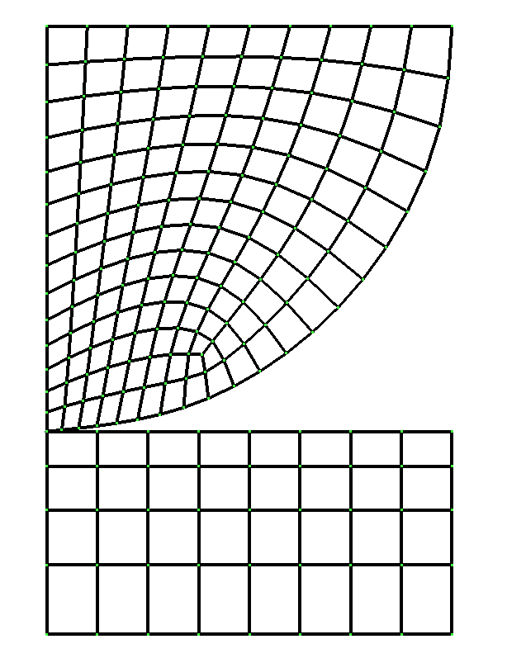

Figure 9.1.6: Hertz Contact Problem Analysis Model

(1) Verification results of contact radius

The theoretical formula to calculate the contact radius is as follows.

　　　　　　Herein, $E^{*}=E/2(1-μ^{2})$. In this calculation, the contact radius becomes a = 1.36 when pressure F = 100.

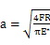

The equivalent nodal force of the point of contact is shown in Figure 9.1.7. This nodal force distribution is extrapolated to acquire the contact radius.

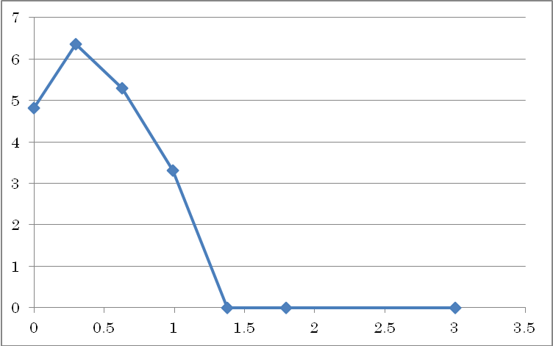

Figure 9.1.7: Equivalent Nodal Force Distribution of Contact Point

(2) Verification results of maximum shear stress

　In this theoretical solution, the maximum shear stress is $τ_{max}=0.30\sqrt{\frac{{FE}^{*}}{πR}}$ in contact position $z=0.78a$. In this calculation condition it becomes $τ_{max}=14.2$. In contrast to this, the calculation result of $τ_{max}=15.6$ was acquired.

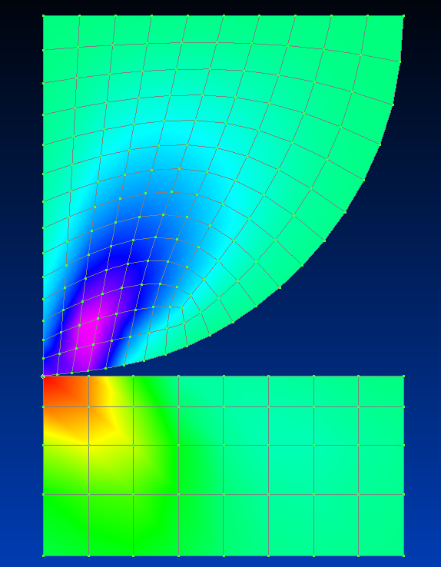

Figure 9.1.8: Shear Stress Distribution (Maximum Value = 15.6)

##### Eigenvalue analysis

The verification model of verification case exJ ~ K is the same model as in verification case exA ~ G. The conceptual diagram of the verification model is shown in Figure 9.1.9. An eigenvalue analysis for this model was implemented. The eigenvalues to be acquired are the linear - cubic eigenvalues. In addition, the iterative method solver is used in exJ, and the direct method solver is used in exK. The verifications results are shown in Table 9.1.9 ~ Table 9.1.12.

L

Figure 9.1.9: Verification Model

The vibration eigenvalue of the cantilever beam can be acquired by the following equations.

|  |  |
| --- | --- |
| Linear : | (9.1) |
| Quadratic : | (9.2) |
| Cubic : | (9.3) |

The characteristics of the verification model are as follows.

|  |  |
| --- | --- |
|  | (9.4) |

Therefore, up to a cubic eigenvalue becomes as follows.

n1 = 3.609e3

n2 = 2.262e4

n3 = 6.335e4

Table 9.1.9: exJ: Verification Results with Iterative Method (Linear Eigenvalue)

|  |  |  |  |  |
| --- | --- | --- | --- | --- |
| Case Name | No. of  Elements | Predicted Value: n1=3.609e3 | | Remarks |
| NASTRAN | FrontISTR |
| J231 | 40 | 5.861e3 | 5.861e3 | 33 nodes / plane  stress problem |
| J232 | 40 | 3.596e3 | 3.593e3 | 105 nodes / plane  stress problem |
| J241 | 20 | 3.586e3 | 4.245e3 | 33 nodes / plane  stress problem |
| J242 | 20 | 3.590e3 | 3.587e3 | 85 nodes / plane  stress problem |
| J341 | 240 | 5.442e3 | 5.429e3 | 99 nodes |
| J342 | 240 | 3.621e3 | 3.595e3 | 525 nodes |
| J351 | 80 | 3.695e3 | 4.298e3 | 99 nodes |
| J352 | 80 | 3.610e3 | 3.609e3 | 381 nodes |
| J361 | 40 | 3.679e3 | 3.619e3 | 99 nodes |
| J362 | 40 | 3.611e3 | 3.606e3 | 330 nodes |

Table 9.1.10: exJ: Verification Results with Iterative Method (Quadratic Eigenvalue)

|  |  |  |  |  |
| --- | --- | --- | --- | --- |
| Case Name | No. of  Elements | Predicted Value: n1=2.262e4 | | Remarks |
| NASTRAN | FrontISTR |
| J231 | 40 | 3.350e4 | 3.351e4 | 33 nodes / plane  stress problem |
| J232 | 40 | 2.163e4 | 2.156e4 | 105 nodes / plane  stress problem |
| J241 | 20 | 2.149e4 | 2.516e4 | 33 nodes / plane  stress problem |
| J242 | 20 | 2.149e4 | 2.143e4 | 85 nodes / plane  stress problem |
| J341 | 240 | 3.145e4 | 3.138e4 | 99 nodes |
| J342 | 240 | 2.171e4 | 2.155e4 | 525 nodes |
| J351 | 80 | 2.208e4 | 2.546e4 | 99 nodes |
| J352 | 80 | 2.156e4 | 2.149e4 | 381 nodes |
| J361 | 40 | 2.202e4 | 2.168e4 | 99 nodes |
| J362 | 40 | 2.154e4 | 2.144e4 | 330 nodes |

Note: Since the linear and quadratic eigenvalues of the 3D model have multiple roots, the value based on the cubic equation is used to describe the quadratic value in the table.

Table 9.1.11: exK: Verification Results with Direct Method (Linear Eigenvalue)

|  |  |  |  |  |
| --- | --- | --- | --- | --- |
| Case Name | No. of  Elements | Predicted Value: n1=3.609e3 | | Remarks |
| NASTRAN | FrontISTR |
| J231 | 40 | 5.861e3 | 5.861e3 | 33 nodes / plane  stress problem |
| J232 | 40 | 3.596e3 | 3.593e3 | 105 nodes / plane  stress problem |
| J241 | 20 | 3.586e3 | 4.245e3 | 33 nodes / plane  stress problem |
| J242 | 20 | 3.590e3 | 3.587e3 | 85 nodes / plane  stress problem |
| J341 | 240 | 5.442e3 | 5.429e3 | 99 nodes |
| J342 | 240 | 3.621e3 | 3.595e3 | 525 nodes |
| J351 | 80 | 3.695e3 | 4.298e3 | 99 nodes |
| J352 | 80 | 3.610e3 | 3.609e3 | 381 nodes |
| J361 | 40 | 3.679e3 | 3.619e3 | 99 nodes |
| J362 | 40 | 3.611e3 | 3.606e3 | 330 nodes |
| J731 | 40 | - | 3.606e3 | 33 nodes |
| J741 | 20 | - | 3.594e3 | 33 nodes |

Table 9.1.12: exK: Verification Results with Direct Method (Quadratic Eigenvalue)

|  |  |  |  |  |
| --- | --- | --- | --- | --- |
| Case Name | No. of  Elements | Predicted Value: n1=2.262e4 | | Remarks |
| NASTRAN | FrontISTR |
| J231 | 40 | 3.350e4 | 3.351e4 | 33 nodes / plane  stress problem |
| J232 | 40 | 2.163e4 | 2.156e4 | 105 nodes / plane  stress problem |
| J241 | 20 | 2.149e4 | 2.516e4 | 33 nodes / plane  stress problem |
| J242 | 20 | 2.149e4 | 2.143e4 | 85 nodes / plane  stress problem |
| J341 | 240 | 3.145e4 | 3.138e4 | 99 nodes |
| J342 | 240 | 2.171e4 | 2.155e4 | 525 nodes |
| J351 | 80 | 2.208e4 | 2.546e4 | 99 nodes |
| J352 | 80 | 2.156e4 | 2.149e4 | 381 nodes |
| J361 | 40 | 2.202e4 | 2.168e4 | 99 nodes |
| J362 | 40 | 2.154e4 | 2.144e4 | 330 nodes |
| J731 | 40 | - | 2.156e4 | 33 nodes |
| J741 | 20 | - | 2.153e4 | 33 nodes |

Note: Since the linear and quadratic eigenvalues of the 3D model have multiple roots, the value based on the cubic equation is used to describe the quadratic value in the table.

##### Heat conduction analysis

Conditions common to a steady heat conduction analysis are shown in Figure 9.1.10. The individual conditions of verification case exM - exT are shown in Figure 9.1.11. Mesh partitioning equivalent to that of exA was used.

Temperature distribution tables for each case of the verification results are shown in Table 9.1.13 ~ Table 9.1.20.

(Insulation)

(Insulation)



(1) Model Conceptual Diagram



(2) Mesh Partition

図断面積

Length between AB: L = 10.0m

Cross-sectional area: A = 1.0 mm2

Temperature dependency of thermal conductivity

　　Thermal conductivity λ(W/mK) Temperature (ºC)

　　　　50.0 0.

35.0 500.

20.0 1000.

Figure 9.1.10: Verification Conditions of Steady Heat Conduction Analysis

exM: Linear material



(Insulation)

(Insulation)

(Insulation)

(Insulation)

(Insulation)

(Insulation)

(Insulation)

(Insulation)

(Insulation)

(Insulation)

exN: Specified temperature problem

exO: Concentrated heat flux problem

exP: Distributed heat flux problem

exQ: Convective heat transfer problem

exR: Radiant heat transfer problem

exS: Volumetric heat generation problem

exT: Internal gap problem

Figure 9.1.11: Analysis Conditions for each Verification Case

Table 9.1.13: exM: Verification Results of Steady Calculation by Linear Material

|  |  |  |  |  |  |  |  |  |
| --- | --- | --- | --- | --- | --- | --- | --- | --- |
| Case Name | Element Type | No. of Elements / Nodes | Distance from End A (m) | | | | | |
| End A | 2.0 | 4.0 | 6.0 | 8.0 | End B |
| M361A | 361 | 40／33 | 0.0 | 100. | 200. | 300. | 400. | 500. |
| M361B | 361 | 40／105 | 0.0 | 100. | 200. | 300. | 400. | 500. |
| M361C | 361 | 20／33 | 0.0 | 100. | 200. | 300. | 400. | 500. |
| M361D | 361 | 20／85 | 0.0 | 100. | 200. | 300. | 400. | 500. |
| M361E | 361 | 240／99 | 0.0 | 100. | 200. | 300. | 400. | 500. |
| M361F | 361 | 24／525 | 0.0 | 100. | 200. | 300. | 400. | 500. |
| M361G | 361 | 80／99 | 0.0 | 100. | 200. | 300. | 400. | 500. |

Table 9.1.14: exN: Verification Results of Specified Temperature Problem

|  |  |  |  |  |  |  |  |  |
| --- | --- | --- | --- | --- | --- | --- | --- | --- |
| Case Name | Element Type | No. of Elements / Nodes | Distance from End A (m) | | | | | |
| End A | 2.0 | 4.0 | 6.0 | 8.0 | End B |
| ABAQUS | 361 | 40／99 | 0.0 | 87.3 | 179.7 | 278.2 | 384.3 | 500. |
| N231 | 231 | 40／33 | 0.0 | 87.2 | 179.5 | 278.0 | 384.1 | 500. |
| N232 | 232 | 40／105 | 0.0 | 86.0 | 178.3 | 276.8 | 382.9 | 500. |
| N241 | 241 | 20／33 | 0.0 | 87.3 | 179.7 | 278.2 | 384.3 | 500. |
| N242 | 242 | 20／85 | 0.0 | 87.3 | 179.7 | 278.2 | 384.3 | 500. |
| N341 | 341 | 240／99 | 0.0 | 87.3 | 179.7 | 278.2 | 384.3 | 500. |
| N342 | 342 | 24／525 | 0.0 | 87.9 | 179.9 | 278.0 | 383.6 | 500. |
| N351 | 351 | 80／99 | 0.0 | 87.3 | 179.7 | 278.2 | 384.3 | 500. |
| N352 | 352 | 80／381 | 0.0 | 87.3 | 179.7 | 278.2 | 384.3 | 500. |
| N361 | 361 | 40／99 | 0.0 | 87.3 | 179.7 | 278.2 | 384.3 | 500. |
| N362 | 362 | 40／330 | 0.0 | 87.3 | 179.7 | 278.2 | 384.3 | 500. |
| N731 | 731 | 40／33 | 0.0 | 87.3 | 179.7 | 278.2 | 384.3 | 500. |
| N741 | 741 | 20／33 | 0.0 | 87.3 | 179.7 | 278.2 | 384.3 | 500. |

Table 9.1.15: exO: Verification Results of Concentrated Heat Flux Problem

|  |  |  |  |  |  |  |  |  |
| --- | --- | --- | --- | --- | --- | --- | --- | --- |
| Case Name | Element Type | No. of Elements / Nodes | Distance from End A (m) | | | | | |
| End A | 2.0 | 4.0 | 6.0 | 8.0 | End B |
| ABAQUS | 361 | 40／99 | 0.0 | 103.2 | 213.7 | 333.3 | 464.8 | 612.6 |
| O231 | 231 | 40／33 | 0.0 | 103.2 | 213.7 | 333.3 | 464.8 | 612.6 |
| O232 | 232 | 40／105 | 0.0 | 103.2 | 213.7 | 333.3 | 464.8 | 612.6 |
| O241 | 241 | 20／33 | 0.0 | 103.2 | 213.7 | 333.3 | 464.8 | 612.6 |
| O242 | 242 | 20／85 | 0.0 | 103.2 | 213.7 | 333.4 | 465.2 | 618.0 |
| O341 | 341 | 240／99 | - | - | - | - | - | - |
| O342 | 342 | 24／525 | 0.0 | 104.4 | 214.9 | 334.7 | 466.3 | 614.6 |
| O351 | 351 | 80／99 | - | - | - | - | - | - |
| O352 | 352 | 80／381 | 0.0 | 103.2 | 213.7 | 333.3 | 465.0 | 624.2 |
| O361 | 361 | 40／99 | 0.0 | 103.2 | 213.7 | 333.3 | 464.8 | 612.6 |
| O362 | 362 | 40／330 | 0.0 | 103.2 | 213.7 | 333.4 | 465.5 | 623.5 |
| O731 | 731 | 40／33 | 0.0 | 103.2 | 213.7 | 333.3 | 464.8 | 612.5 |
| O741 | 741 | 20／33 | 0.0 | 103.2 | 213.7 | 333.3 | 464.8 | 612.6 |

Table 9.1.16: exP: Verification Results of Distributed Heat Flux Problem

|  |  |  |  |  |  |  |  |  |
| --- | --- | --- | --- | --- | --- | --- | --- | --- |
| Case Name | Element Type | No. of Elements / Nodes | Distance from End A (m) | | | | | |
| End A | 2.0 | 4.0 | 6.0 | 8.0 | End B |
| ABAQUS | 361 | 40／99 | 0.0 | 103.2 | 213.7 | 333.3 | 464.8 | 612.6 |
| P231 | 231 | 40／33 | 0.0 | 103.2 | 213.7 | 333.3 | 464.8 | 612.6 |
| P232 | 232 | 40／105 | 0.0 | 103.2 | 213.7 | 333.3 | 464.8 | 612.6 |
| P241 | 241 | 20／33 | 0.0 | 103.2 | 213.7 | 333.3 | 464.8 | 612.6 |
| P242 | 242 | 20／85 | 0.0 | 103.2 | 213.7 | 333.3 | 464.8 | 612.6 |
| P341 | 341 | 240／99 | - | - | - | - | - | - |
| P342 | 342 | 24／525 | 0.0 | 103.2 | 213.7 | 333.3 | 464.8 | 612.6 |
| P351 | 351 | 80／99 | - | - | - | - | - | - |
| P352 | 352 | 80／381 | 0.0 | 103.2 | 213.7 | 333.3 | 464.8 | 612.6 |
| P361 | 361 | 40／99 | 0.0 | 103.2 | 213.7 | 333.3 | 464.8 | 612.6 |
| P362 | 362 | 40／330 | 0.0 | 103.2 | 213.7 | 333.4 | 465.5 | 612.6 |
| P731 | 731 | 40／33 | 0.0 | 103.2 | 213.7 | 333.3 | 464.8 | 612.5 |
| P741 | 741 | 20／33 | 0.0 | 103.2 | 213.7 | 333.3 | 464.8 | 612.6 |

Table 9.1.17: exQ: Verification Results of Convective Heat Transfer Problem

|  |  |  |  |  |  |  |  |  |
| --- | --- | --- | --- | --- | --- | --- | --- | --- |
| Case Name | Element Type | No. of Elements / Nodes | Distance from End A (m) | | | | | |
| End A | 2.0 | 4.0 | 6.0 | 8.0 | End B |
| ABAQUS | 361 | 40／99 | 0.0 | 89.2 | 183.8 | 284.8 | 393.9 | 513.2 |
| Q231 | 231 | 40／33 | 0.0 | 89.2 | 183.8 | 284.8 | 393.9 | 513.2 |
| Q232 | 232 | 40／105 | 0.0 | 89.2 | 183.8 | 284.8 | 393.9 | 513.2 |
| Q241 | 241 | 20／33 | 0.0 | 89.2 | 183.8 | 284.8 | 393.9 | 513.2 |
| Q242 | 242 | 20／85 | 0.0 | 89.2 | 183.8 | 284.8 | 393.9 | 513.2 |
| Q341 | 341 | 240／99 | - | - | - | - | - | - |
| Q342 | 342 | 240／525 | 0.0 | 89.2 | 183.8 | 284.8 | 393.9 | 513.2 |
| Q351 | 351 | 80／99 | - | - | - | - | - | - |
| Q352 | 352 | 80／381 | 0.0 | 89.2 | 183.8 | 284.8 | 393.9 | 513.2 |
| Q361 | 361 | 40／99 | 0.0 | 89.2 | 183.8 | 284.8 | 393.9 | 513.2 |
| Q362 | 362 | 40／330 | 0.0 | 89.2 | 183.8 | 284.8 | 393.9 | 513.2 |
| Q731 | 731 | 40／33 | 0.0 | 89.2 | 183.8 | 284.8 | 393.9 | 513.2 |
| Q741 | 741 | 20／33 | 0.0 | 89.2 | 183.8 | 284.8 | 393.9 | 513.2 |

Table 9.1.18: exR: Verification Results of Radiant Heat Transfer Problem

|  |  |  |  |  |  |  |  |  |
| --- | --- | --- | --- | --- | --- | --- | --- | --- |
| Case Name | Element Type | No. of Elements / Nodes | Distance from End A (m) | | | | | |
| End A | 2.0 | 4.0 | 6.0 | 8.0 | End B |
| ABAQUS | 361 | 40／99 | 0.0 | 89.5 | 184.4 | 285.8 | 395.3 | 515.2 |
| R231 | 231 | 40／33 | 0.0 | 89.5 | 184.4 | 285.8 | 395.3 | 515.2 |
| R232 | 232 | 40／105 | 0.0 | 89.5 | 184.4 | 285.8 | 395.3 | 515.2 |
| R241 | 241 | 20／33 | 0.0 | 89.5 | 184.4 | 285.8 | 395.3 | 515.2 |
| R242 | 242 | 20／85 | 0.0 | 89.5 | 184.4 | 285.8 | 395.3 | 515.2 |
| R341 | 341 | 240／99 | - | - | - | - | - | - |
| R342 | 342 | 240／525 | 0.0 | 89.5 | 184.4 | 285.8 | 395.3 | 515.2 |
| R351 | 351 | 80／99 | - | - | - | - | - | - |
| R352 | 352 | 80／381 | 0.0 | 89.5 | 184.4 | 285.8 | 395.3 | 515.2 |
| R361 | 361 | 40／99 | 0.0 | 89.5 | 184.4 | 285.8 | 395.3 | 515.2 |
| R362 | 362 | 40／330 | 0.0 | 89.5 | 184.4 | 285.8 | 395.3 | 515.2 |
| R731 | 731 | 40／33 | 0.0 | 89.5 | 184.4 | 285.8 | 395.3 | 515.2 |
| R741 | 741 | 20／33 | 0.0 | 89.5 | 184.4 | 285.8 | 395.3 | 515.2 |

Table 9.1.19: exS: Verification Results of Volumetric Heat Generation Problem

|  |  |  |  |  |  |  |  |  |
| --- | --- | --- | --- | --- | --- | --- | --- | --- |
| Case Name | Element Type | No. of Elements / Nodes | Distance from End A (m) | | | | | |
| End A | 2.0 | 4.0 | 6.0 | 8.0 | End B |
| ABAQUS | 361 | 40／99 | 0.0 | 103.2 | 213.7 | 333.3 | 464.8 | 612.6 |
| S231 | 231 | 40／33 | 0.0 | 103.2 | 213.7 | 333.3 | 464.8 | 612.6 |
| S232 | 232 | 40／105 | 0.0 | 103.2 | 213.7 | 333.3 | 464.8 | 612.6 |
| S241 | 241 | 20／33 | 0.0 | 103.2 | 213.7 | 333.3 | 464.8 | 612.6 |
| S242 | 242 | 20／85 | 0.0 | 103.2 | 213.7 | 333.3 | 464.8 | 612.6 |
| S341 | 341 | 240／99 | - | - | - | - | - | - |
| S342 | 342 | 24／525 | 0.0 | 103.2 | 213.7 | 333.3 | 464.8 | 612.6 |
| S351 | 351 | 80／99 | - | - | - | - | - | - |
| S352 | 352 | 80／381 | 0.0 | 103.2 | 213.7 | 333.3 | 464.8 | 612.6 |
| S361 | 361 | 40／99 | 0.0 | 103.2 | 213.7 | 333.3 | 464.8 | 612.6 |
| S362 | 362 | 40／330 | 0.0 | 103.2 | 213.7 | 333.3 | 464.8 | 612.6 |
| S731 | 731 | 40／33 | 0.0 | 103.2 | 213.7 | 333.3 | 464.8 | 612.6 |
| S741 | 741 | 20／33 | 0.0 | 103.2 | 213.7 | 333.3 | 464.8 | 612.6 |

Table 9.1.20: exT: Verification Results of Internal Gap Problem

|  |  |  |  |  |  |  |  |  |
| --- | --- | --- | --- | --- | --- | --- | --- | --- |
| Case Name | Element Type | No. of Elements / Nodes | Distance from End A (m) | | | | | |
| End A | 2.0 | 4.0 | 6.0 | 8.0 | End B |
| ABAQUS | 361 | 40／99 | 0.0 | 88.6 | 182.4 | 282.6 | 387.7 | 500.0 |
| T231 | 231 | 40／33 | 0.0 | 88.6 | 182.4 | 282.6 | 387.7 | 500.0 |
| T232 | 232 | 40／105 | 0.0 | 88.6 | 182.4 | 282.6 | 387.7 | 500.0 |
| T241 | 241 | 20／33 | 0.0 | 88.6 | 182.4 | 282.6 | 387.7 | 500.0 |
| T242 | 242 | 20／85 | 0.0 | 88.6 | 182.4 | 282.6 | 387.7 | 500.0 |
| T341 | 341 | 240／99 | - | - | - | - | - | - |
| T342 | 342 | 24／525 | 0.0 | 88.6 | 182.4 | 282.6 | 387.7 | 500.0 |
| T351 | 351 | 80／99 | - | - | - | - | - | - |
| T352 | 352 | 80／381 | 0.0 | 88.6 | 182.4 | 282.6 | 387.7 | 500.0 |
| T361 | 361 | 40／99 | 0.0 | 88.6 | 182.4 | 282.6 | 387.7 | 500.0 |
| T362 | 362 | 40／330 | 0.0 | 88.6 | 182.4 | 282.6 | 387.7 | 500.0 |
| T731 | 731 | 40／33 | 0.0 | 88.6 | 182.4 | 282.6 | 387.7 | 500.0 |
| T741 | 741 | 20／33 | 0.0 | 88.6 | 182.4 | 282.6 | 387.7 | 500.0 |

##### Linear dynamic analysis

In exW, the same cantilever beam as in item (1) was used as the subject to perform the linear dynamic analysis. The verification conditions are shown in Figure 9.1.12. In this verification, the affects in which the time increments may have on the results for the same mesh partition was verified. As a dynamic analysis method, both the implicit method and the explicit method were used, and element types 361 and 342 were used. The verification results are shown in Table 9.1.22 and Figure 9.1.13 ~ Figure 9.1.15.



Analysis Model



Time History of External Force F

Theoretical solution of vibration point displacement:



Figure 9.1.12: Verification Conditions of Linear Dynamic Analysis

Verification conditions:

Length L 10.0 mm

Cross-sectional width a 1.0 mm

Cross-sectional height b 1.0 mm

Young's Modulus E 4000.0 kgf /mm2

Poisson's Ratio ν 0.3

Density ρ 1.0E-09 kgfs2/mm3

Gravitational acceleration g 9800.0 mm/s2

External force F0 1.0 kgf

Element Hexahedral linear element

Tetrahedral quadratic element

Solution Implicit method

Parameterγof Newmark-βmethod　　 1/2

Parameterβof Newmark-βmethod　 　1/4

Explicit method

Damping N/A

Table 9.1.21: Verification Conditions of Linear Dynamic Analysis (Continued)

|  |  |  |  |  |  |
| --- | --- | --- | --- | --- | --- |
| Case Name | Element Type | No. of Nodes | No. of Elements | Solution | Time Increment  Δt(s) |
| W361_c0_im_m2_t1 | 361 | 99 | 40 | Implicit method | 1.0E-06 |
| W361_c0_im_m2_t2 | 361 | 99 | 40 | Implicit method | 1.0E-05 |
| W361_c0_im_m2_t3 | 361 | 99 | 40 | Implicit method | 1.0E-04 |
| W361_c0_ex_m2_t1 | 361 | 99 | 40 | Explicit method | 1.0E-08 |
| W361_c0_ex_m2_t2 | 361 | 99 | 40 | Explicit method | 1.0E-07 |
| W361_c0_ex_m2_t3 | 361 | 99 | 40 | Explicit method | 1.0E-06 |
| W342_c0_im_m2_t1 | 342 | 525 | 240 | Implicit method | 1.0E-06 |
| W342_c0_im_m2_t2 | 342 | 525 | 240 | Implicit method | 1.0E-05 |
| W342_c0_im_m2_t3 | 342 | 525 | 240 | Implicit method | 1.0E-04 |
| W342_c0_ex_m2_t1 | 342 | 525 | 240 | Explicit method | 1.0E-08 |
| W342_c0_ex_m2_t2 | 342 | 525 | 240 | Explicit method | 5.0E-08 |
| W342_c0_ex_m2_t3 | 342 | 525 | 240 | Explicit method | 1.0E-07 |

Table 9.1.22: exW: Verification Results of Linear Dynamic Analysis for Cantilever Beam

|  |  |  |  |  |  |  |
| --- | --- | --- | --- | --- | --- | --- |
| Case Name | Element Type | No. of Nodes | No. of Elements | Solution | z Direction Displacement: uz (mm) when Time t = 0.002 (s) | |
| Theoretical Solution Repeated to Sextic Equation | FrontISTR |
| W361_c0_im_m2_t1 | 361 | 99 | 40 | Implicit method | 1.9753 | 1.9302 |
| W361_c0_im_m2_t2 | 361 | 99 | 40 | Implicit method | 1.9753 | 1.8686 |
| W361_c0_im_m2_t3 | 361 | 99 | 40 | Implicit method | 1.9753 | 0.3794 |
| W361_c0_ex_m2_t1 | 361 | 99 | 40 | Explicit method | 1.9753 | 1.9302 |
| W361_c0_ex_m2_t2 | 361 | 99 | 40 | Explicit method | 1.9753 | 1.9247 |
| W361_c0_ex_m2_t3 | 361 | 99 | 40 | Explicit method | 1.9753 | Divergence |
| W342_c0_im_m2_t1 | 342 | 525 | 240 | Implicit method | 1.9753 | 1.9431 |
| W342_c0_im_m2_t2 | 342 | 525 | 240 | Implicit method | 1.9753 | 1.8719 |
| W342_c0_im_m2_t3 | 342 | 525 | 240 | Implicit method | 1.9753 | 0.3873 |
| W342_c0_ex_m2_t1 | 342 | 525 | 240 | Explicit method | 1.9753 | 1.9359 |
| W342_c0_ex_m2_t2 | 342 | 525 | 240 | Explicit method | 1.9753 | 1.9358 |
| W342_c0_ex_m2_t3 | 342 | 525 | 240 | Explicit method | 1.9753 | Divergence |

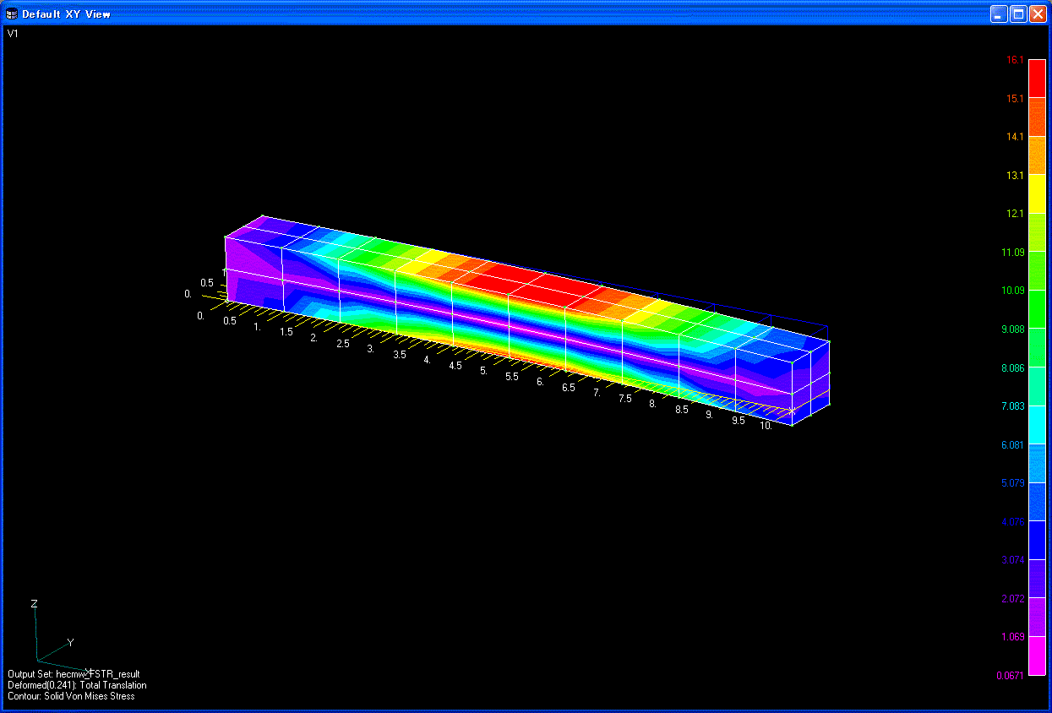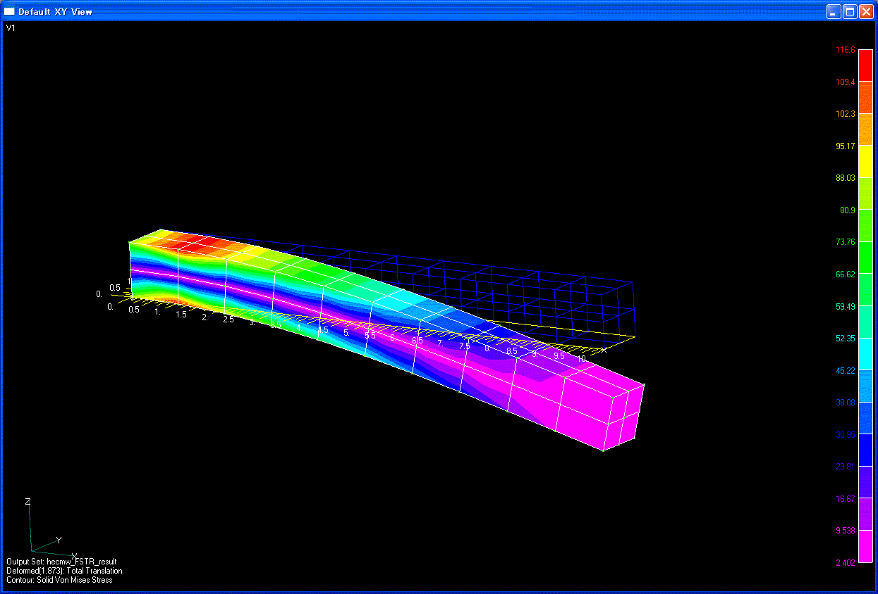

(a) t=2.0E-03(s)　　　　　　　　　　　　　　　　　(b) t=4.0E-03(s)

Figure 9.1.13: Deformed Figure and Equivalent Stress Distribution of Cantilever Beam (W361_c0_im_m2_t2)

Theoretical Solution

(to Sextic)

Implicit Method m2_t2

Implicit Method m2_t1

Implicit Method m2_t3



(a)　 Element Type 361: Implicit method

Theoretical Solution (to Sextic)

Implicit Method m2_t2

Implicit Method m2_t1

Implicit Method m2_t3



(b)　 Element Type 361: Explicit method

Figure 9.1.14: Time History of Vibration Point Displacement uz

Theoretical Solution

(to Sextic)

Implicit Method m2_t2

Implicit Method m2_t1

Implicit Method m2_t3



(a)　 Element Type 342: Implicit method

Theoretical Solution

(to Sextic)

Implicit Method m2_t2

Implicit Method m2_t1

Implicit Method m2_t3



(b)　 Element Type 342: Explicit method

Figure 9.1.15: Time History of Vibration Point Displacement uz

##### Frequency Response Analysis

A cantilever beam was used for the verification and validation of frequency response analayis.The results were compared with those of ABAQUS. The analysis model and boundary conditions are shown below.

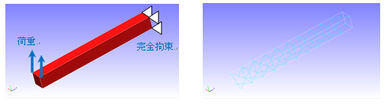

Constraints

Load

Analysis model (Element type= 341, Number of Elements:126, Number of Nodes: 55)

Analysis conditions：

Young’s modulus E 210000 N/mm2

Poisson’s ratio ν 0.3

Density ρ 7.89E-09t/mm3

Gravity g 9800.0 mm/s2

Applied force F0 1.0 N

Rayleigh damping parameter Rm 0.0

Rayleigh damping parameter Rk 7.2E-07

　Eigenvalue upto 5th mode obtained by eigenvalue analysis are listed below.

|  |  |  |
| --- | --- | --- |
| mode | FrontISTR | ABAQUS |
| 1 | 14952 | 14952 |
| 2 | 15002 | 15003 |
| 3 | 84604 | 84539 |
| 4 | 84771 | 84697 |
| 5 | 127054 | 126852 |

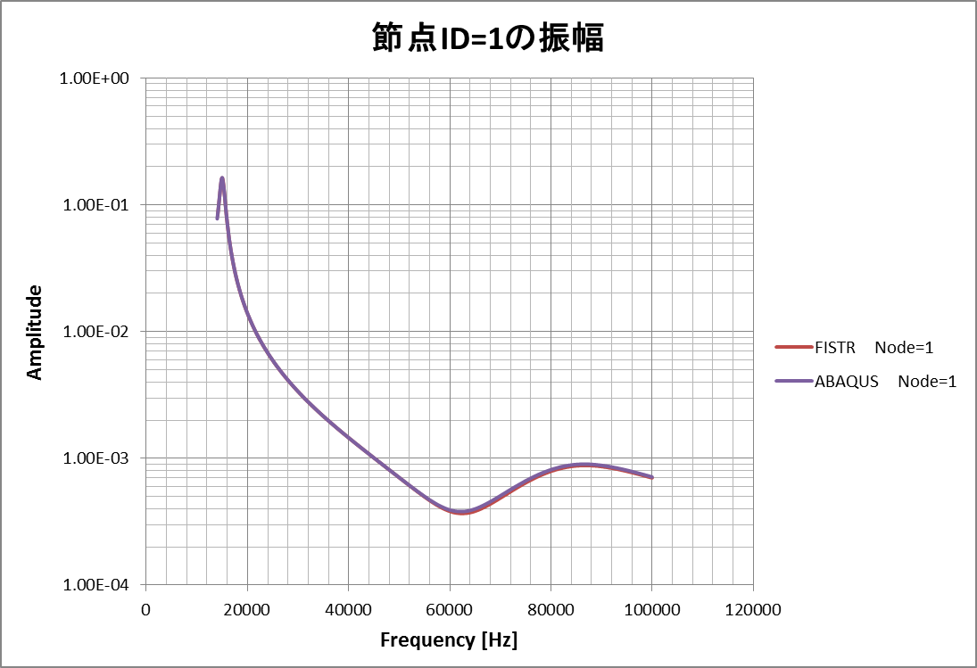

Amplitude of displacement at a monitoring node

Fig. 9.1.16 : Frequency dependency of the displacement amplitude at loaded point

## Example of Actual Model for Elastic Static Analysis

### Analysis Model

A list of an actual model verification example for the elastic static analysis is shown in Table 9.2.1. The shape of the model (portions excluded) is shown in Figure 9.2.1 ~ Figure 9.2.5. In order to execute an example of element type 731 and 741, a separate direct method solver is required.

Table 9.2.1: Example of Actual Model Verification for Elastic Static Analysis

|  |  |  |  |  |
| --- | --- | --- | --- | --- |
| Case  Name | Element  Type | Verification Model | No. of  Nodes | No. of Degrees  of Freedom |
| EX01A | 342 | Connecting rod  (100,000 nodes) | 94,074 | 282,222 |
| EX01B | 342 | Connecting rod  (330,000 nodes) | 331,142 | 993,426 |
| EX02 | 361 | Block with hole | 37,386 | 112,158 |
| EX03 | 342 | Turbine blade | 10,095 | 30,285 |
| EX04 | 741 | Cylindrical shell | 10,100 | 60,600 |
| EX05A | 731 | Wine glass (coarse) | 7,240 | 43,440 |
| EX05B | 731 | Wine glass (medium) | 48,803 | 292,818 |
| EX05C | 731 | Wine glass (fine) | 100,602 | 603,612 |



Figure 9.2.1: Connecting Rod (EX01A)



Figure 9.2.2: Block with Hole (EX02)



Figure 9.2.3: Turbine Blade (EX03, EX06)



Figure 9.2.4: Cylindrical Shell (EX04, EX09)



Figure 9.2.5: Wine Glass (EX05, EX10A)

### Analysis Results

#### Example of Analysis Results

An example of the analysis results is shown in Figure 9.2.6 ~ Figure 9.2.9.

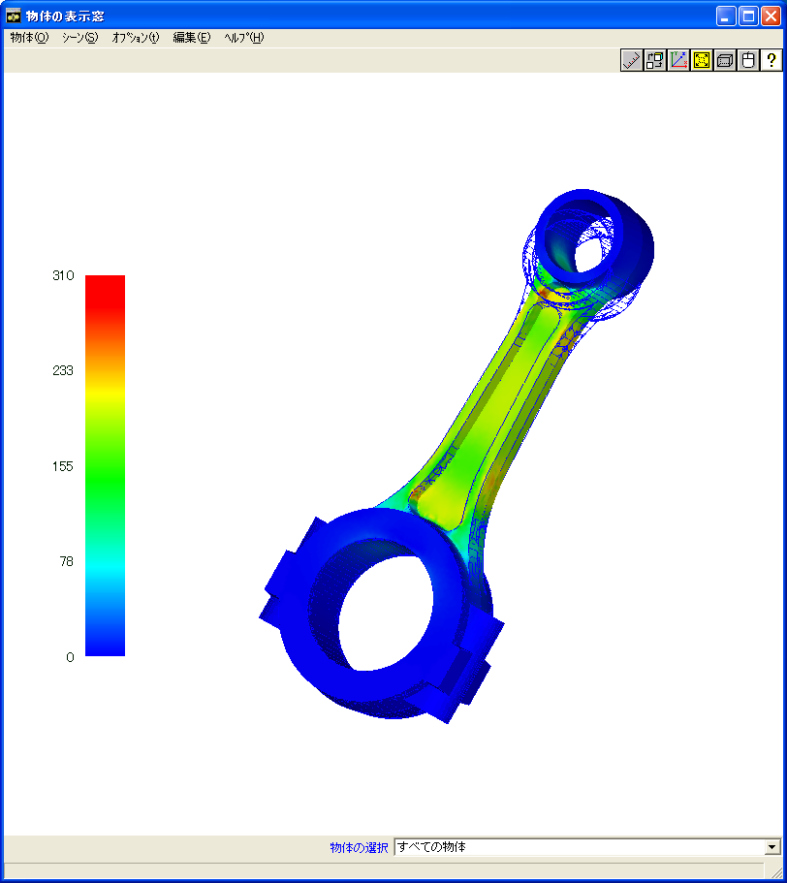

Figure 9.2.6: EX01A Analysis Results (Mises Stress and Deformed Figure (10 times))

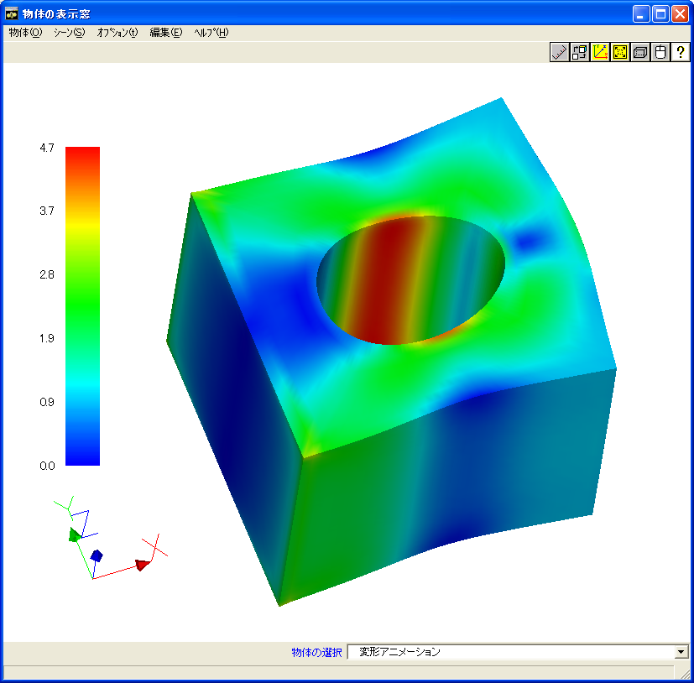

Figure 9.2.7: EX02 Analysis Results (Mises Stress and Deformed Figure (100 times))

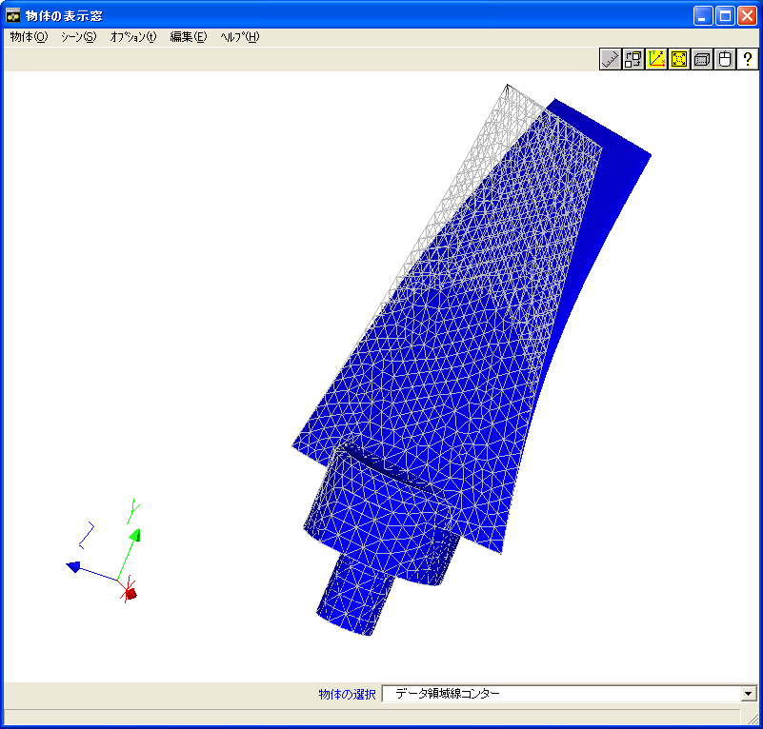

Figure 9.2.8: EX03 Analysis Results (Deformed Figure (10 times))

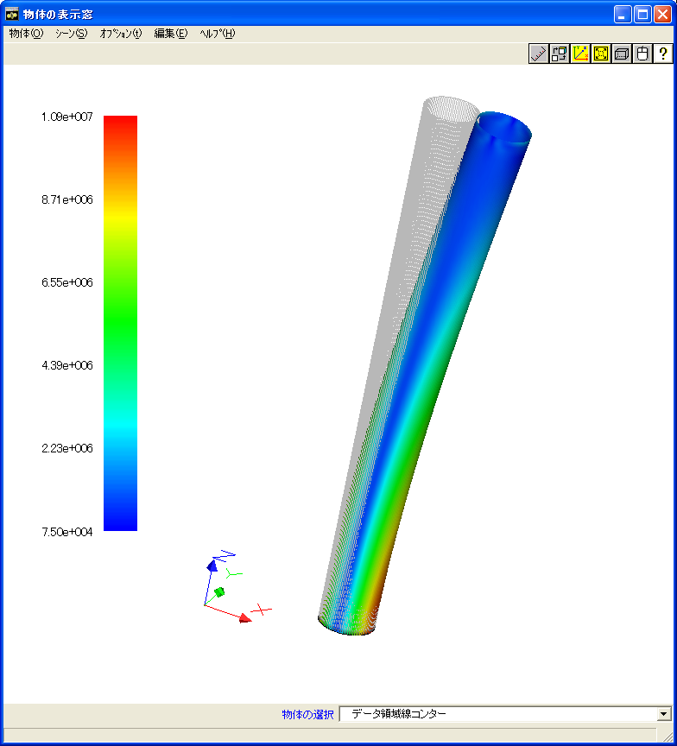

Figure 9.2.9: EX04 Analysis Results (Deformed Figure (100 times))

#### Verification Results of Analysis Performance by Verification Example EX02

An equivalent block model with a hole as in verification example EX02 was used to perform the analysis by general purpose commercial software ABAQUS. The maximum and minimum comparison results of FrontISTR and the stress component are shown in Figure 9.2.10. This figure shows that the stress component is extremely coherent.

Next, the results of investigating the affects of domain partitioning in the stress distribution are shown. The domain partitioning was performed according to the RCB method, and X, Y and Z were partitioned into two in each axial direction, and the overall model was partitioned into 8 domains. The partitioned state is shown in Figure 9.2.11. The stress distribution in the analysis results of a single domain model and a model partitioned into eight domains is shown in Figure 9.2.12.



Figure 9.2.10: Comparison of Stress Component with General Purpose Software in EX02

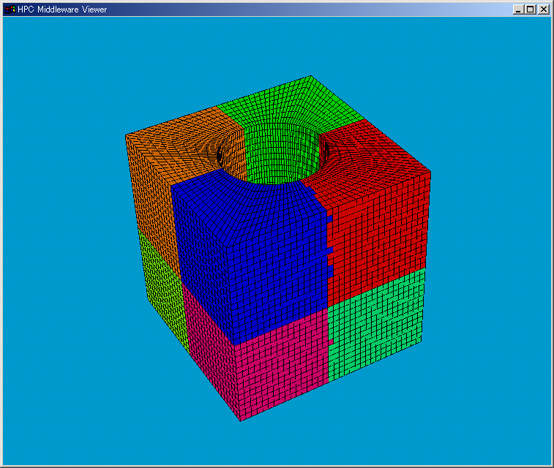

Figure 9.2.11: Eight Domain Partitioned Results of EX02 by RCB Method

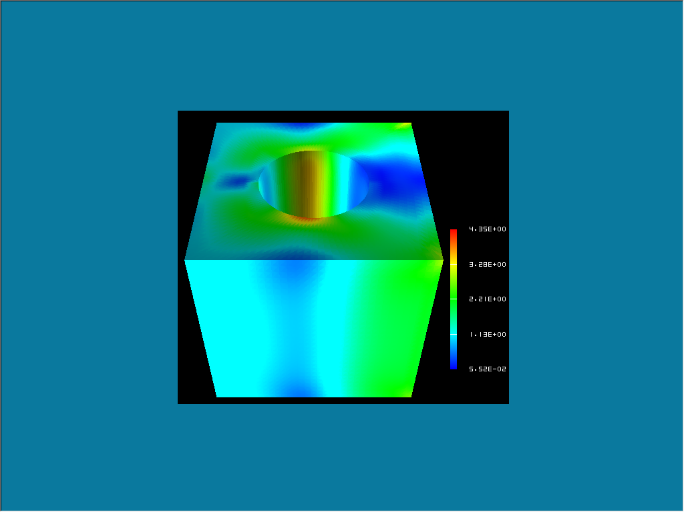

(a) Single Domain Model



(b) Eight Domain Partitioned Model

Figure 9.2.12: Difference of Mises Stress Distribution by Domain Partitioning

Figure 9.2.12 shows no difference between both models, and it is clear that both models are in complete agreement.

Next, the comparison results of the execution time by setting the HEC-MW solver is shown in Table 9.2.2. The convergence history to the solution is shown in Figure 9.2.13.

Table 9.2.2: Comparison of Execution Time by HEC-MW Solver

|  |  |
| --- | --- |
| Solver | Execution Time (s) |
| CGI | 38.79 |
| CGscale | 52.75 |
| BCGS | 60.79 |
| CG8 | 6.65 |

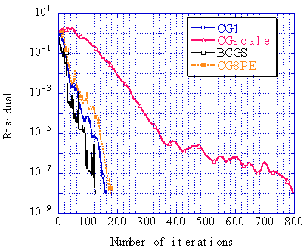

Figure 9.2.13: Comparison of Convergence History by HEC-MW Solver

(Convergence judgment threshold: 1.0x10-8)

#### Comparison of Computing Time by Verification Example EX01A

Verification example EX01A (connecting rod) was used to verify the acceleration rate of the calculating speed by domain partitioning. A Xeon 2.8 GHz 24 node cluster computing system was used for the calculations. The results are shown in Figure 9.2.14. In this figure, it is clear that the calculating speed accelerated in proportion to the number of domains.

The difference in the computing time by the environment of the computing system was also examined. The results are shown in Table 9.2.3.



Figure 9.2.14: Accelerating Effectiveness by Domain Partitioning

Table 9.2.3: Comparison of Computing Time by Computing System (1 CPU)



## Example of Actual Model for Eigenvalue Analysis

### Analysis Model

A list of the verification examples of an actual model for the eigenvalue analysis is shown in Table 9.3.1. Among these models, the shapes of the model of EX07 (turbine rotor) and EX08 (spring) are shown in Figure 9.3.1 and Figure 9.3.2. The same shapes as in the verification example for the elastic static analysis where the verification contents are the same is used for the shape of the other models, and is already shown in the above. In order to execute an example of element type 731 and 741, a separate direct method solver is required.

Table 9.3.1: Verification Example of Actual Model for Eigenvalue Analysis

|  |  |  |  |  |
| --- | --- | --- | --- | --- |
| Case  Name | Element  Type | Verification Model | No. of  Nodes | No. of Degrees  of Freedom |
| EX06 | 342 | Turbine blade | 10,095 | 30,285 |
| EX07 | 361 | Turbine rotor | 127,440 | 382,320 |
| EX08 | 342 | Spring | 78,771 | 236,313 |
| EX09 | 741 | Cylindrical shell | 10,100 | 60,600 |
| EX10A | 731 | Wine glass (coarse) | 7,240 | 43,440 |
| EX10B | 731 | Wine glass (medium) | 48,803 | 292,818 |



Figure 9.3.1: Turbine Rotor (EX07)



Figure 9.3.2: Spring (EX08)

### Analysis Results

The vibration mode and natural frequency are shown in the following.

##### EX06 Turbine blade

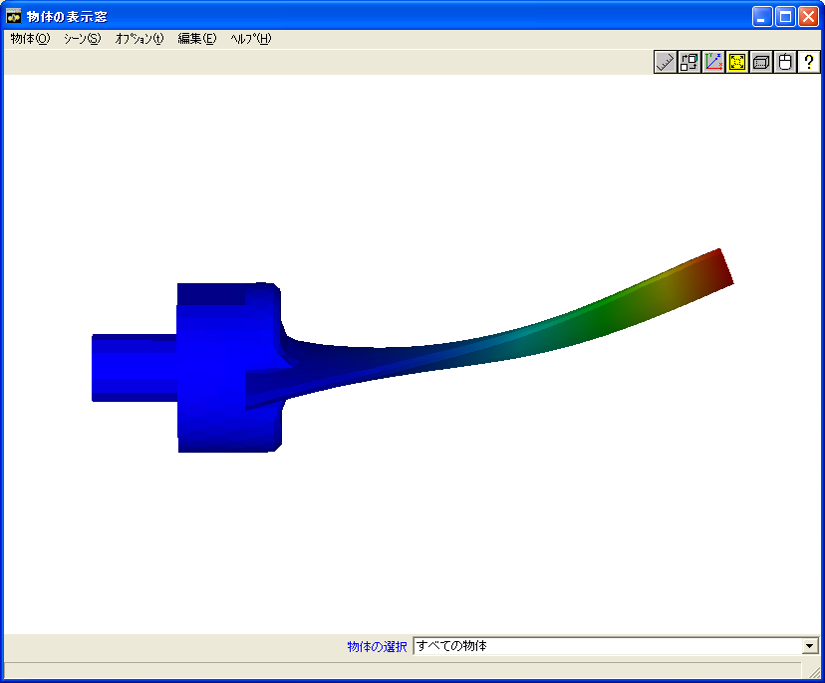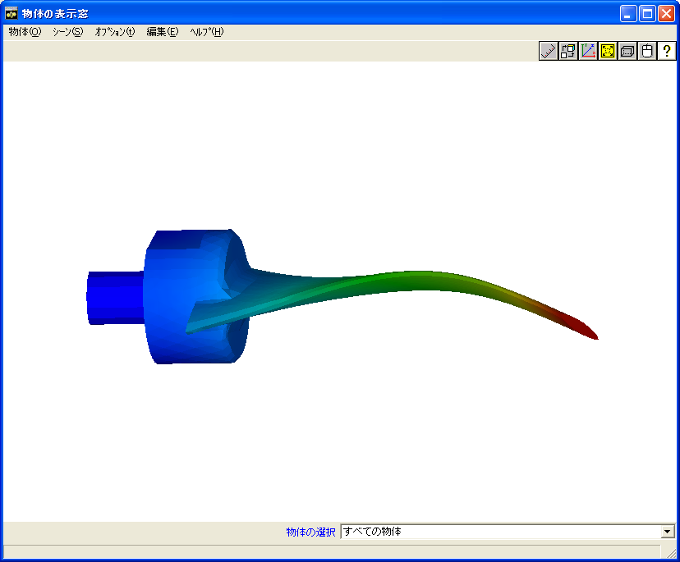

(a) Mode 1 (1170 kHz) 　　(b) Mode 2（3250kHz）

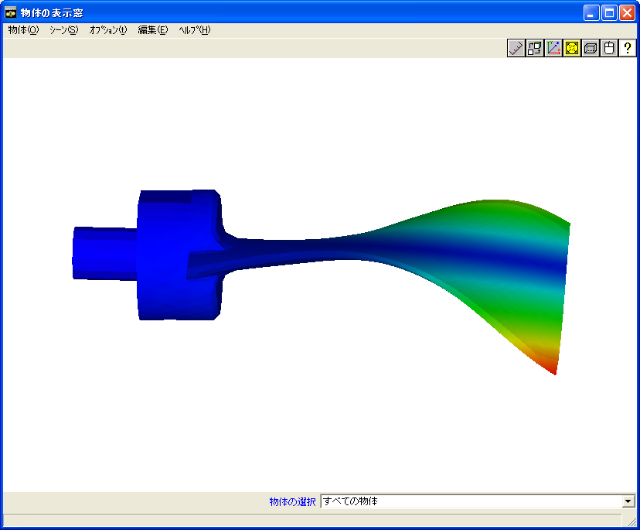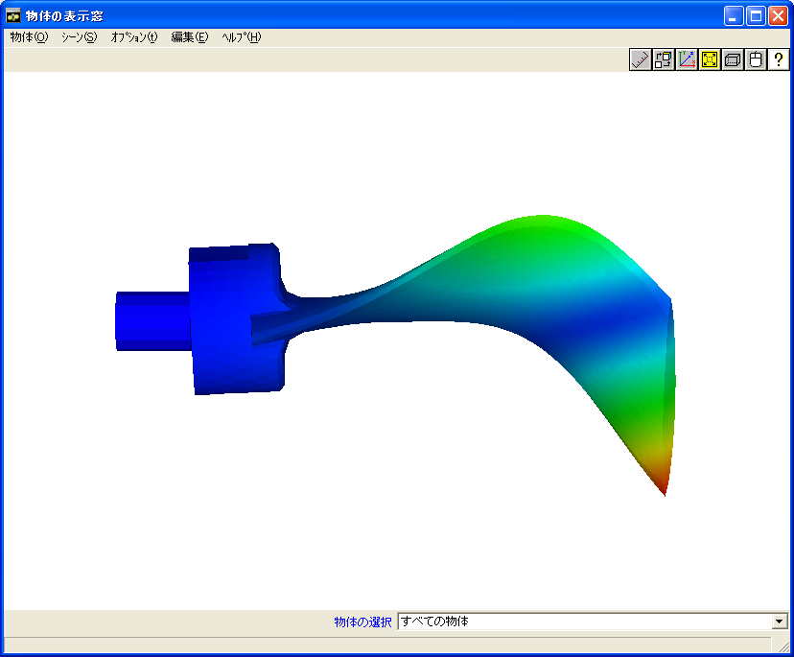

(c) Mode 3（4130kHz） 　　(d) Mode 4（4140kHz）

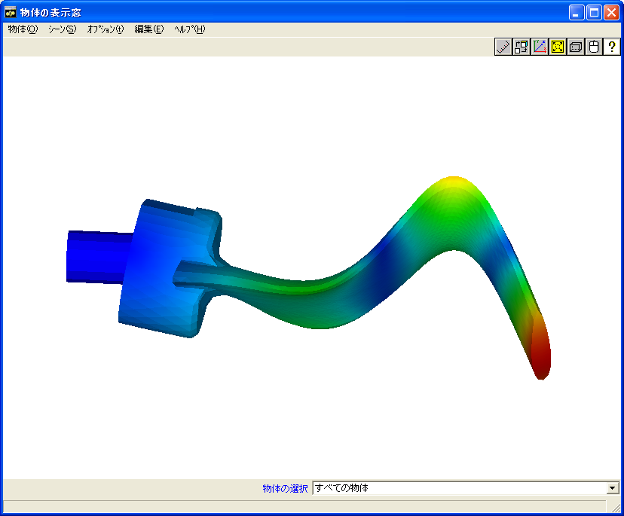

(e) Mode 5（8210kHz）

Figure 9.3.3: EX06 Turbine Blade Vibration Mode

##### EX07 Turbine rotor

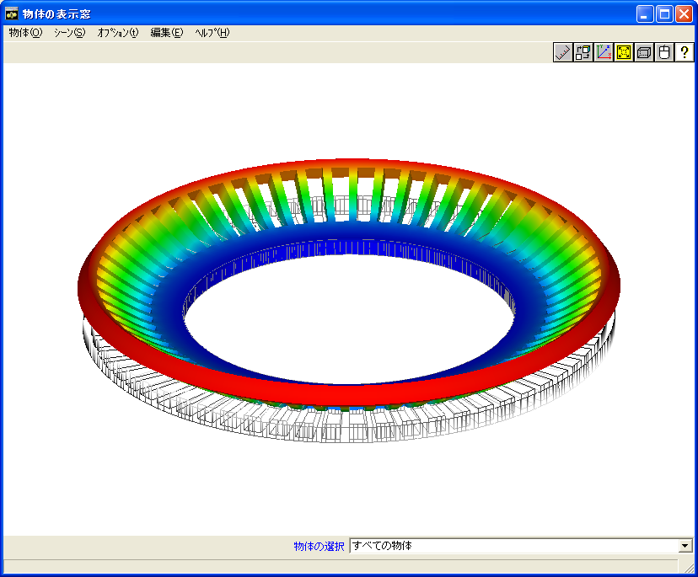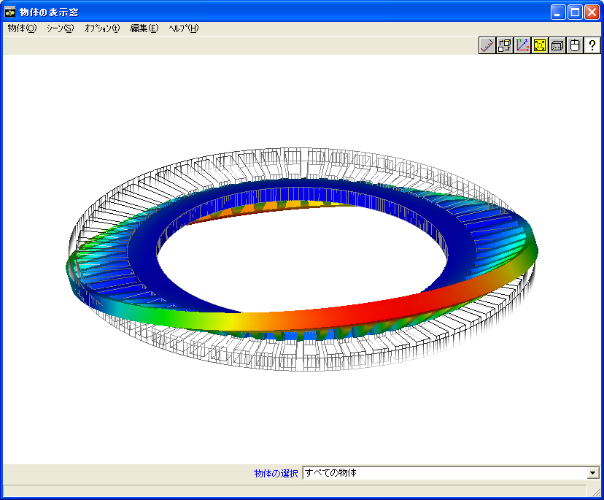

(a) Mode 1（1067Hz） 　　(b) Mode 2（1072Hz）

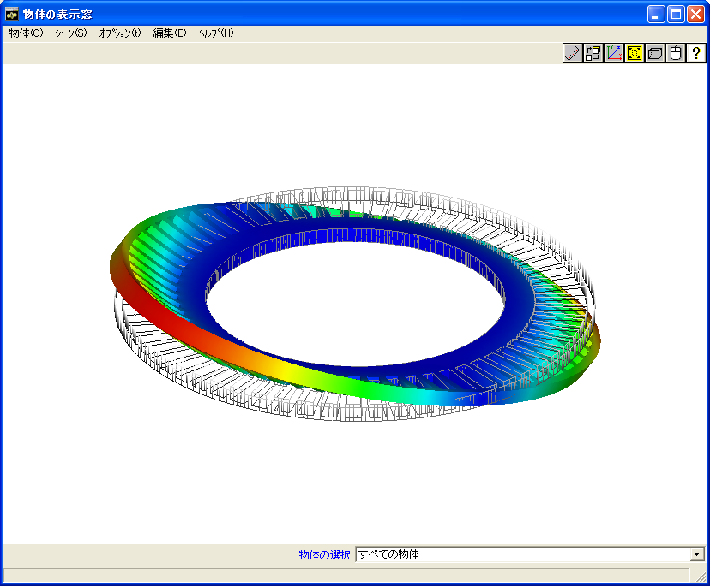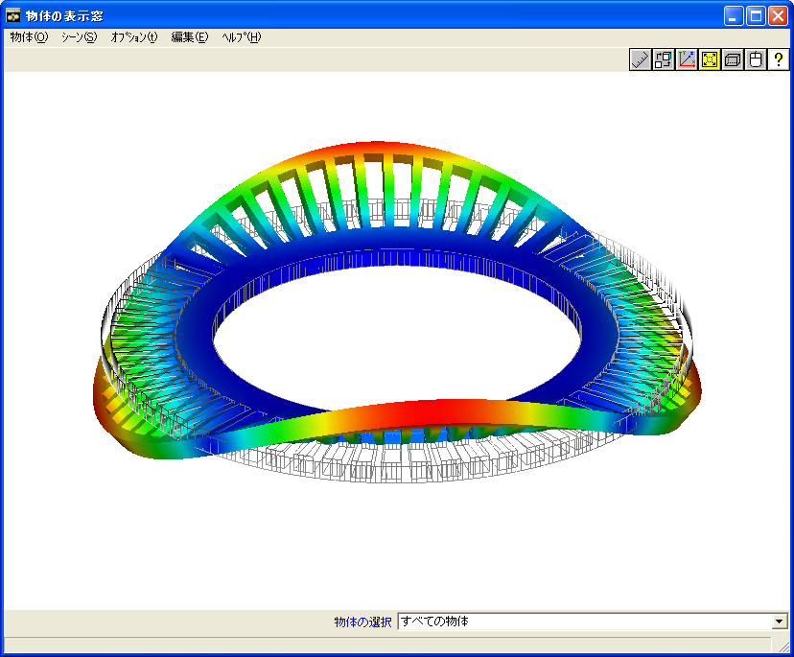

(c) Mode 3（1072Hz） 　　(d) Mode 4（1093Hz）

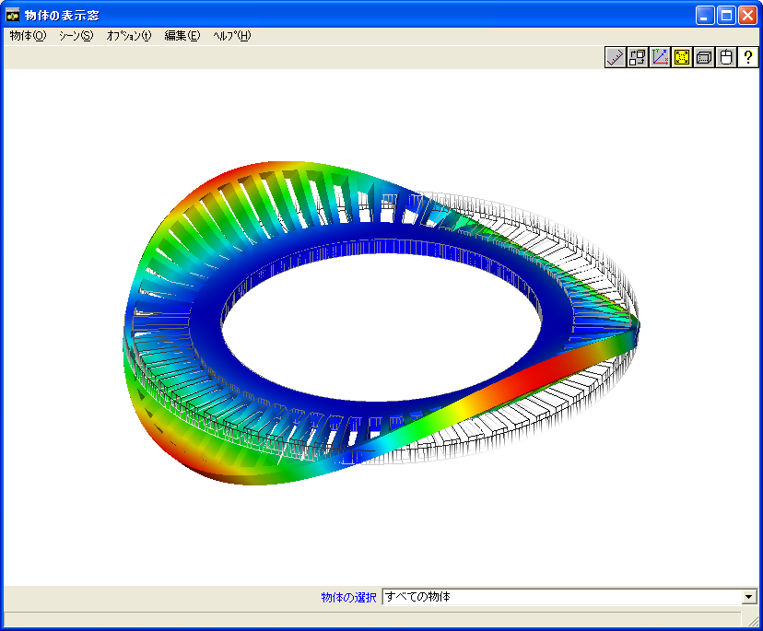

(e) Mode 5（1093Hz）

Figure 9.3.4: EX07 Turbine Rotor Vibration Mode

##### EX08 Spring

Mode 1 (445 Hz)

Mode 2 (446 Hz)

Mode 3 (908 Hz)

Mode 4 (985 Hz)

Mode 5 (1810 Hz)

Vibration Eigenvalue



Figure 9.3.5: EX08 Spring Vibration Mode

##### EX09 Cylindrical shell

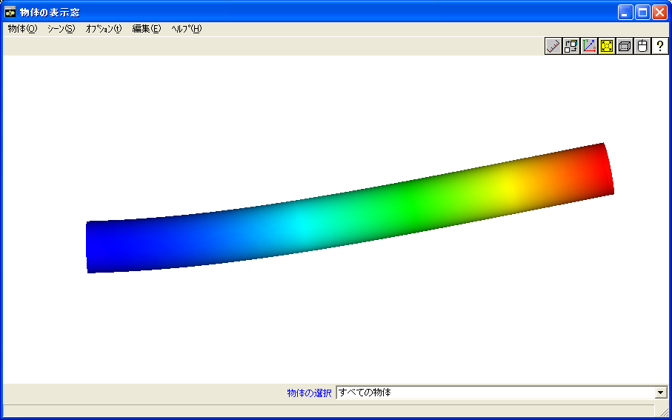

(a) Mode 1,2（109Hz）

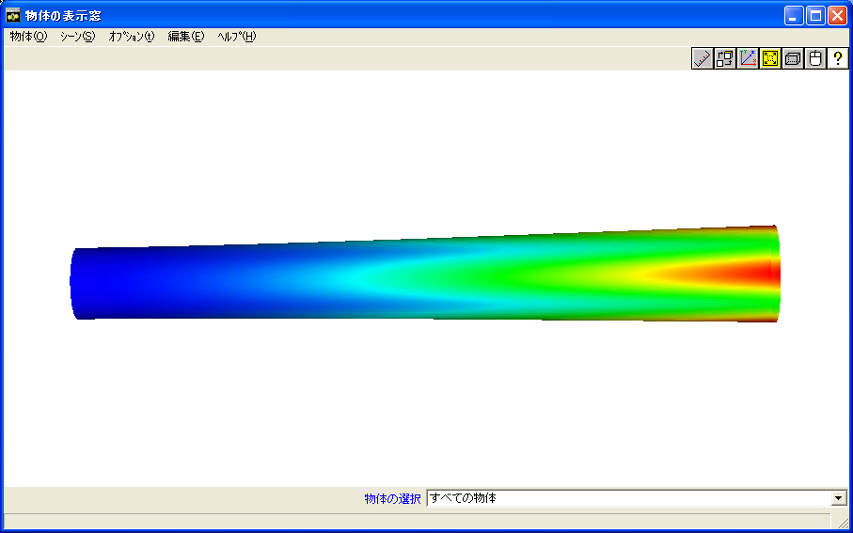

(b) Mode 3,4（570Hz）

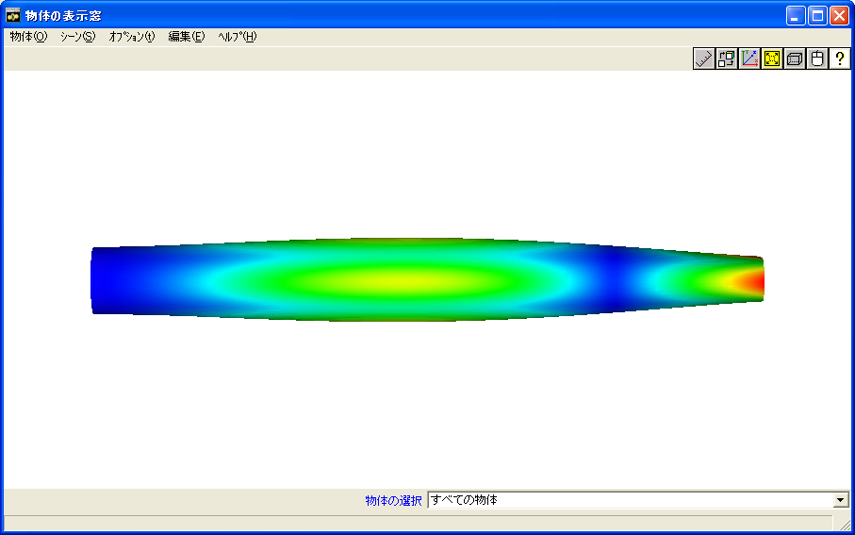

(c) Mode 5（615Hz）

Figure 9.3.6: EX09 Cylindrical Shell Vibration Mode

##### EX10A Wine glass

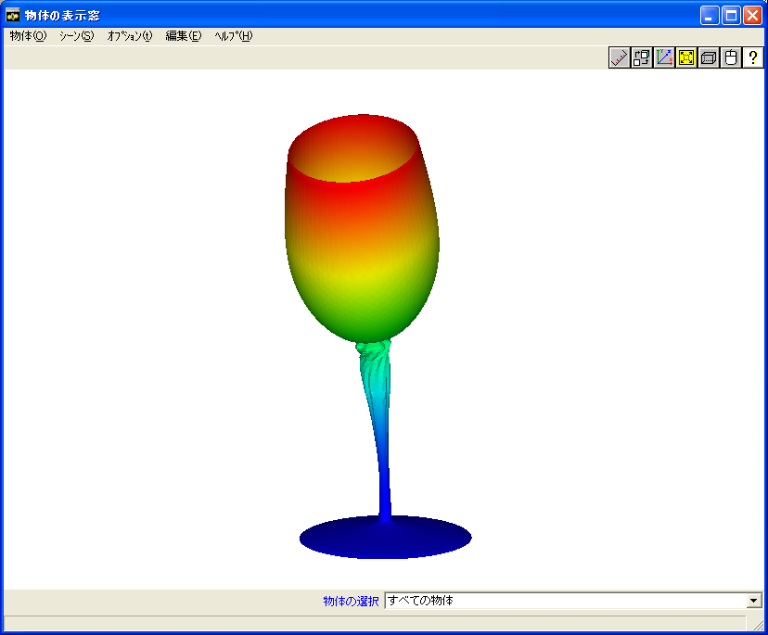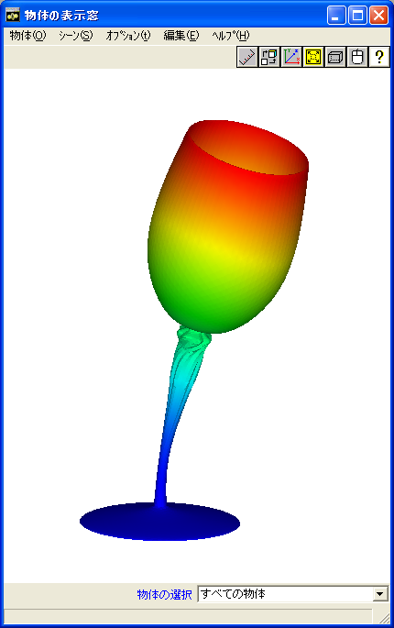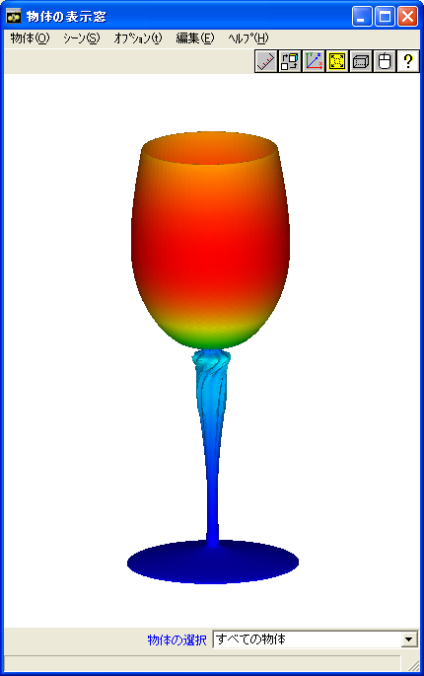

(a) Mode 1（101Hz） (b) Mode 2（102Hz） (c) Mode 3（354Hz）

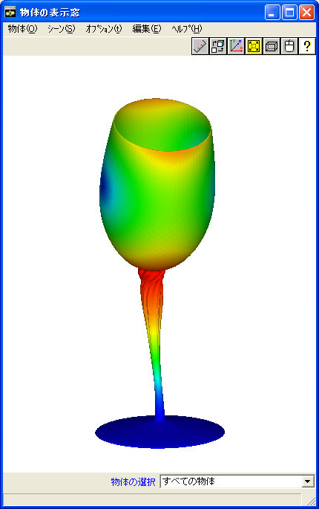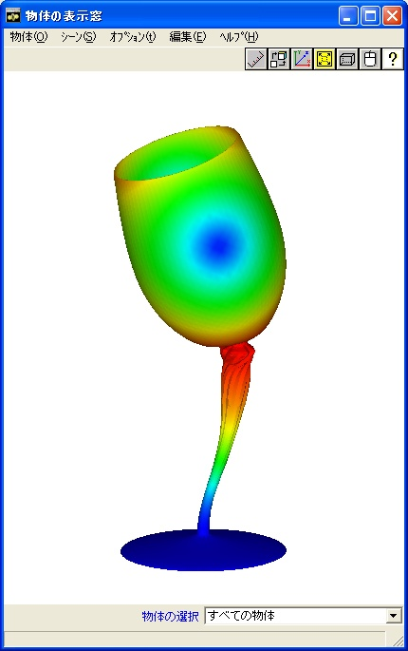

(d) Mode 4（1335Hz） (e) Mode 5（1336Hz）

Figure 9.3.7: EX10A Wine Glass Vibration Mode

## Example of Actual Model for Heat Conduction Analysis

### Analysis Model

In heat conduction analysis, a spent nuclear fuel shipping container was used as the actual model. A verification example of three types of actual models where the roughness of the mesh was changed was used for verification. A list is shown in Table 9.4.1. The shape of the models is shown in Figure 9.4.1 ~ Figure 9.4.4.

Table 9.4.1: Verification Example of Actual Model for Heat Conduction Analysis

|  |  |  |  |  |
| --- | --- | --- | --- | --- |
| Case  Name | Element  Type | Verification Model | No. of  Nodes | No. of Degrees  of Freedom |
| EX21A | 361 | Spent nuclear fuel shipping container | 88,938 | 79,920 |
| EX21B | 361 | 309,941 | 289,800 |
| EX21C | 361 | 1,205,765 | 1,159,200 |

Upper buffer

Basket upper spacers

O-ring

Vent valve

PWR fuel basket

Skirt support ring

Fuel assembly (PWR)

Fin structure ring

Neutron shield

(Silicon rubber)

Radiation fins

Basket lower spacer

Drain valve

Lower buffer

Cover

Upper trunnion

Inner casing

Gamma ray shield (lead)

Outer casing

Bottom plate

Lower trunnion

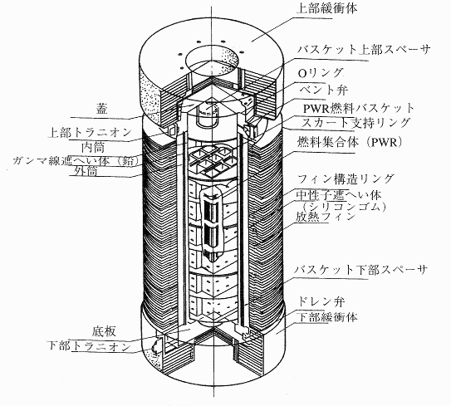

Figure 9.4.1: Spent Nuclear Fuel Shipping Container

Reference: *Transport Engineering of Nuclear Fuel Materials* (Nikkan Kogyo Shimbun) 1998

(Cavity Effective Length)

(Cavity Diameter)

|  |  |
| --- | --- |
| No. | Name |
| 1 | Inner Casing |
| 2 | Gamma Ray Shield |
| 3 | Outer Casing |
| 4 | Top End |
| 5 | Bottom Plate |
| 6 | Cover |
| 7 | Cover Clamping Bolts |
| 8 | Fin Structure Ring |
| 9 | Radiation Fans |
| 10 | Neutron Shield |
| 11 | Neutron Shield Heat Insulating Material |
| 12 | Upper Heat Insulating Material |
| 13 | Vent Valve |
| 14 | Drain Valve |
| 15 | Upper Buffer |
| 16 | Lower Buffer |
| 17 | Upper Trunnion |
| 18 | Lower Trunnion |

|  |  |
| --- | --- |
| Name | Weight (ton) |
| Cover | 4.4 |
| Main Body | 75.2 |
| Basket | 7.1 |
| Fuel Assembly | 6.6 |
| Cooling Water | 3.1 |
| Upper/Lower Buffers | 8.0 |
| Total | 104.4 |

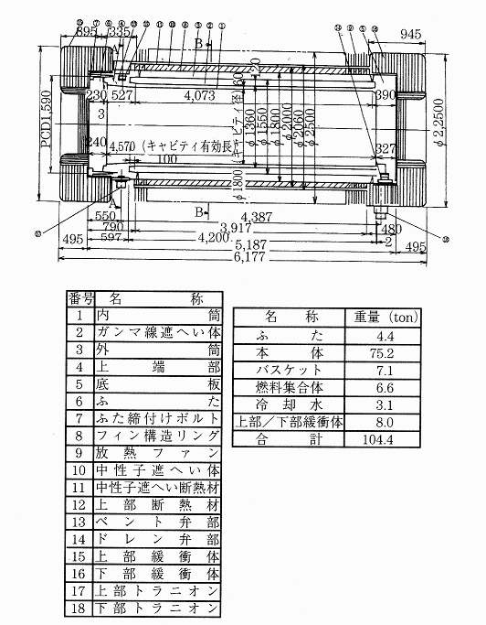

Figure 9.4.2: Dimensions of Spent Nuclear Fuel Shipping Container



Stainless steel

(Bottom plate, inner casing, outer casing, cover)

Silicon rubber/copper

(Neutron shield)

(Inner fin)

Lead (Gamma ray shield)

(Fuel assembly)

Cask Longitudinal Section

Cask Cross Section

Calorific value

Q=41 kw

(External fins)



Figure 9.4.3: Conceptual Diagram of Model

Boundary

Conditions



Figure 9.4.4: Model Boundary Conditions and Mesh Partitioning Figure (EX21A)

### Analysis Results

An example of the analysis results is shown in Figure 9.4.5 ~ Figure 9.4.7.



EX21A EX21B EX21C

Figure 9.4.5: Temperature Distribution Figure

2 Partitions

4 Partitions

8 Partitions

16 Partitions



Figure 9.4.6: Distributed Model Figure

( ): Level of Speed Improvement

No. of CPUs

Computing Time (sec)

No. of CPUs

Computing Time (sec)



Figure 9.4.7: Level of Speed Improvement by Distribution Process

## Example of Actual Model for Linear Dynamic Analysis

### Analysis Model

In the linear dynamic analysis, the machine parts shown in Figure 9.5.1 were used as the actual model. In this actual model, a verification example was set for four cases with different load conditions and damping coefficients. A list is shown in Table 9.5.1.

Table 9.5.1: Verification Example of Actual Model for Linear Dynamic Analysis

|  |  |  |  |  |  |  |
| --- | --- | --- | --- | --- | --- | --- |
| Case  Name | Element  Type | Verification Model | Loading Conditions | Damping Conditions | No. of  Nodes | No. of Degrees  of Freedom |
| EX31A | 342 | Mesh model | Step load (F0) | No | 15,214 | 45,642 |
| EX31B | 342 | Step load (F0) | Yes | 15,214 | 45,642 |
| EX31C | 342 | Square wave pulse (F1) | No | 15,214 | 45,642 |
| EX31D | 342 | Square wave pulse (F1) | Yes | 15,214 | 45,642 |

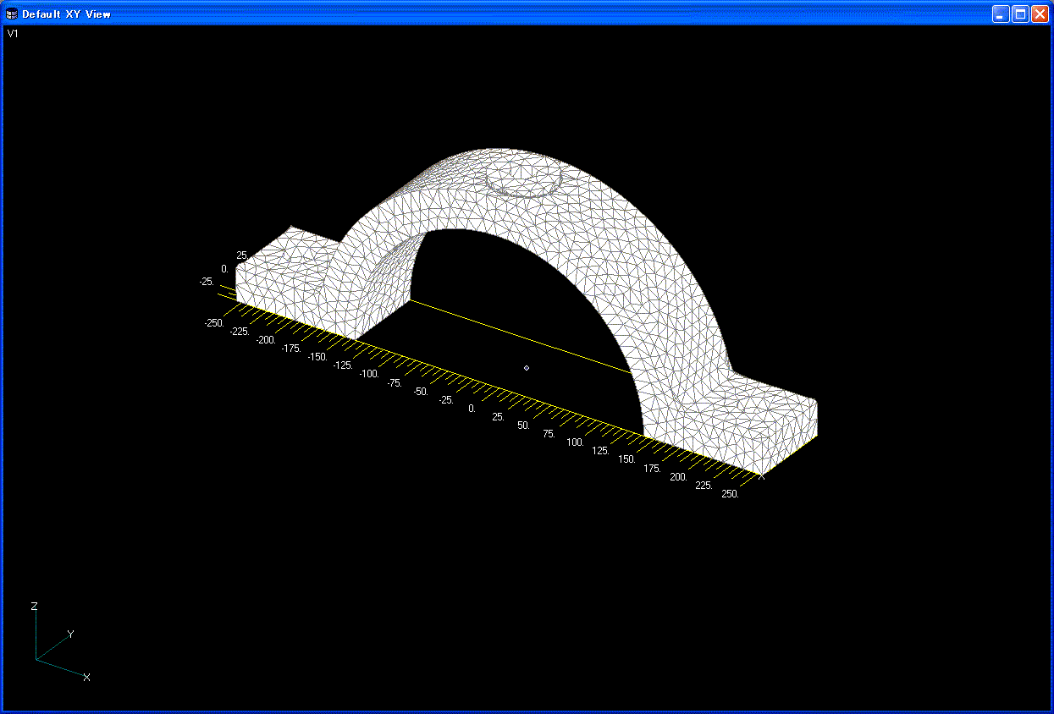

Loading Conditions

Mesh Figure

Figure 9.5.1: Mesh Model

### Analysis Results

Examples of the analysis results are shown in Figure 9.5.2 ~ Figure 9.5.3.

Implicit Method (Step Load) No Damping Implicit Method (Step Load) Damping



(a) In the case of Step Load

Implicit Method (Square Wave Pulse) No Damping Implicit Method (Square Wave Pulse) Damping



(b) In the case of Square Wave Pulse Load

Figure 9.5.2: Time History of Vibration Point Displacement uz

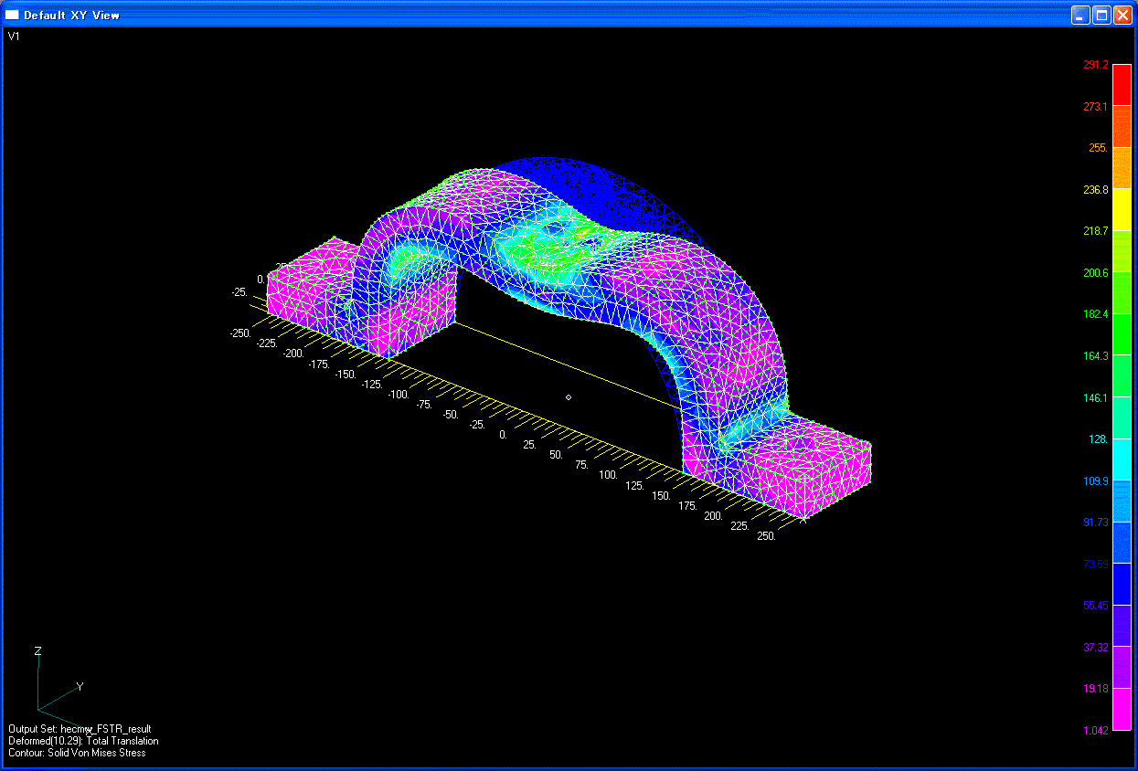

(a) t=5.0E-04(s)

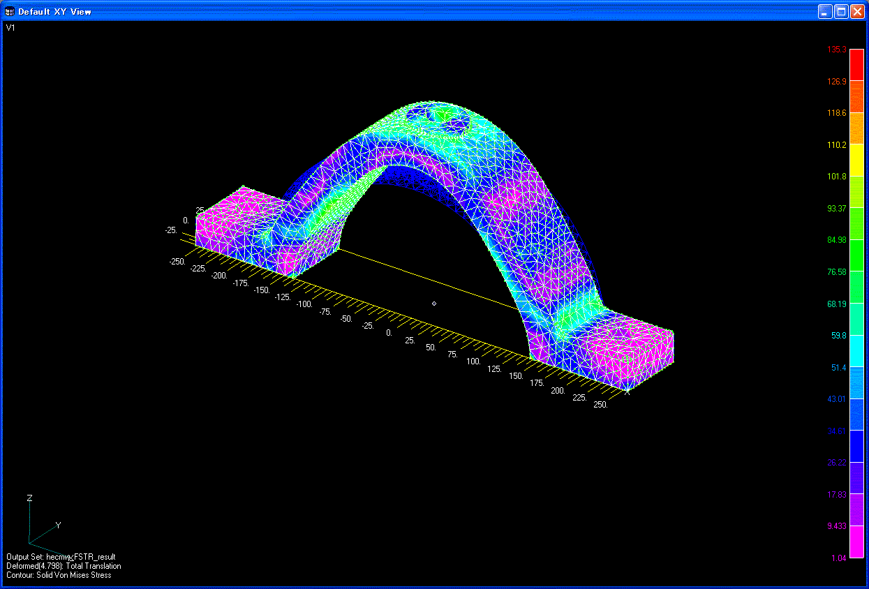

(b) t=4.0E-03(s)

Figure 9.5.3: Deformed Figure and Equivalent Stress Distribution

(Deformed Magnification 5.0): EX31C